Topic w/b Monday 17th May
Monday 17th May 2021
Dance
Learning to: explore and experiment with historic dance styles from the 1970s
create a sequence for performance.

Today you will be learning some movements that were popular in the 1970’s. Watch this video to find out more!
https://vimeo.com/203818084
Now think about your starting position:

Slowly practise each movement
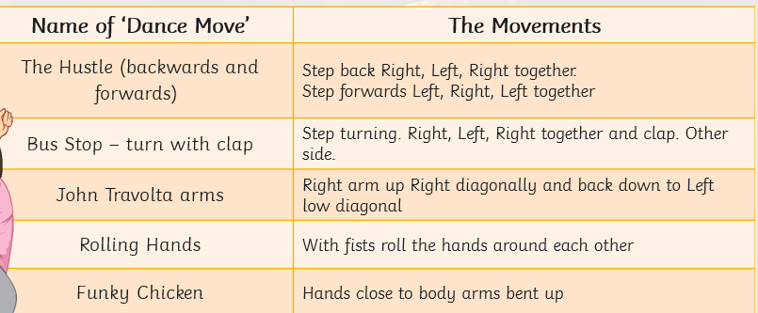

Put sequence together to music https://www.youtube.com/watch?v=op5FxEs1aR0

Tuesday 18th May 2021
Art
Learning to: create a portrait in the style of an artist.
Today you are going to create a portrait in the style of Andy Warhol like this!
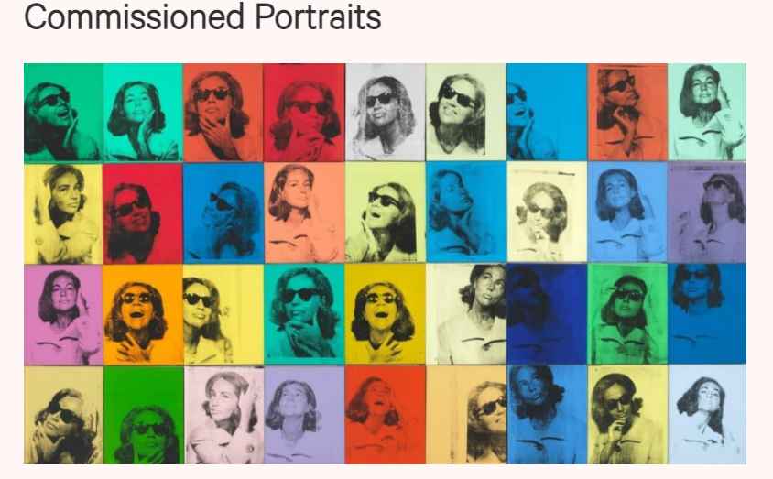
Use a laptop and log in to paintz.app

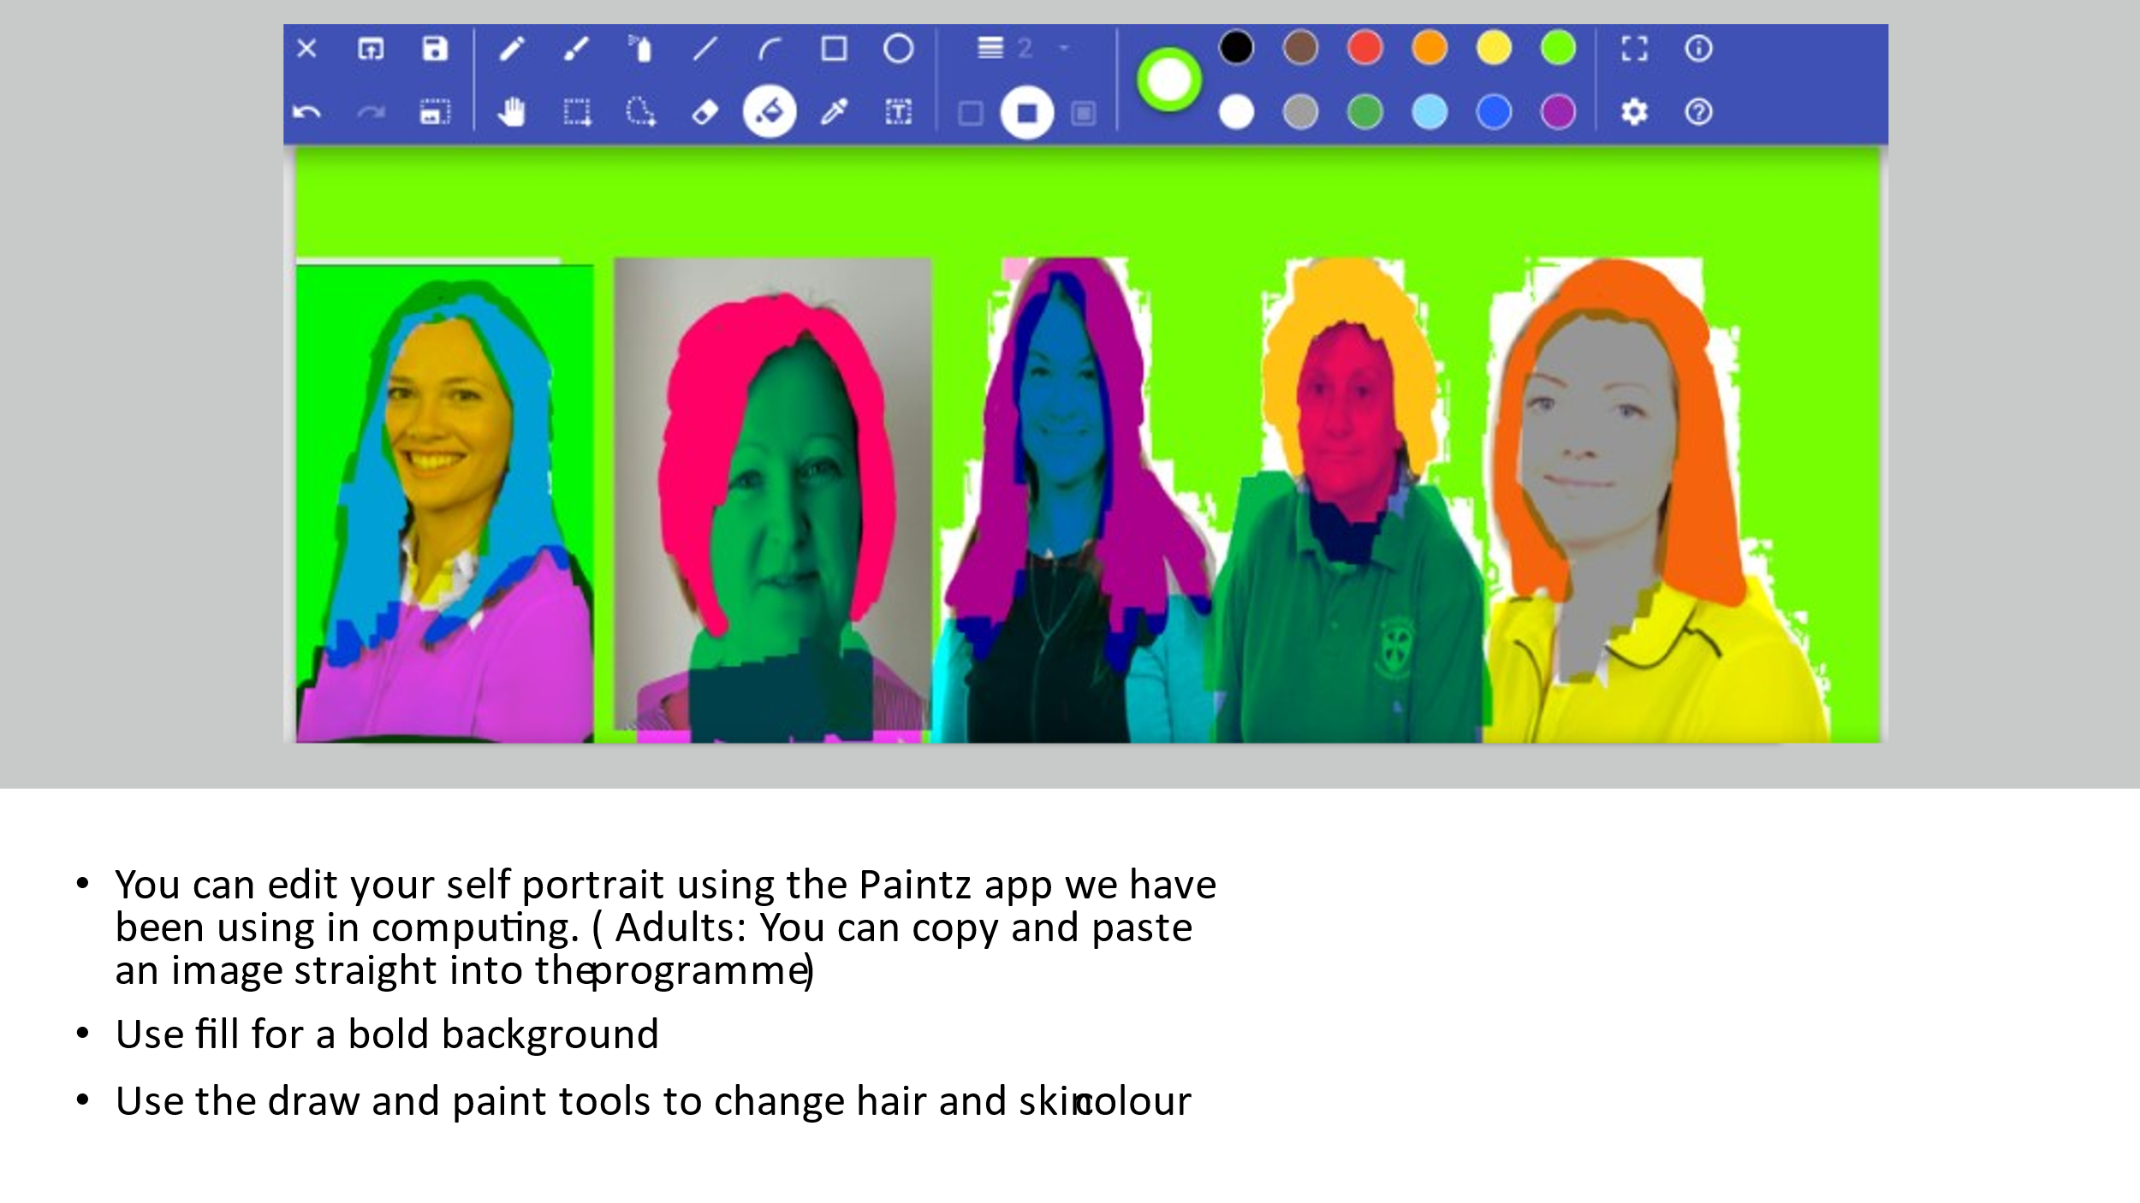
Take a picture of yourself and ue paintz to change it like this!

Wednesday 19th May
Music

Music - from Mrs Jackson You can access this week’s Music lessons using your child’s Charanga log in.

Thursday 20th May
History
Today you will think back to the questions we asked Mr Millington. You are going to draw and label some of the things that have changed in Brookside . Draw 3 things and label them.

Thursday 20th May
DT

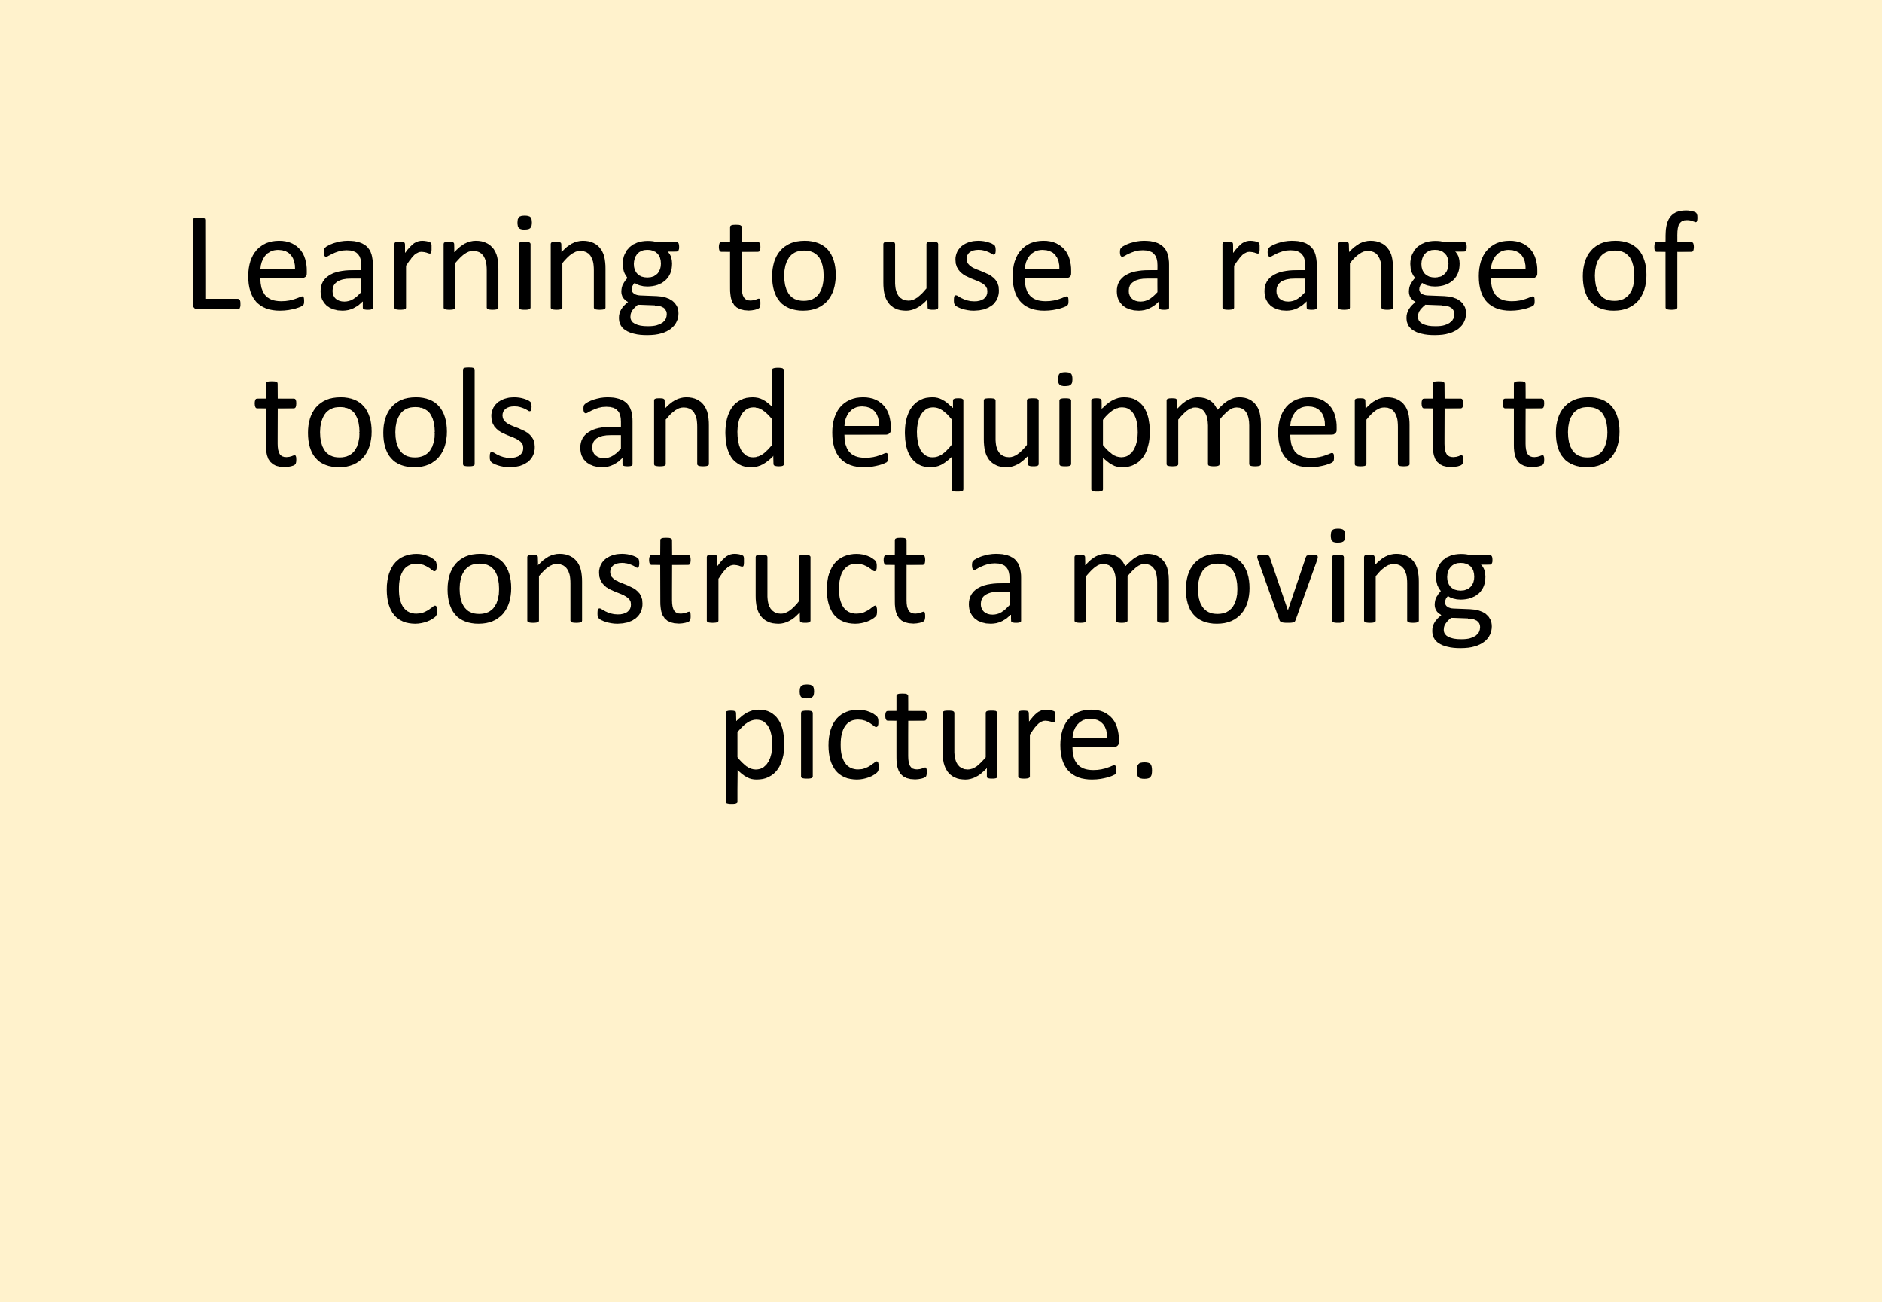

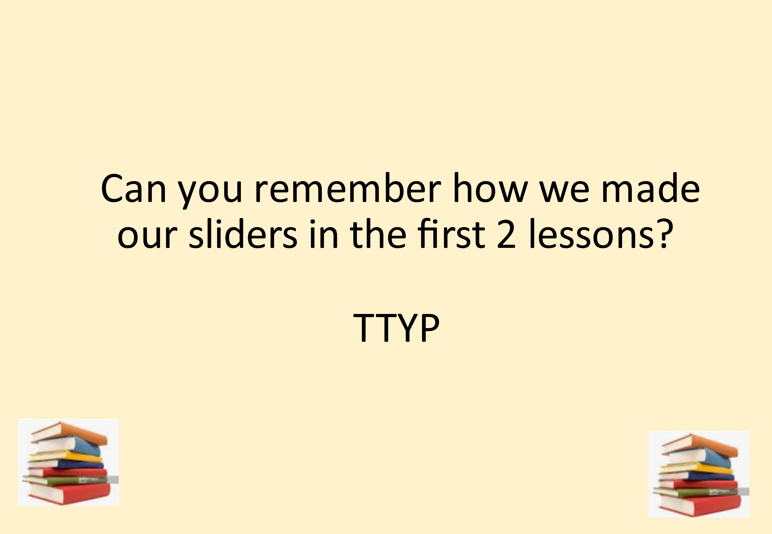

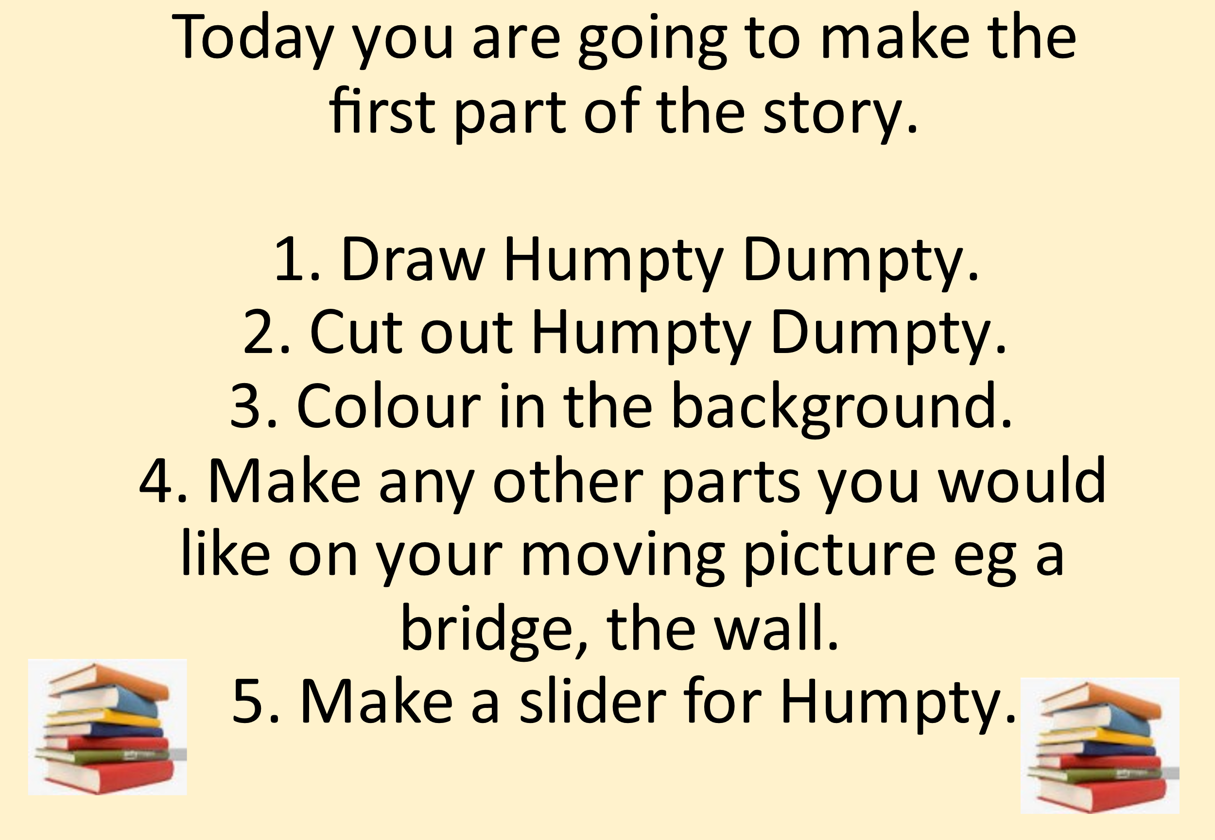

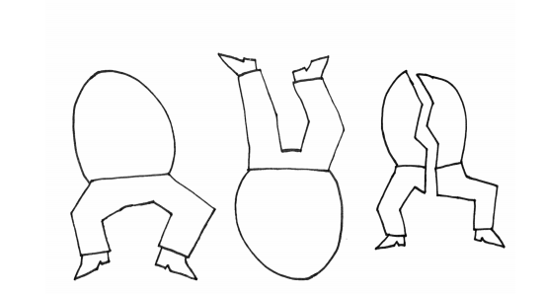

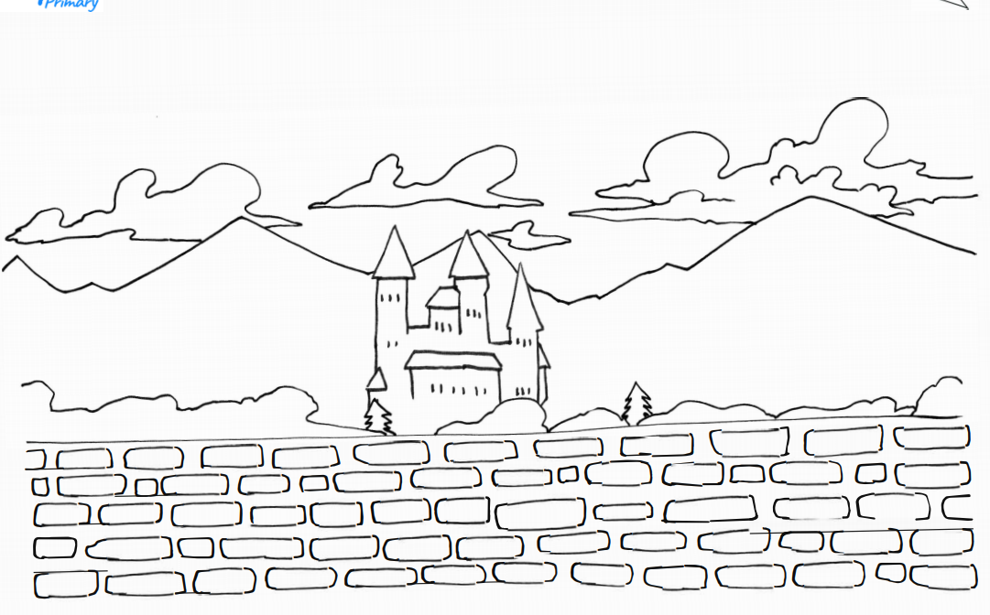

Now use the sheet below to draw the 3 parts of Humpty Dumpty and show what part will move and whether it will need a side to side slider mechanism or an up and down slider mechanism.

Friday 14th May
Geography

