Topic w/b Monday 26th April
Tuesday 4th May 2021
Art
Learning to: use a range of textures
What is a portrait?
A portrait is a painting, photograph, sculpture, of a person. The face and its expression is the focus. It needs to look like the person, and even the mood of the person.
In your last Art lesson, you took a photograph of yourself and your friend using a camera. Today you are going to use a range of materials to create texture in your portrait.
Eg. wool . If you think about the shapes and texture of hair we all have very different hair, straight, curls, long and short.
Felt – skin tones, soft skin
Cotton/fabric for clothes
Now select some materials to represent yourself in a self-portrait.
You can use wax crayons to do rubbings for the background – use a range of surfaces to create textures.
Your portrait should look something like this!
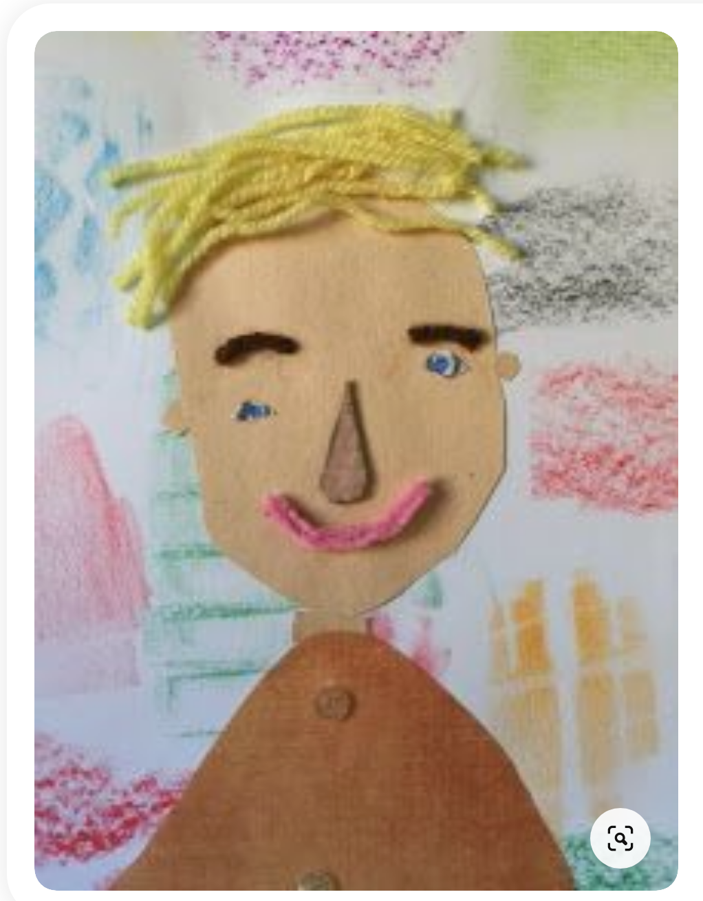

Tuesday 4th May 2021
History

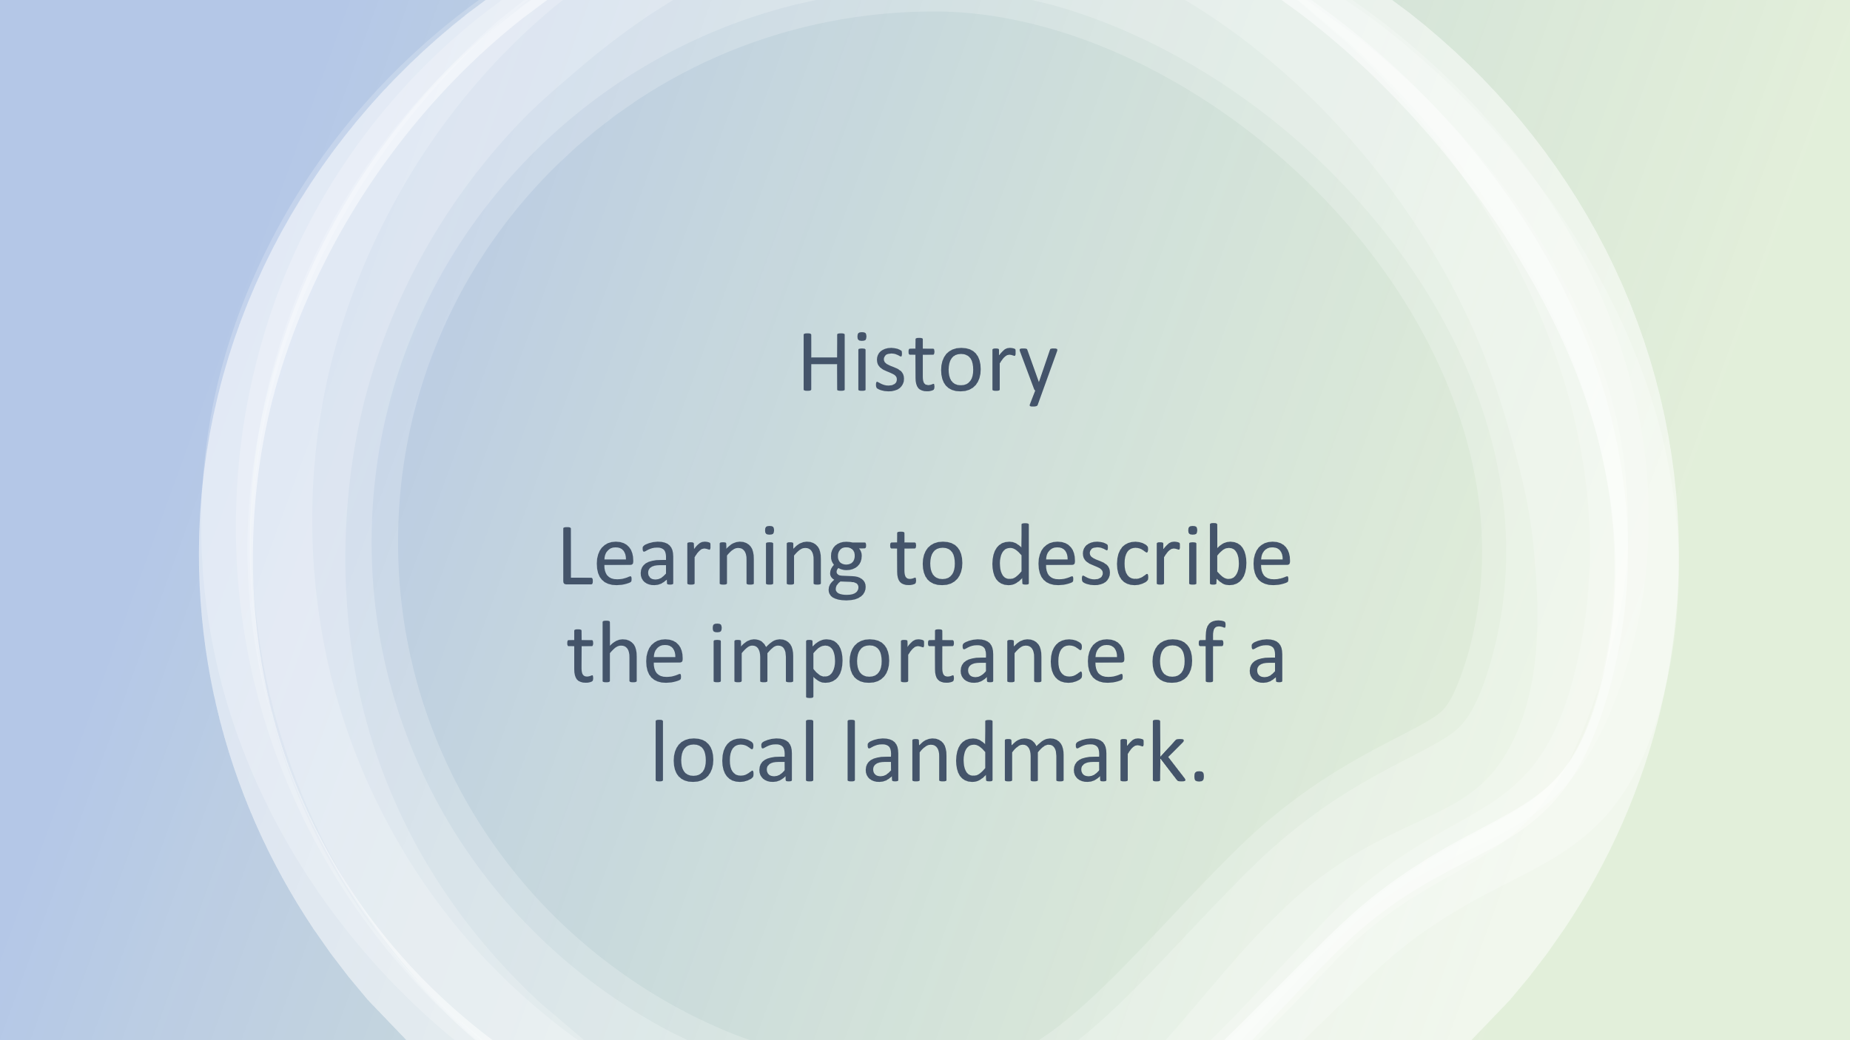
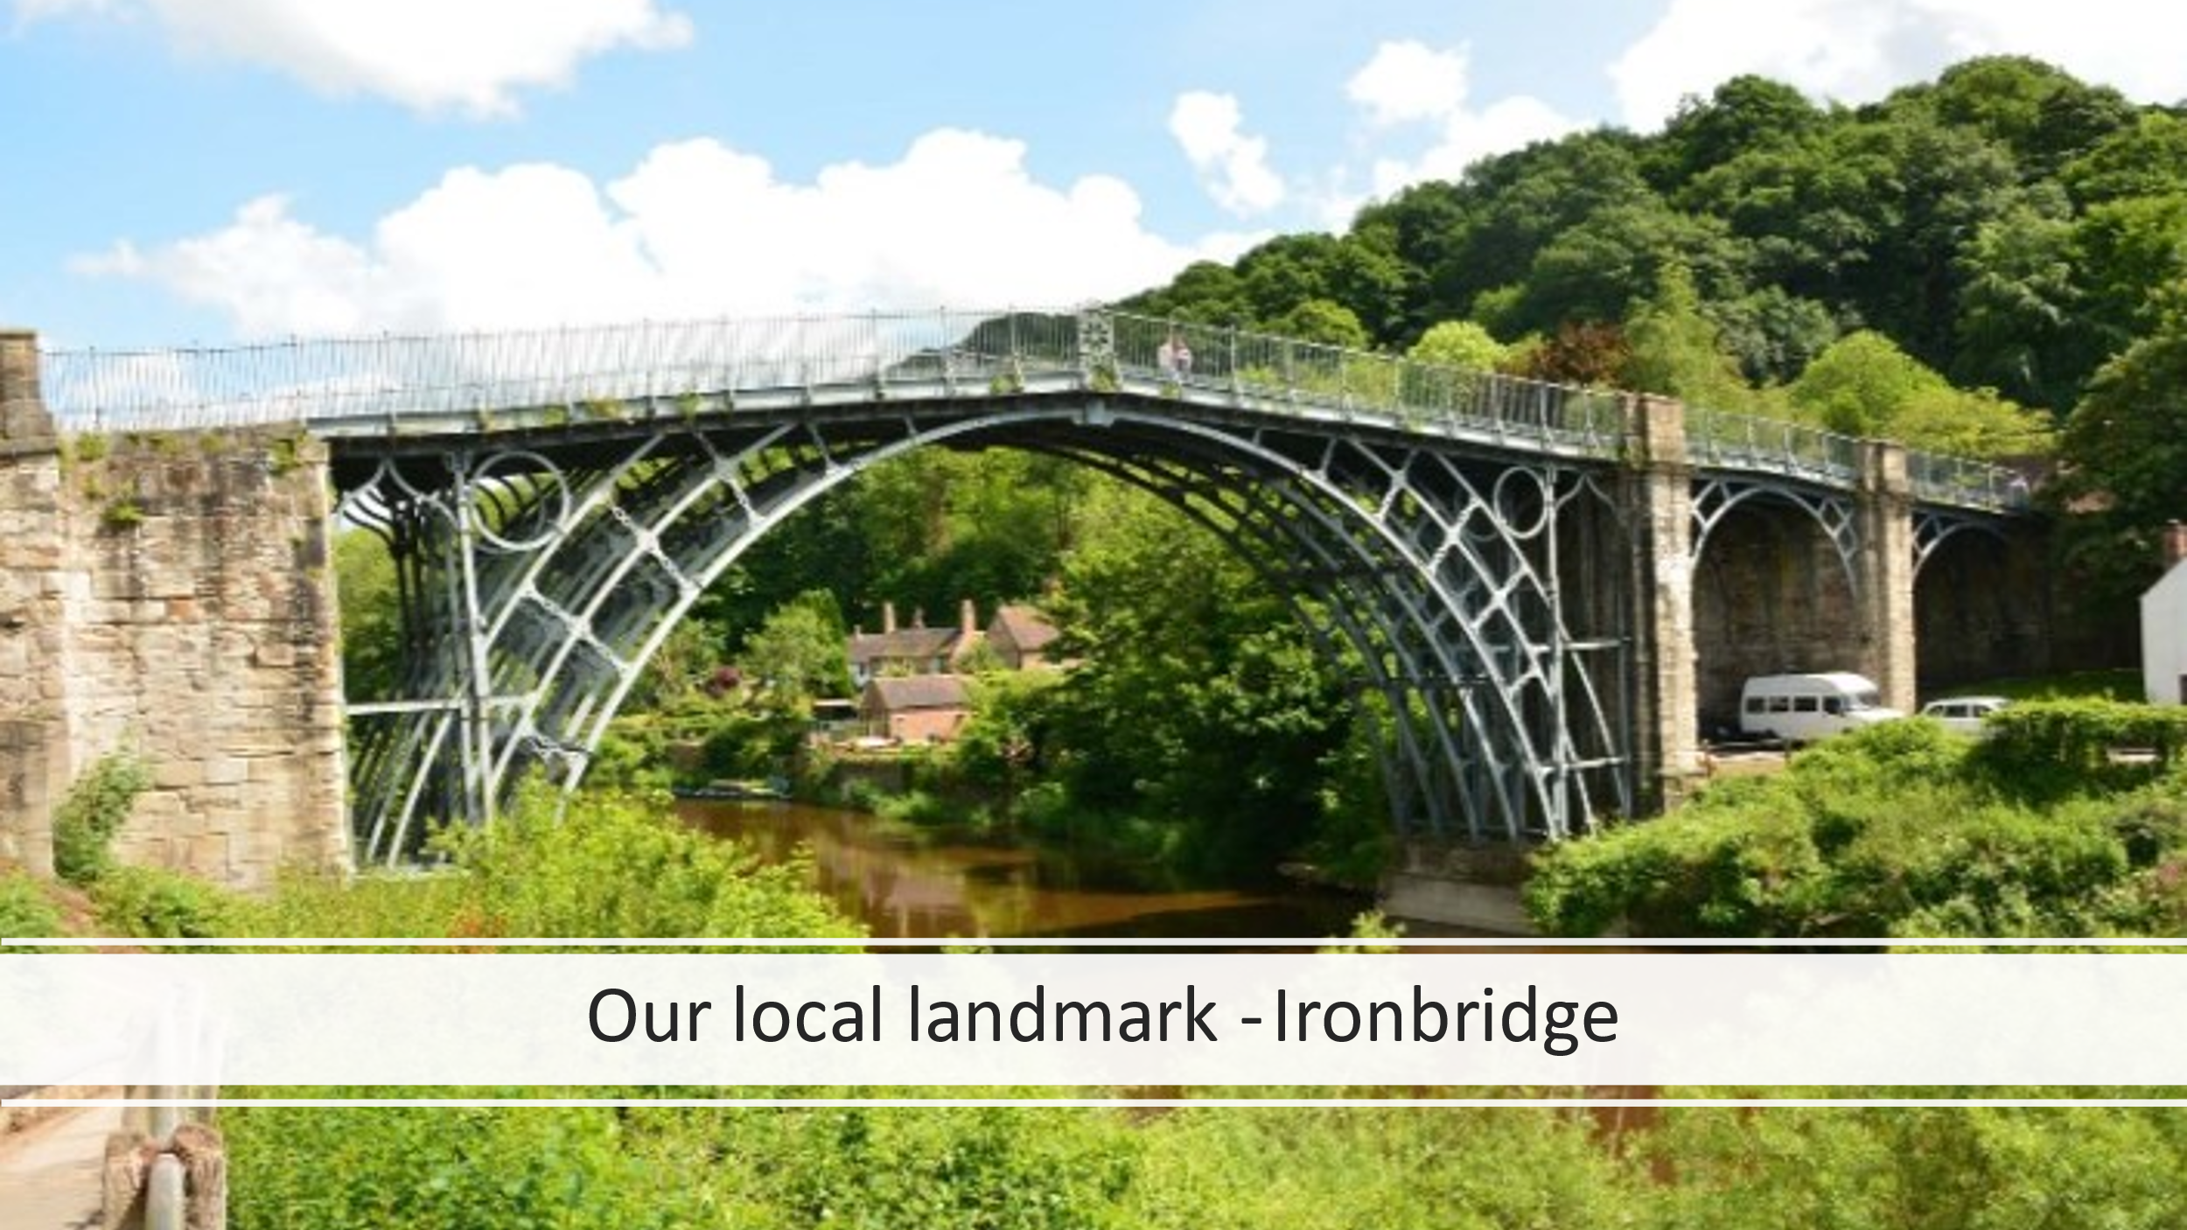

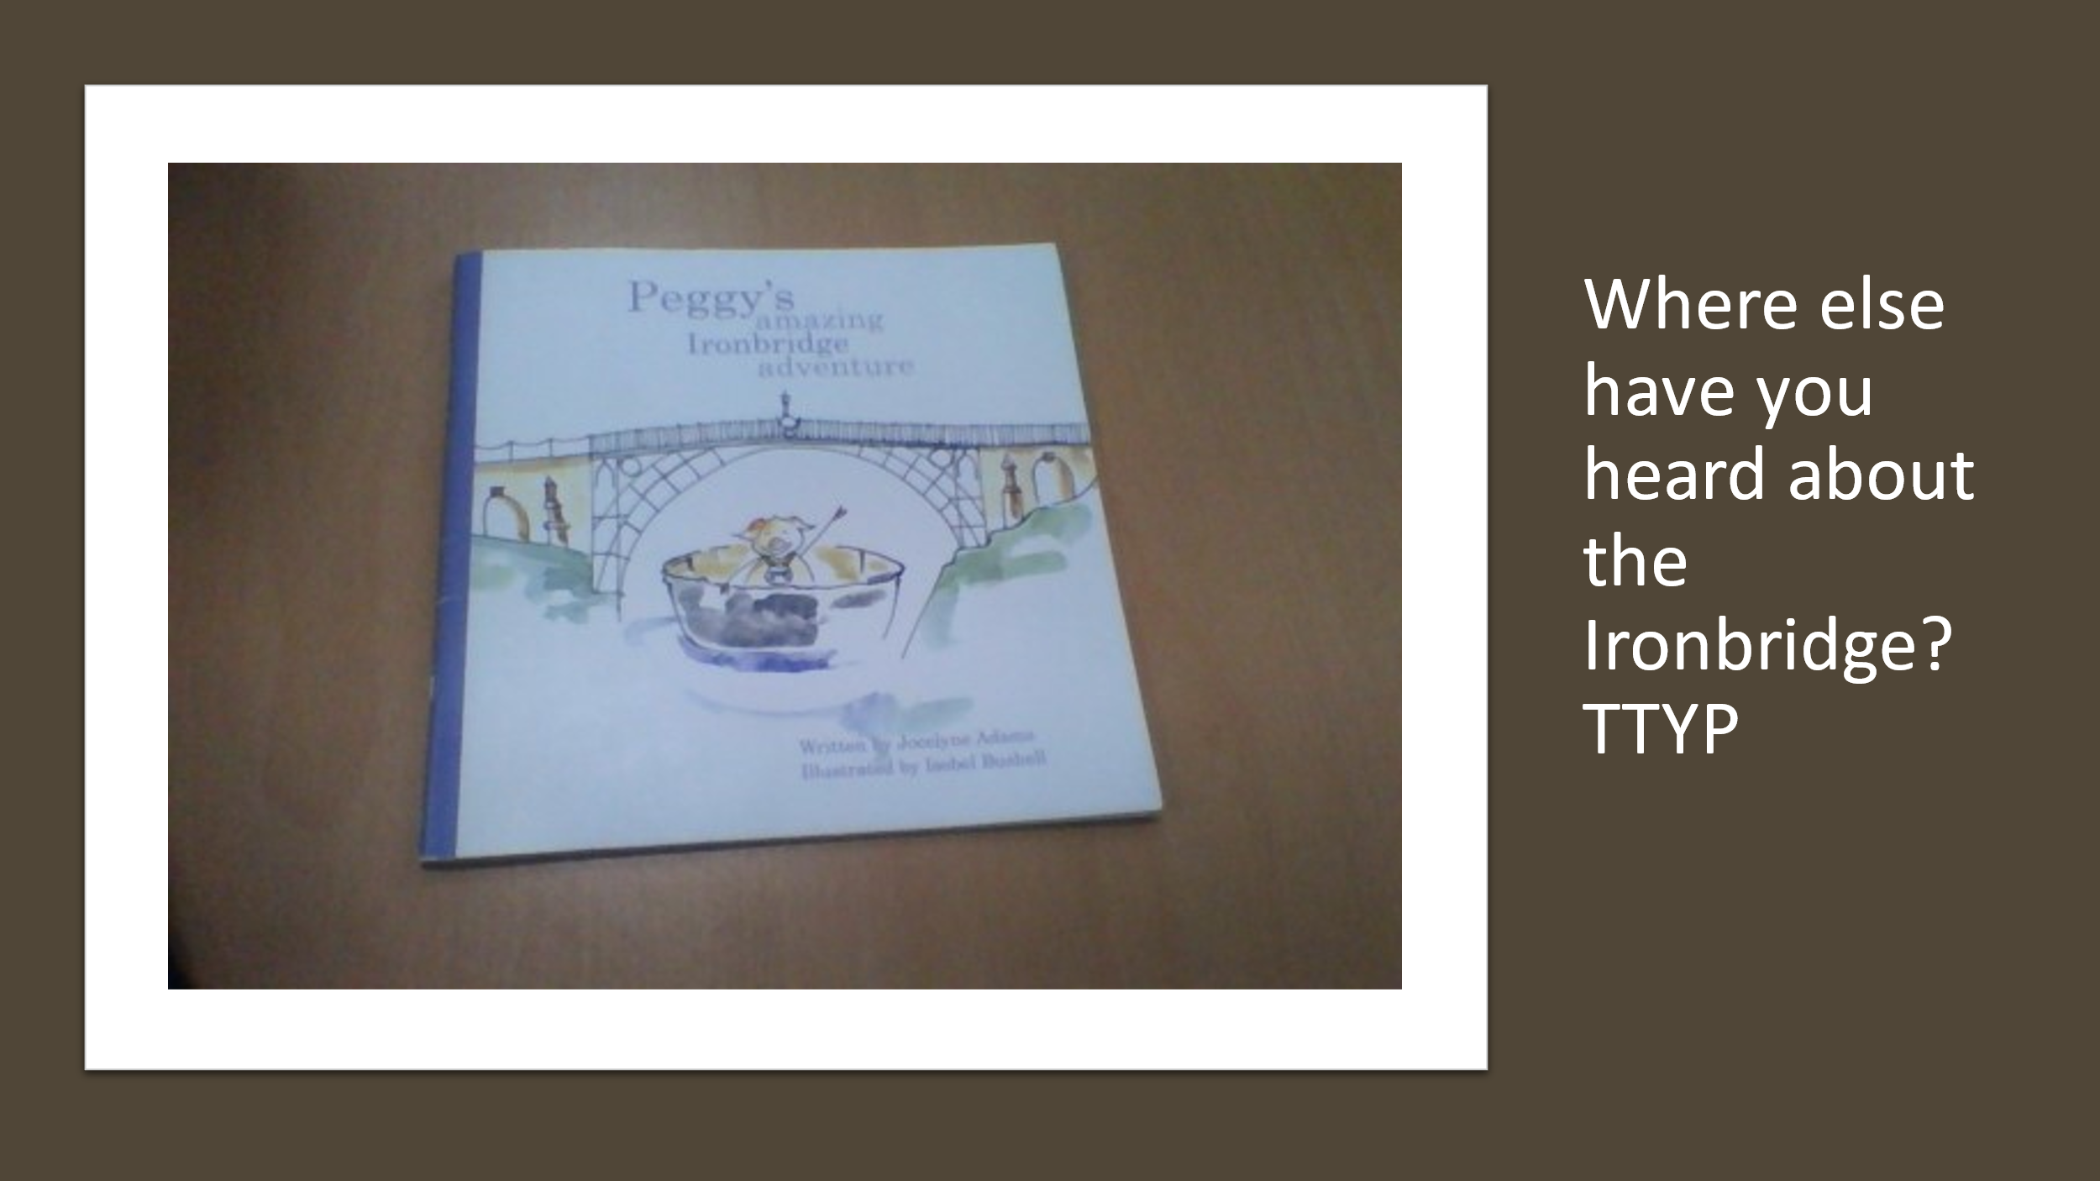
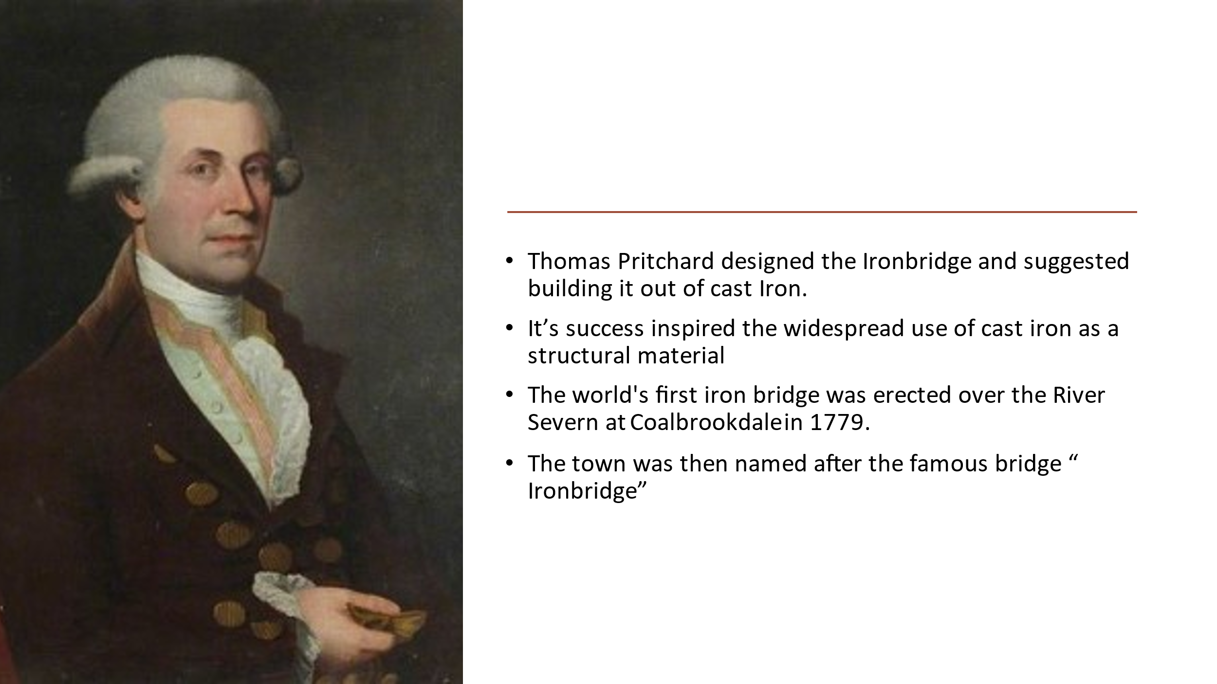
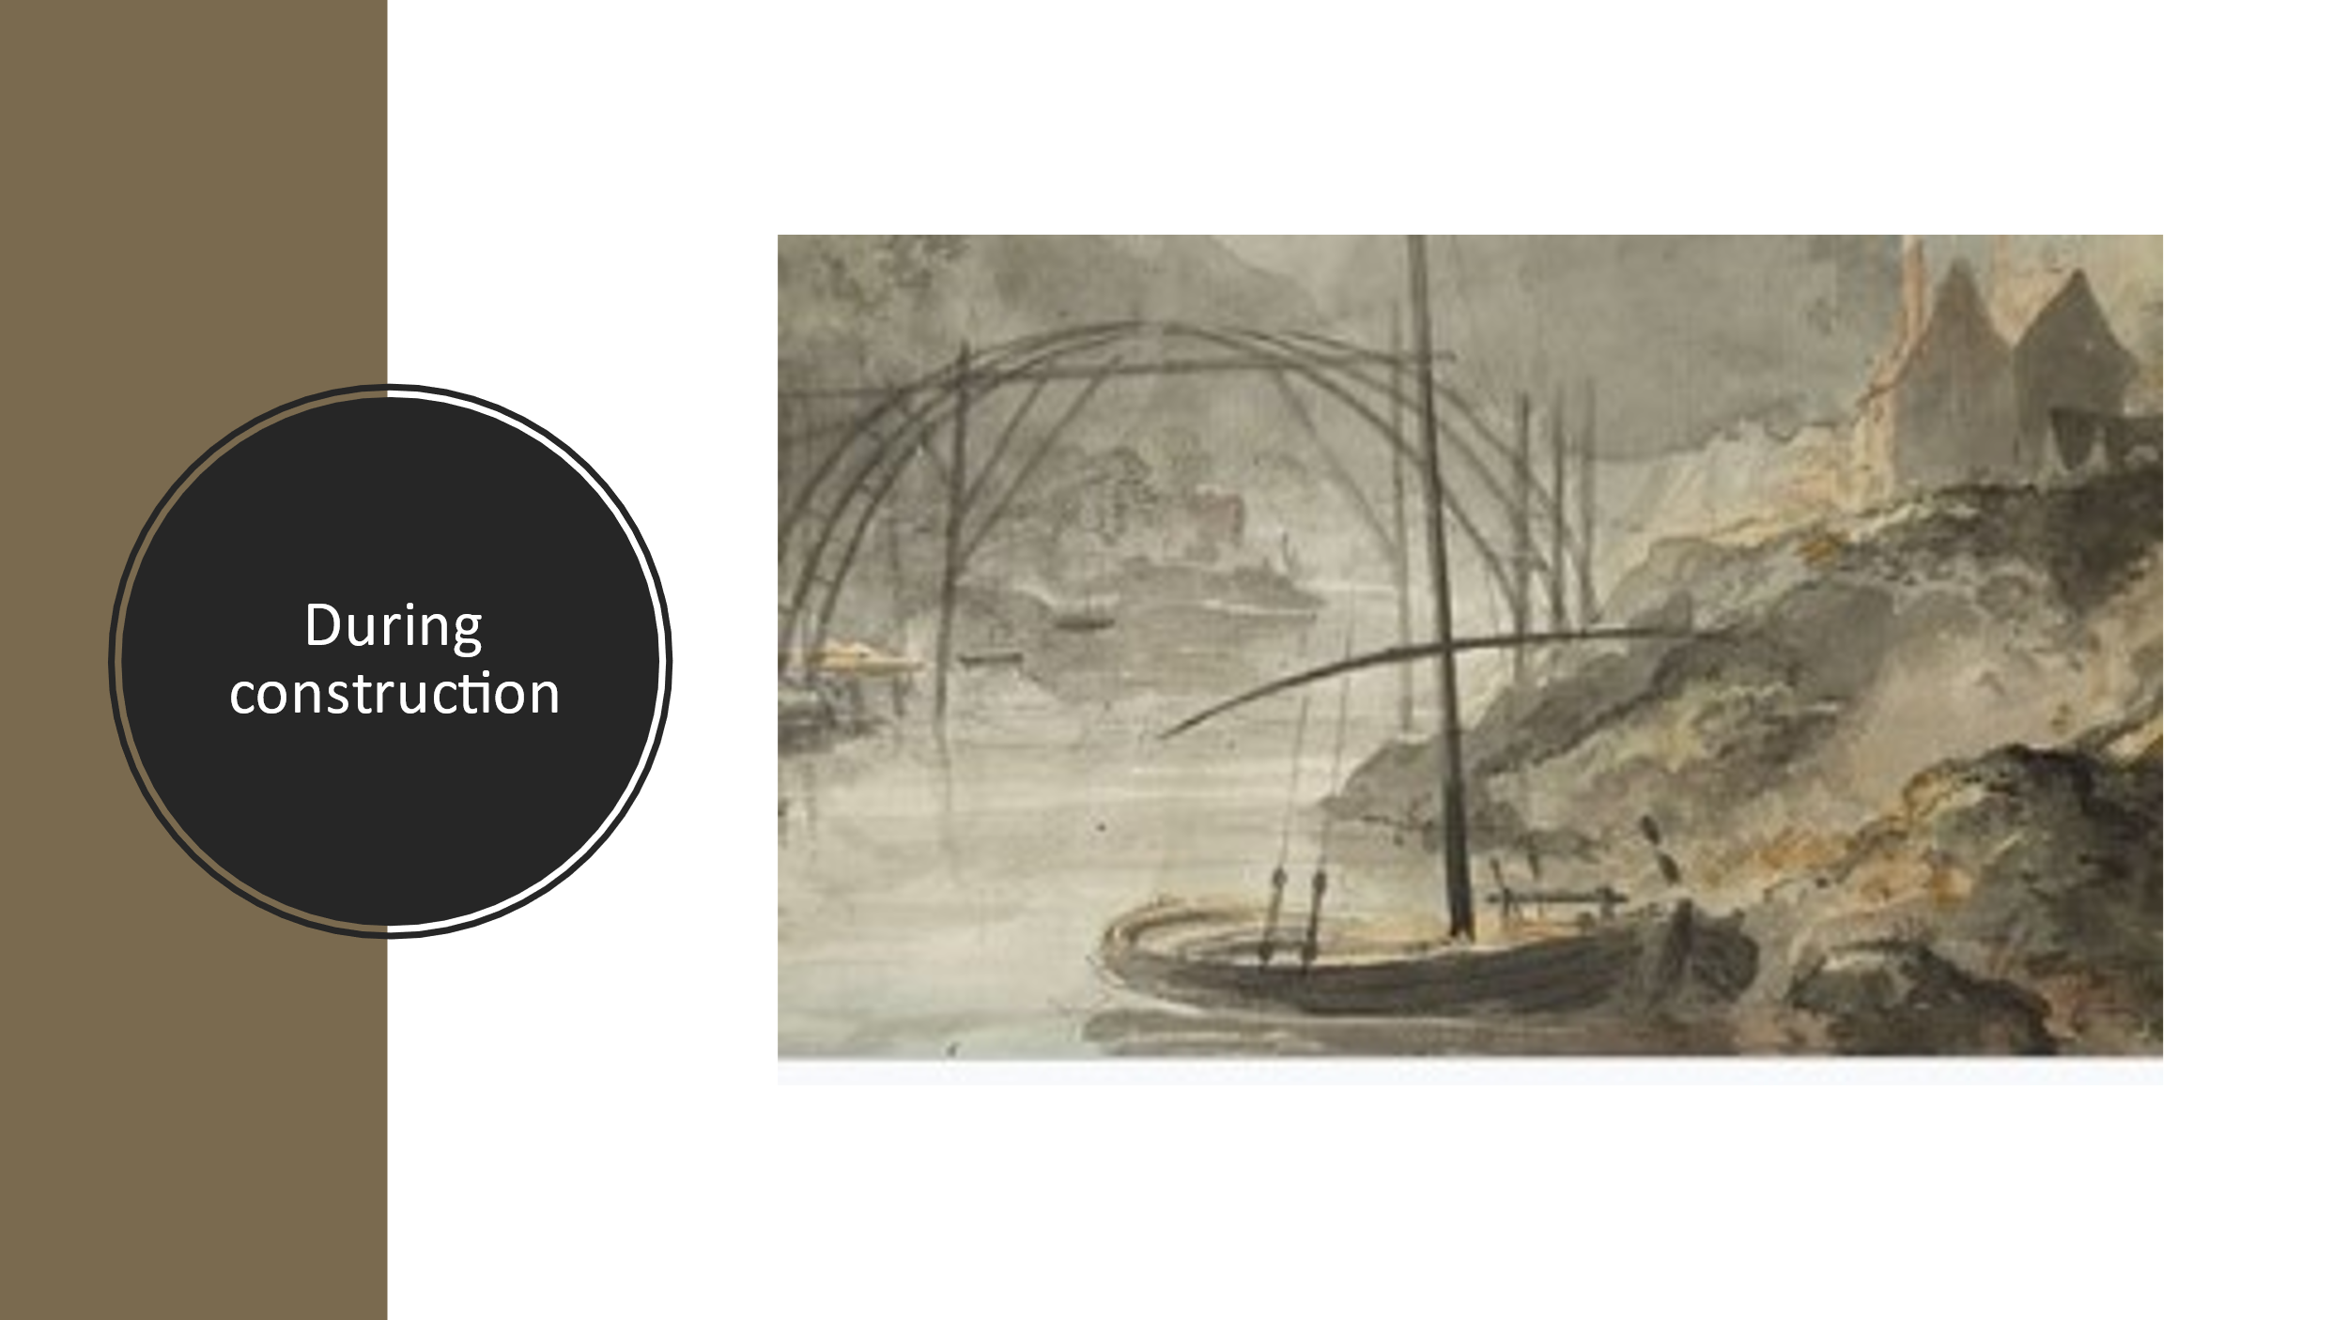
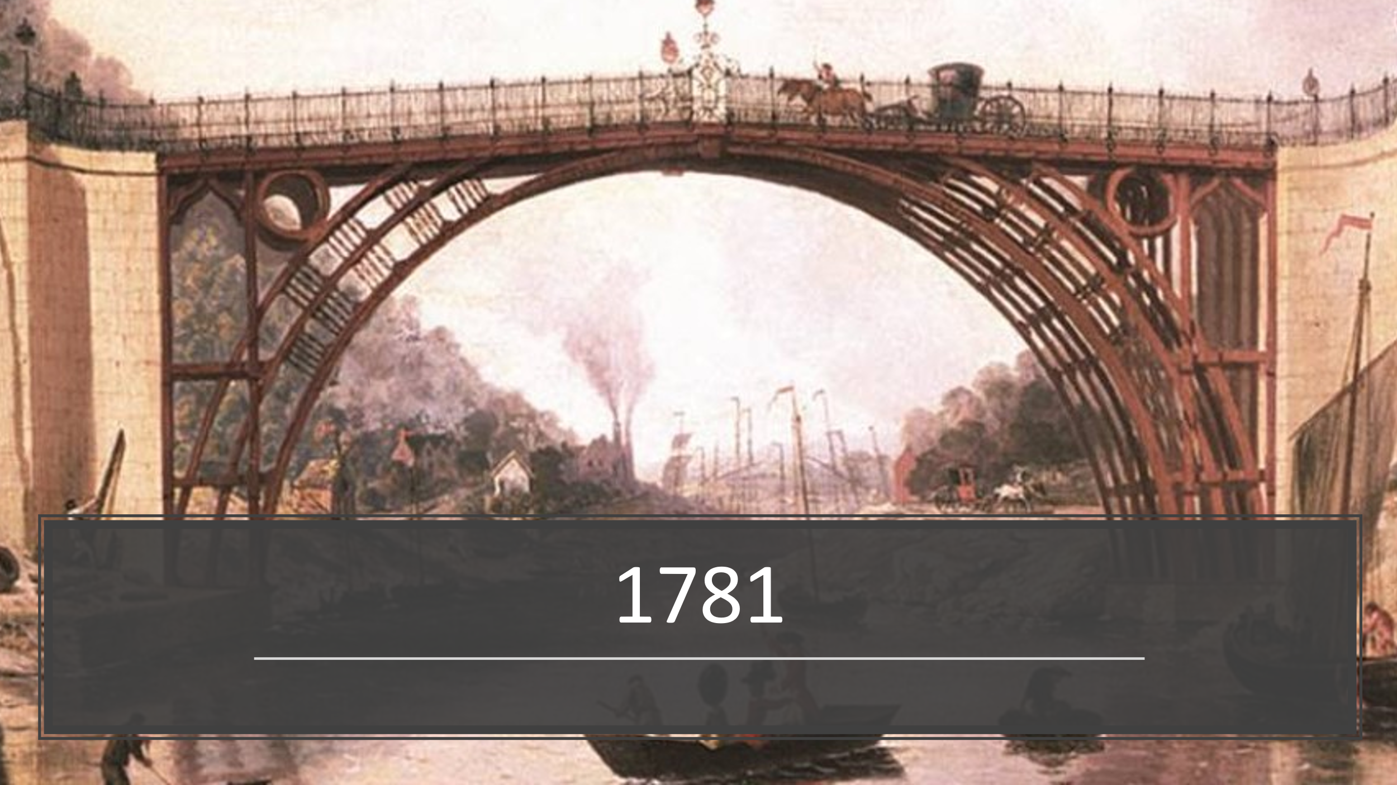

Now write a few sentences about why Ironbridge is a special place!

Wednesday 5th May
Music

Music - from Mrs Jackson You can access this week’s Music lessons using your child’s Charanga log in.

Thursday 6th May
Geography
Once you have looked at the learning slides, draw a picture of the UK and put spots on it to identify where the capital cities are. Next draw the 4 flags on the 4 countries of the United Kingdom.

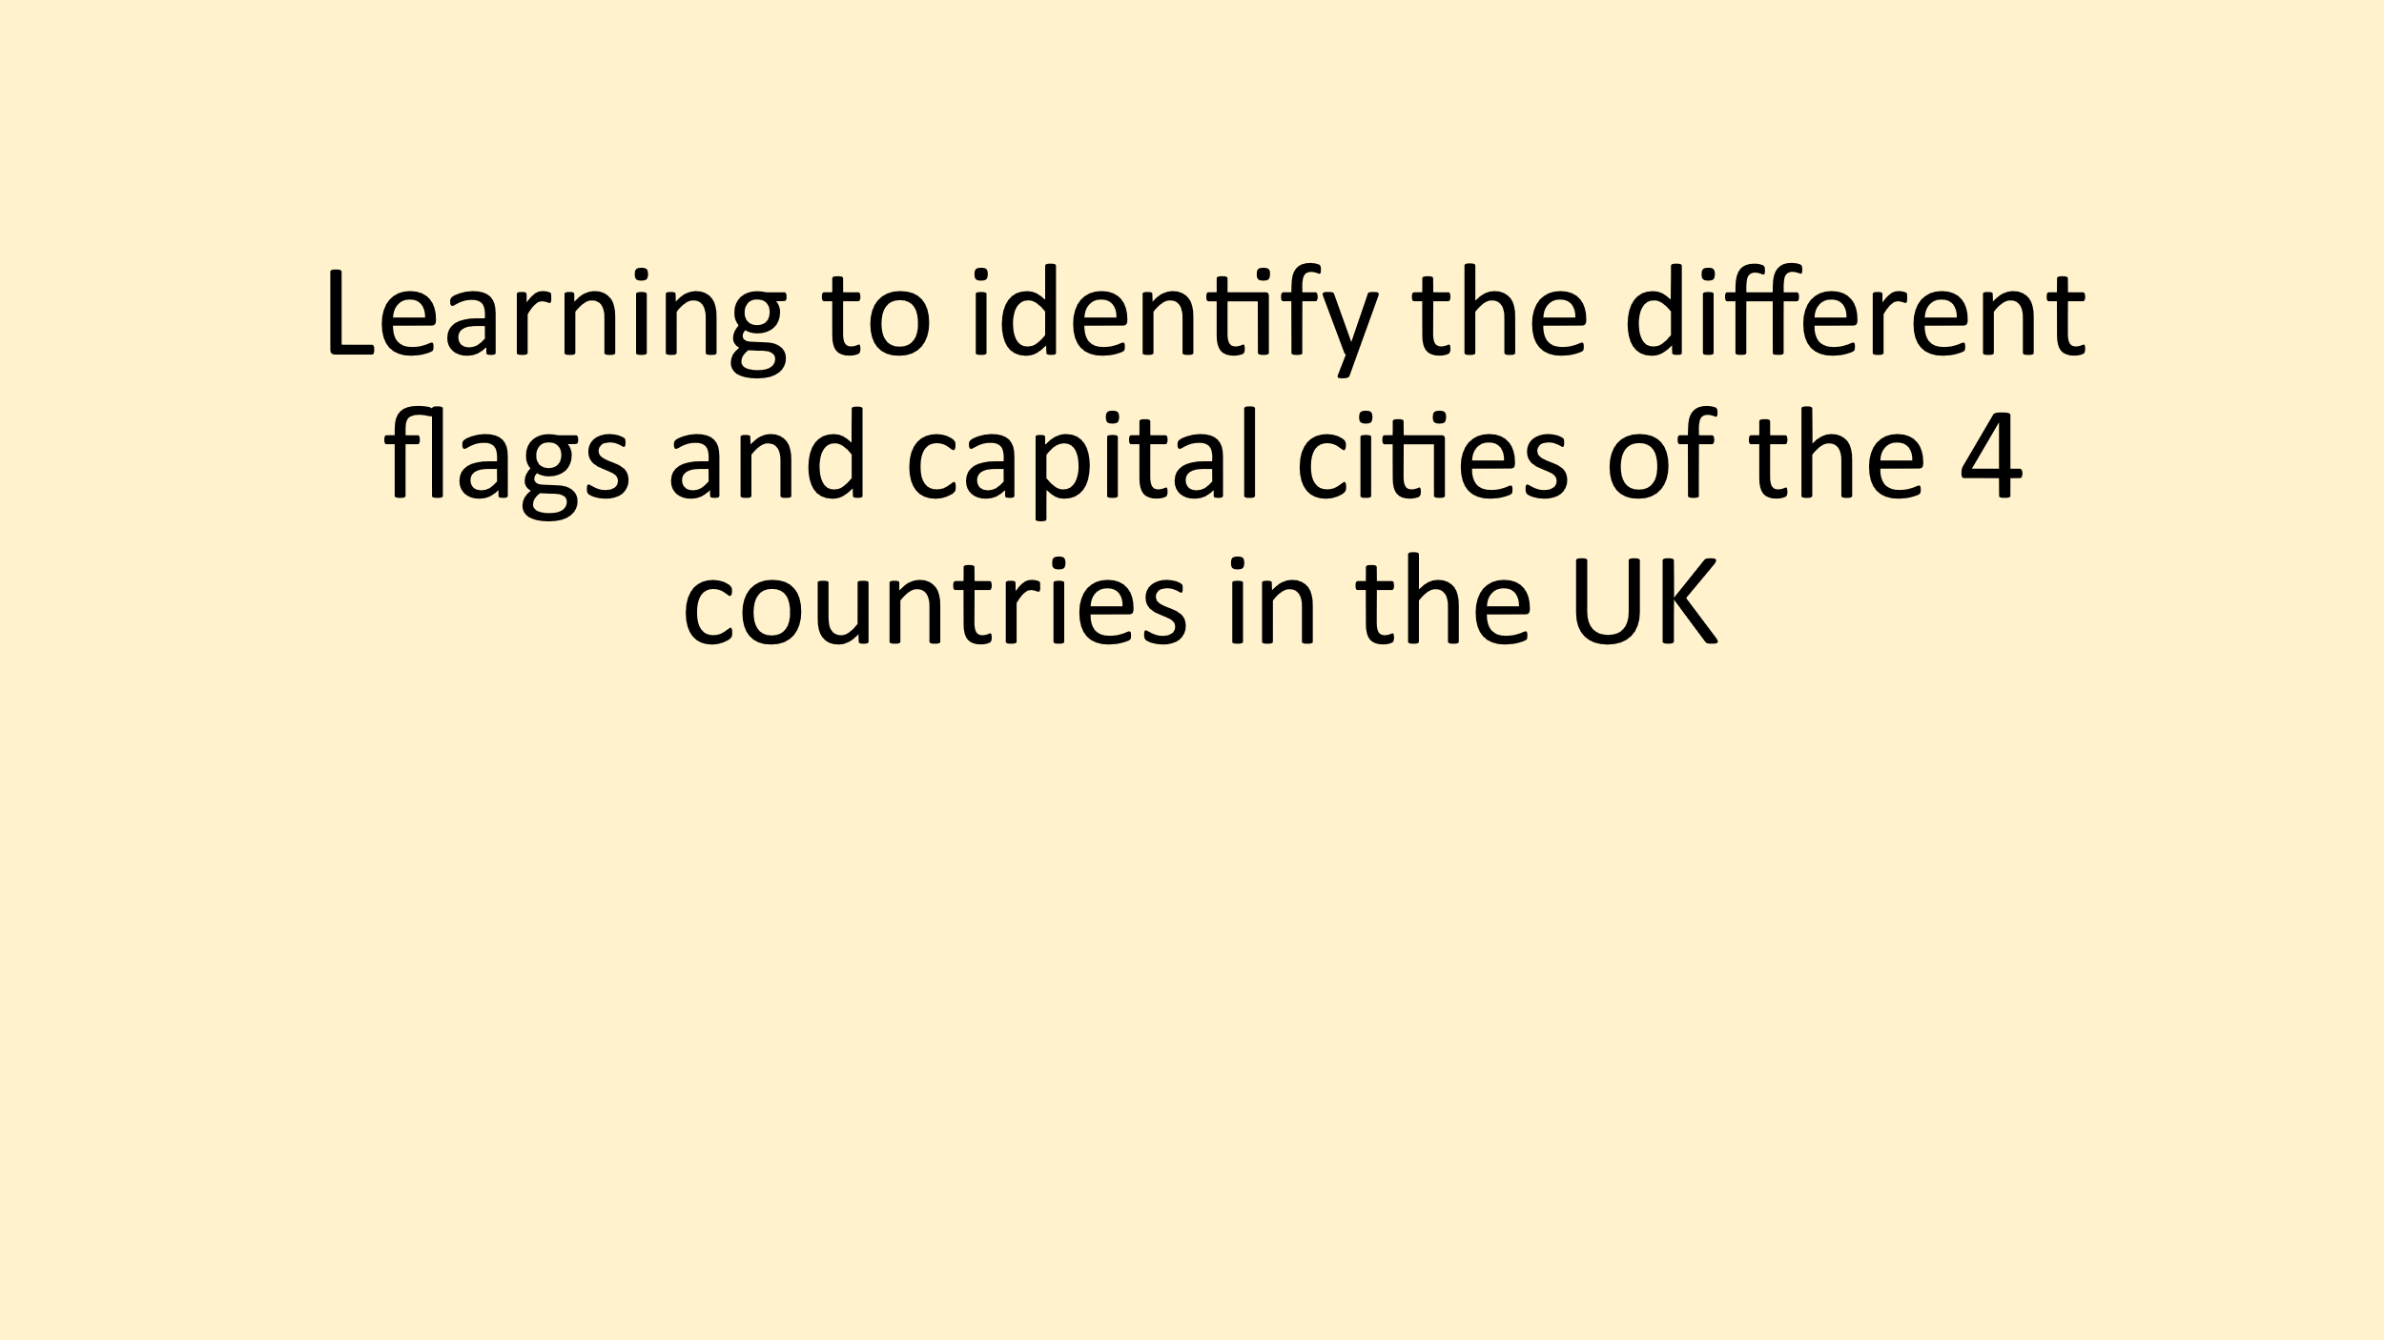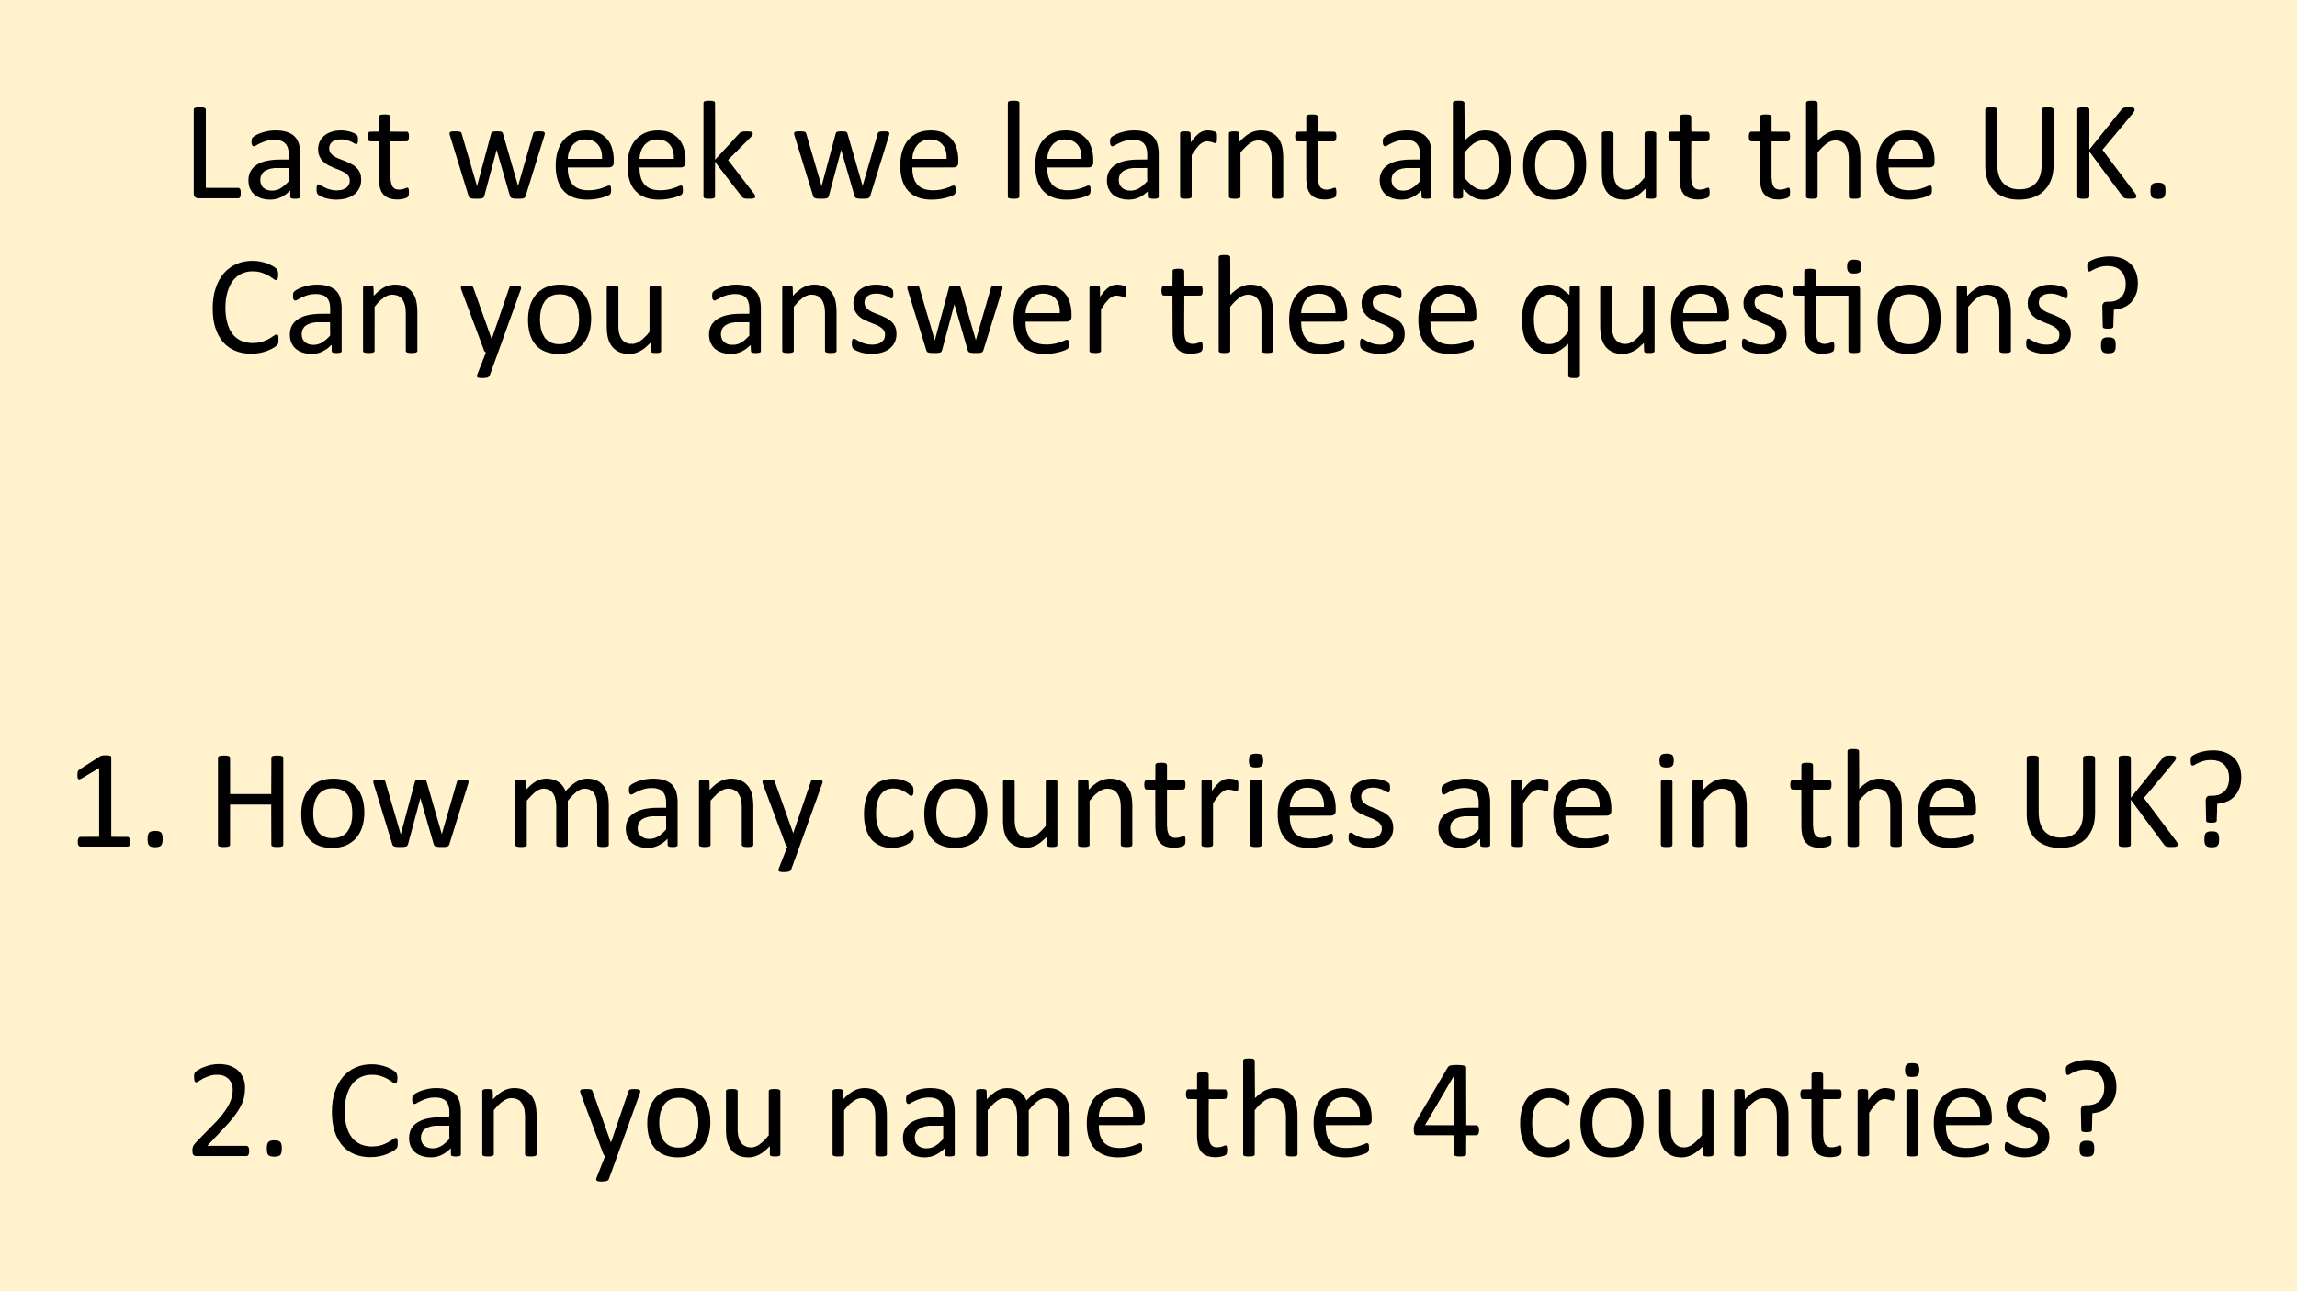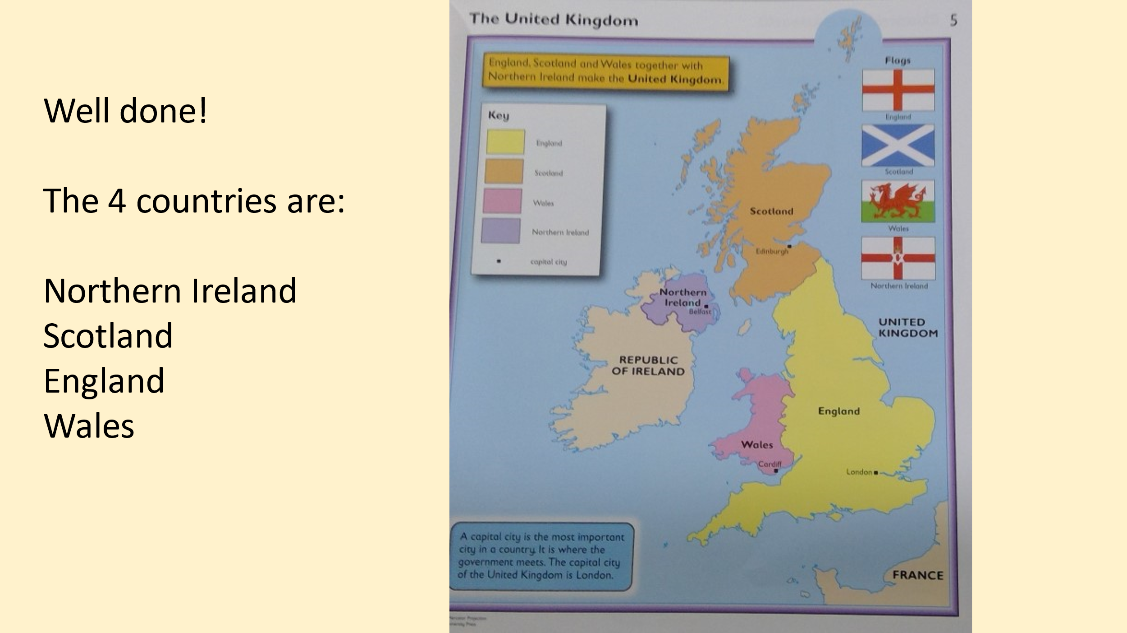

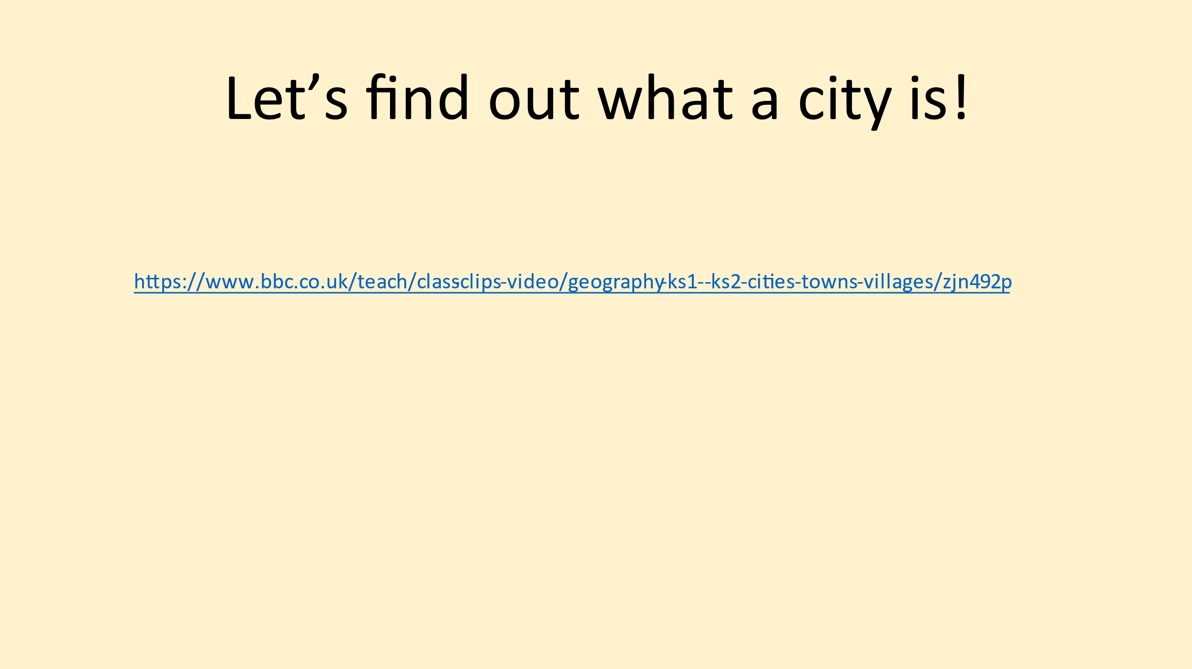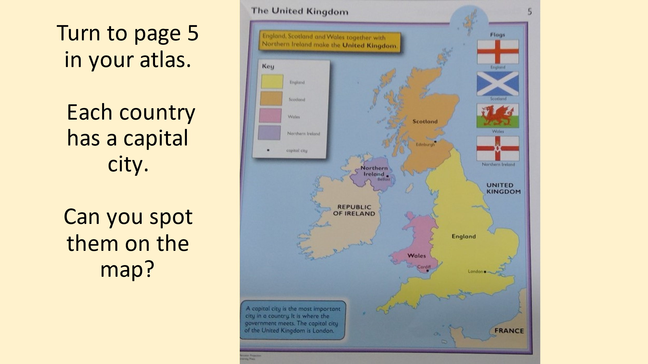

Thursday 6th May
DT
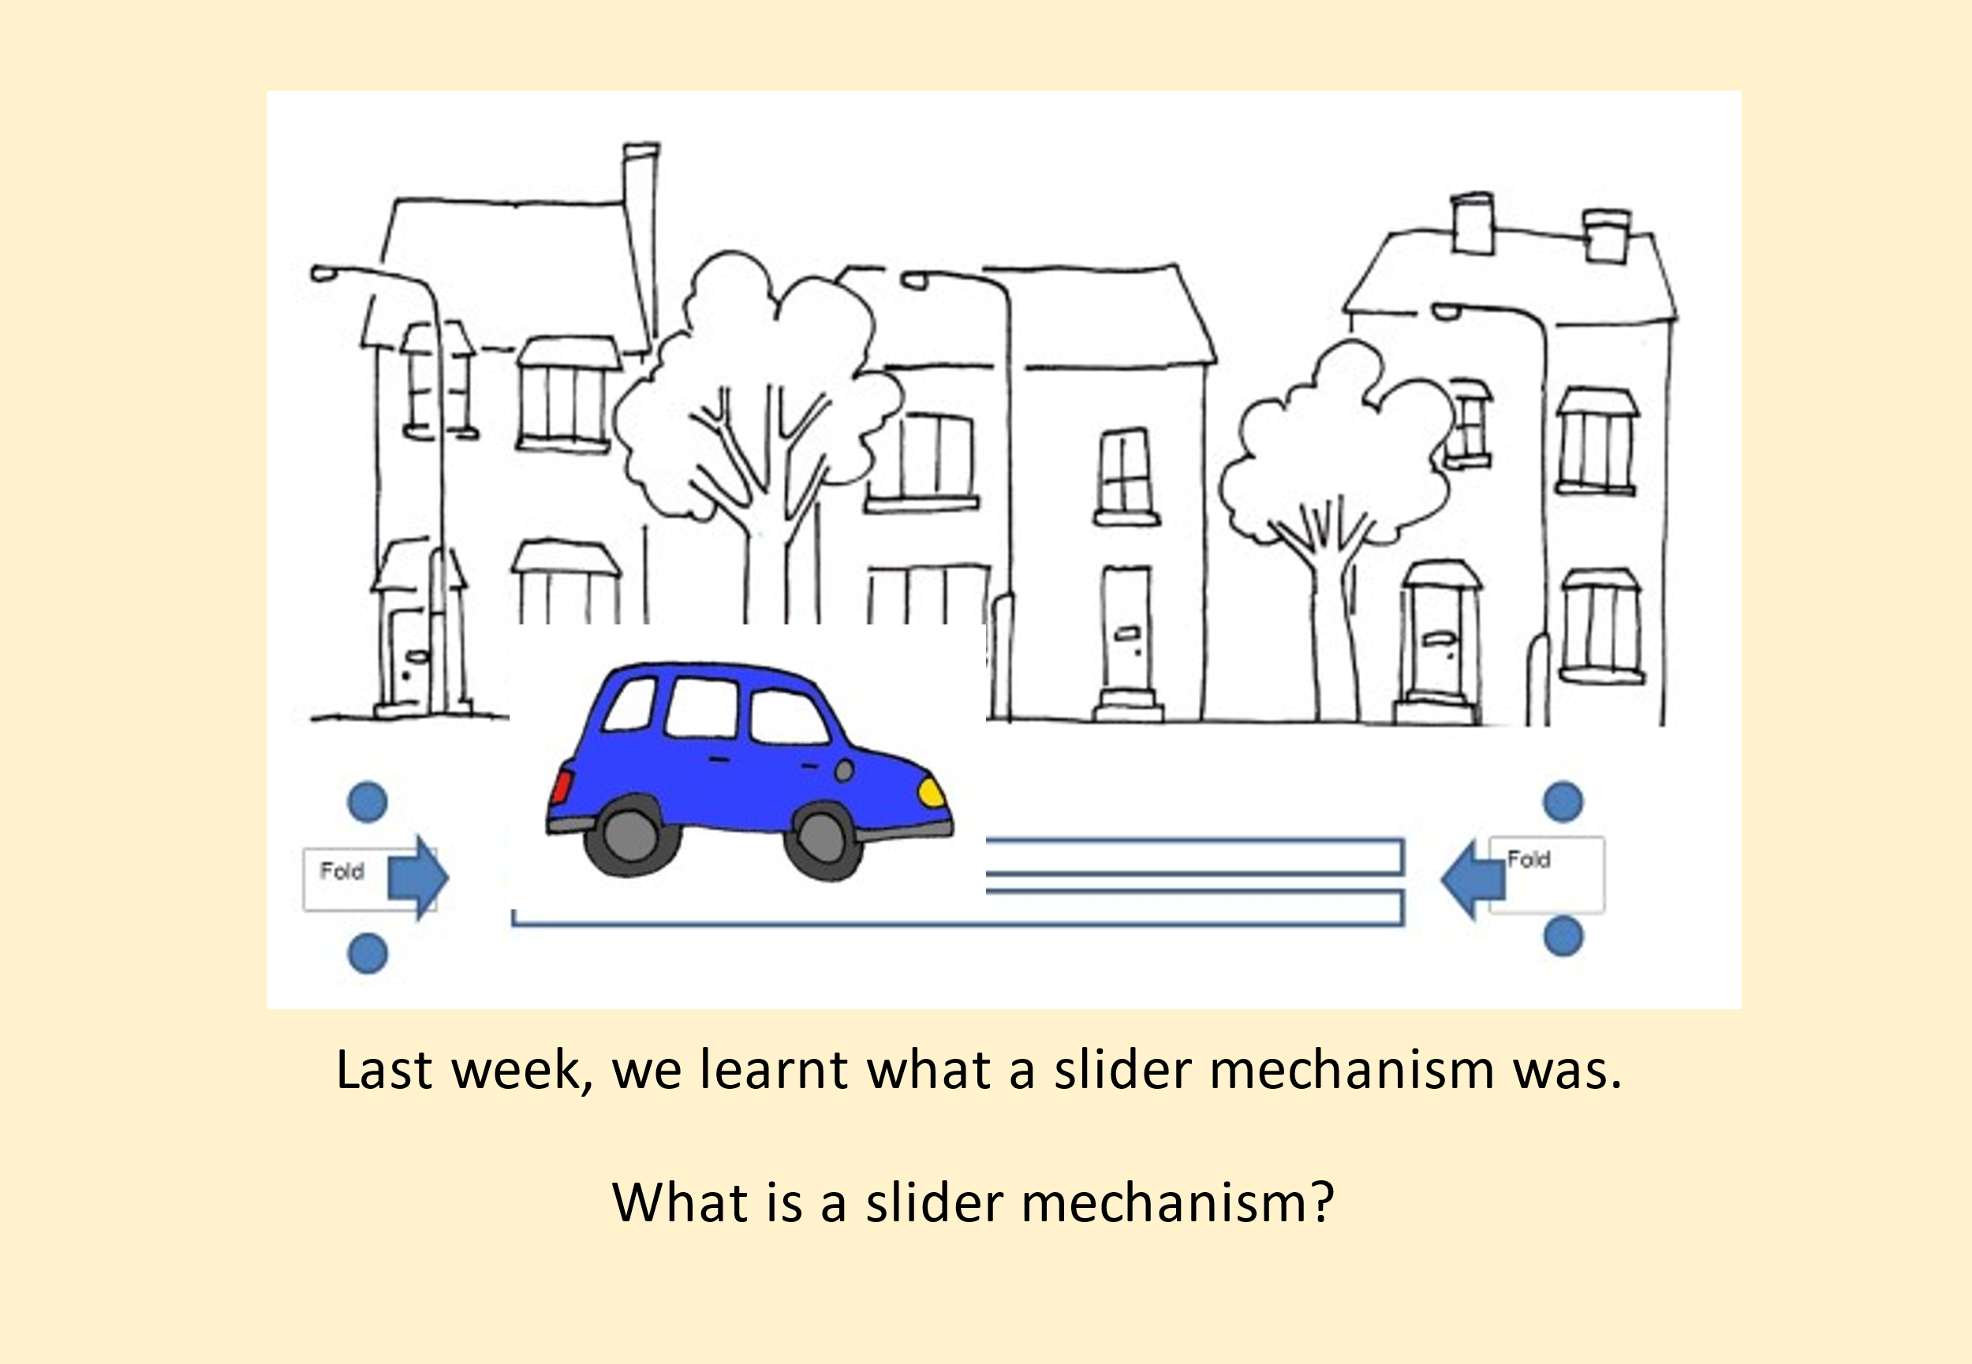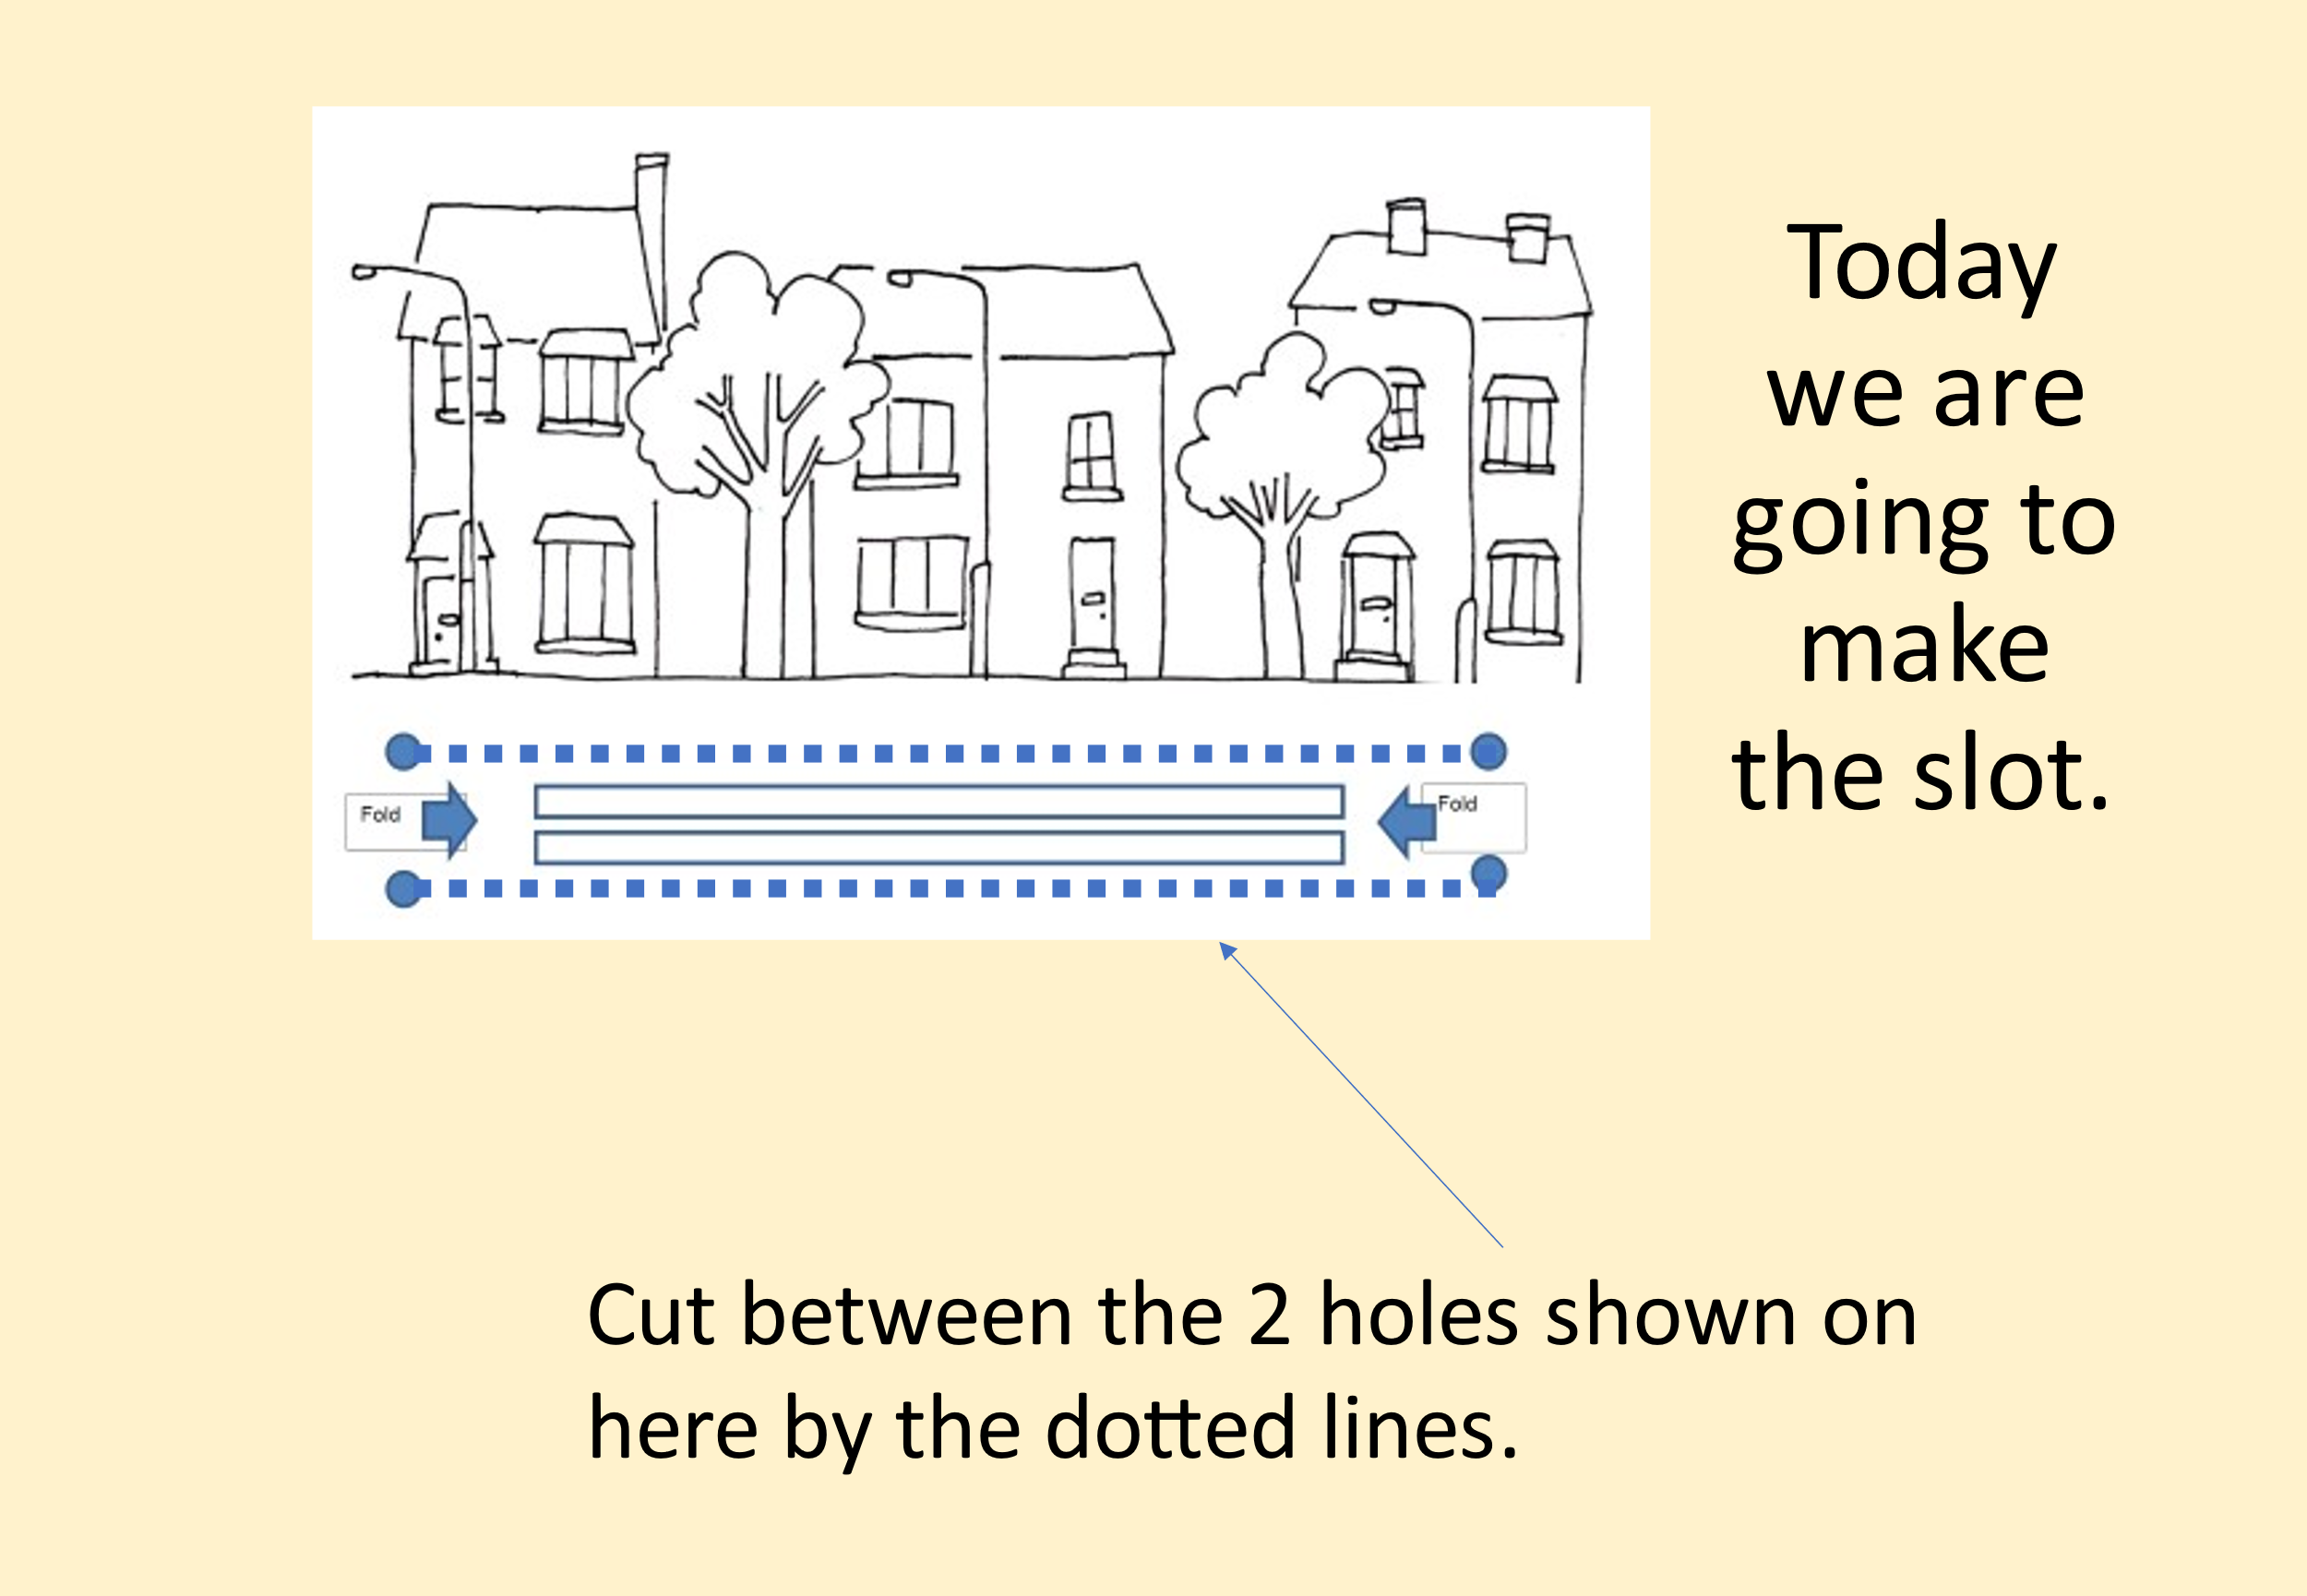

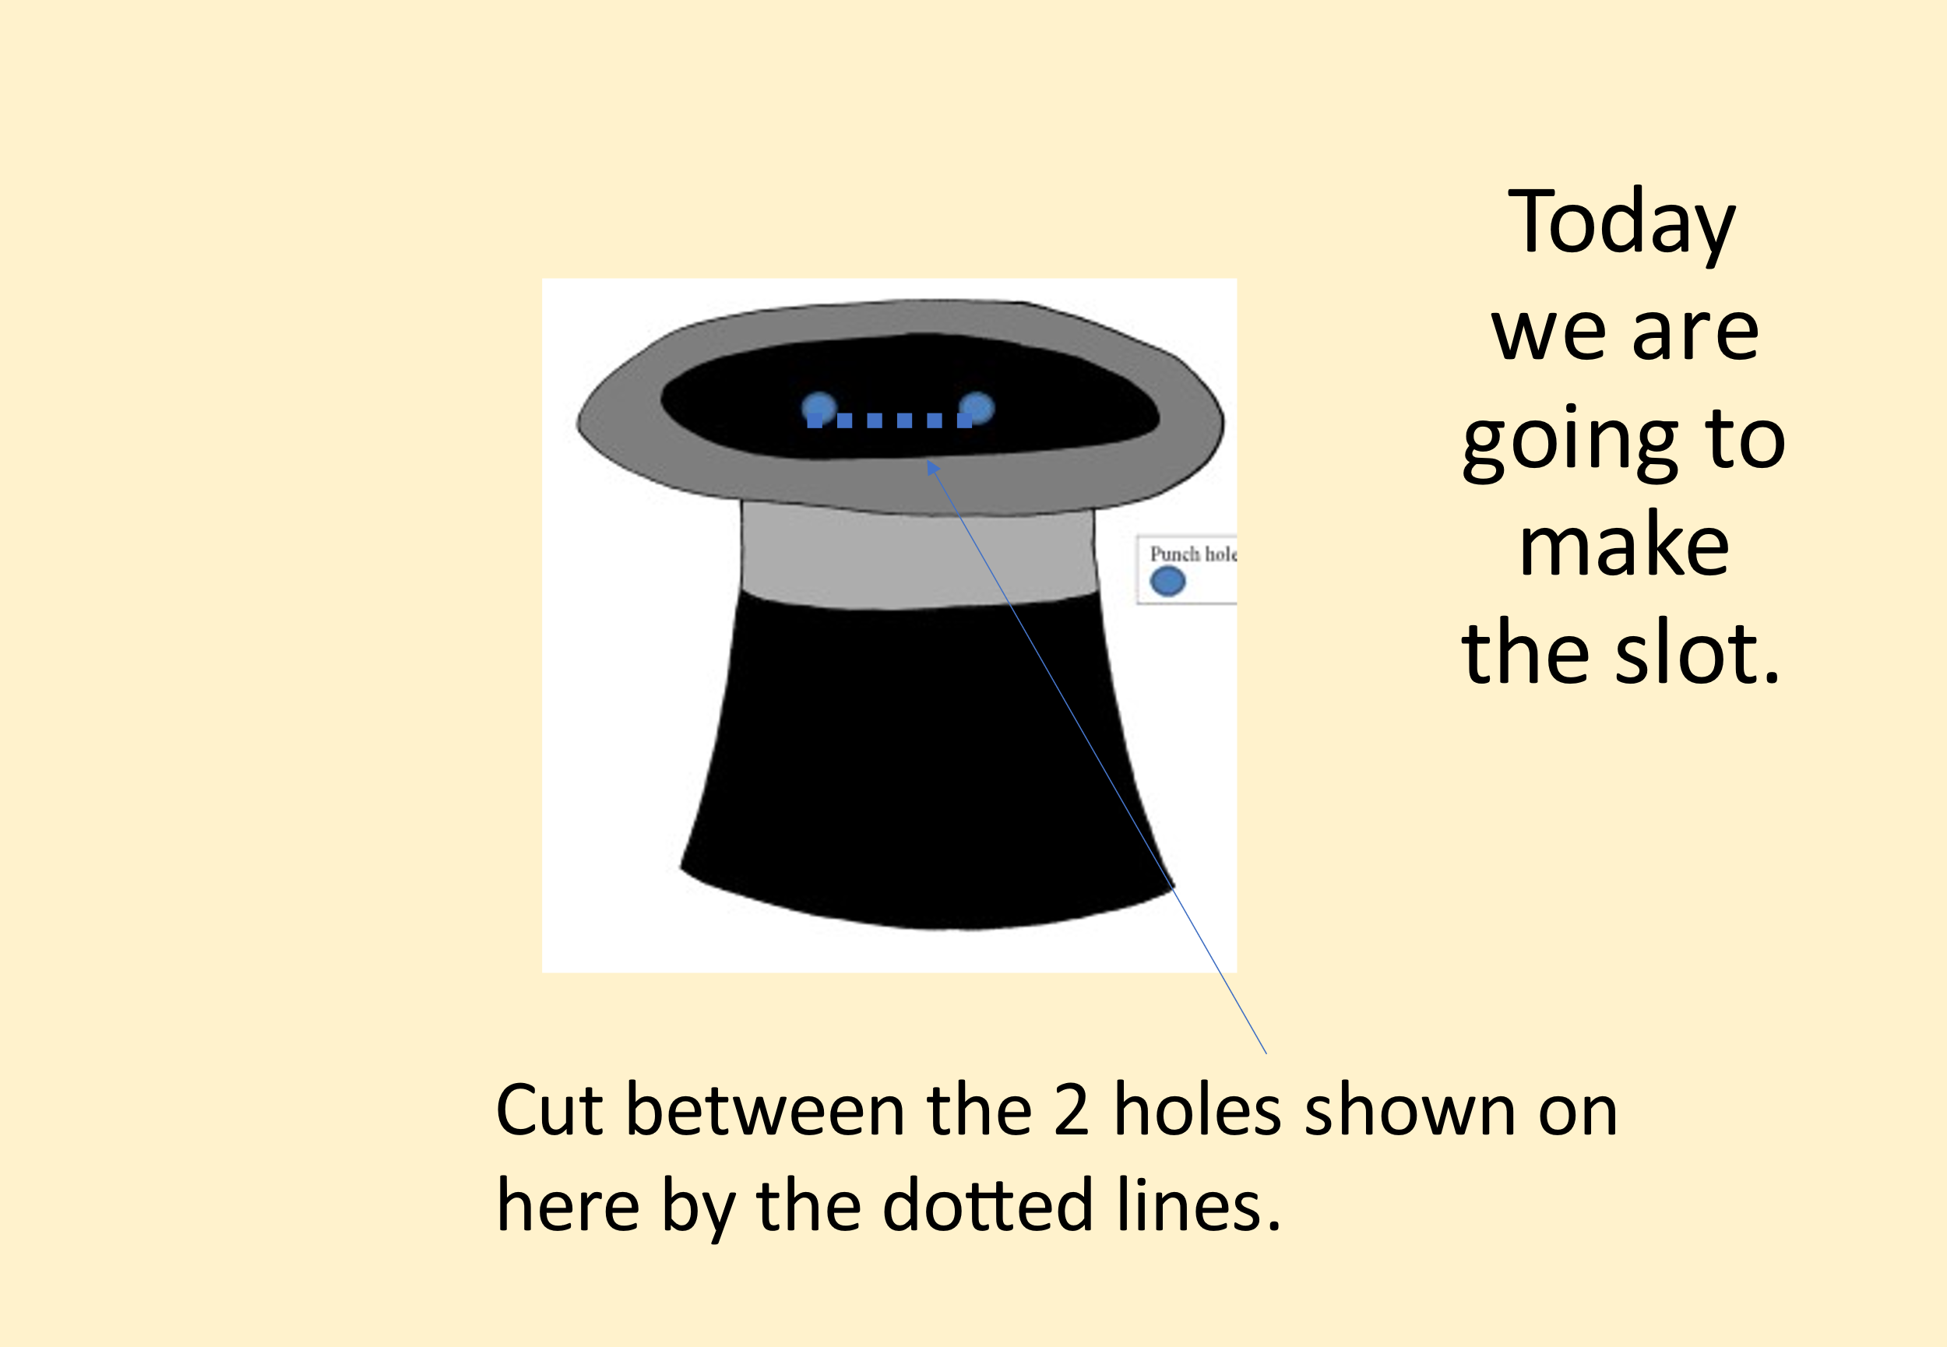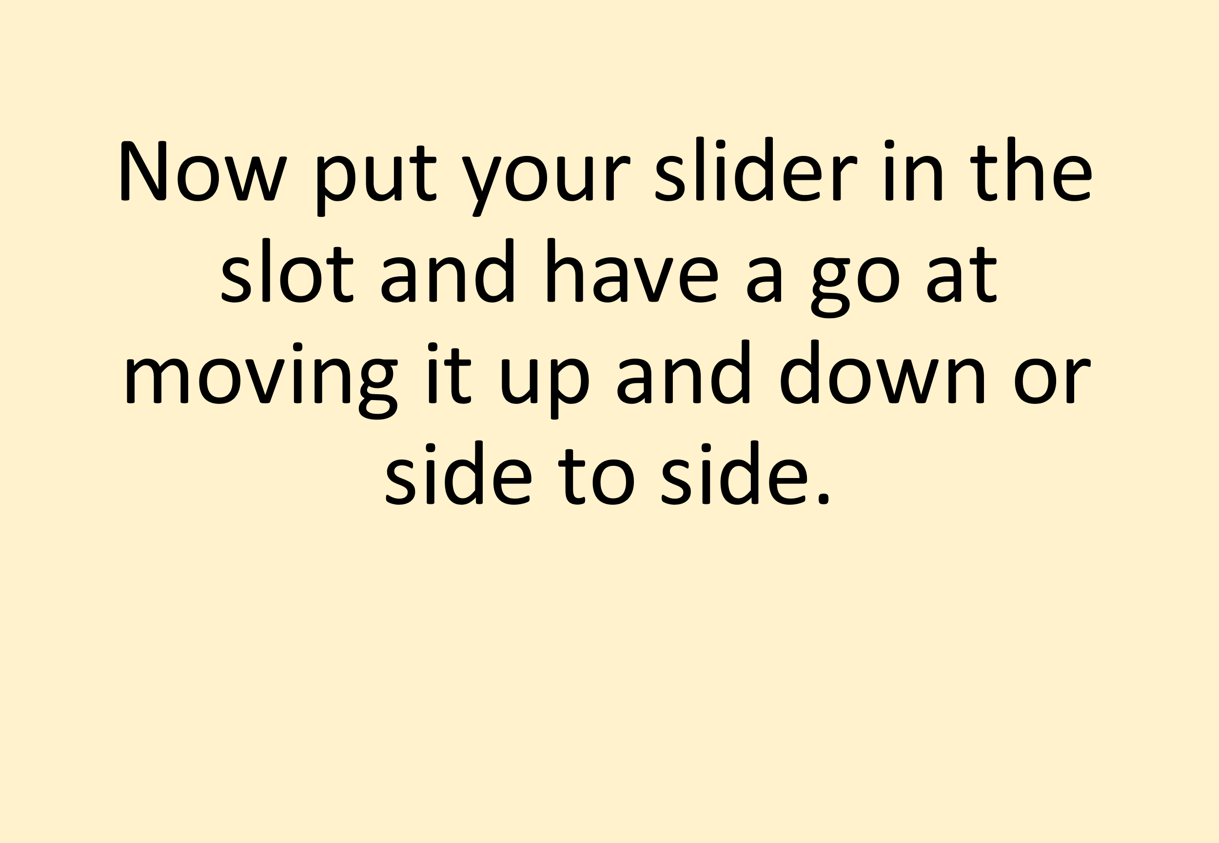

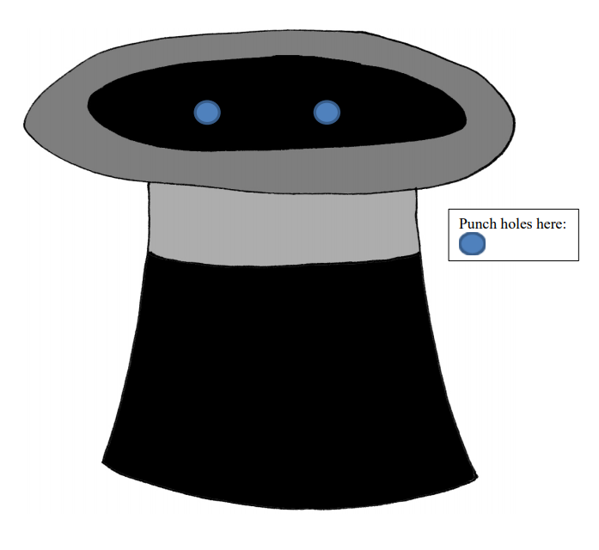

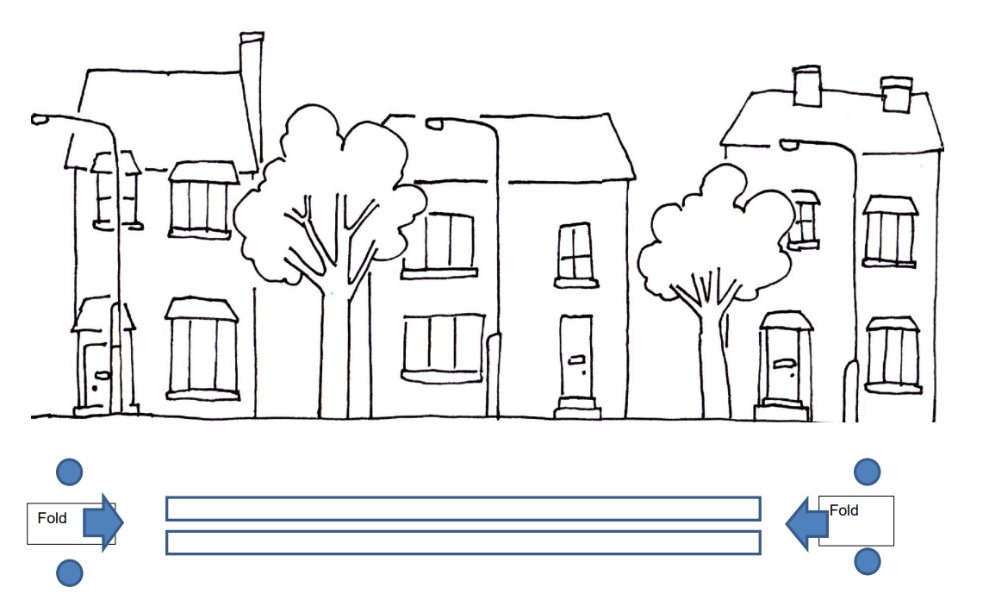

Friday 7th May
Computing

Today children will be writing their own name using word. Find word on a laptop and children use the keys to type their names.

