Maths Home learning w/b 4th May

This week we are learning;
- Use your previous knowledge and understanding of number bonds.
- Recap what a two-digit number is and then using this information to create number sentences by adding on ones.
- Subtract ones from two-digit numbers.
- Add two-digit numbers and ones together with regrouping.

Please watch the videos to accompany each lesson first before completing the independent tasks.

Tuesday 4th May
https://classroom.thenational.academy/lessons/to-apply-knowledge-of-number-bonds-c4v6cc

How many different ways can you make 12? Choose a coin from each circle to make 12.

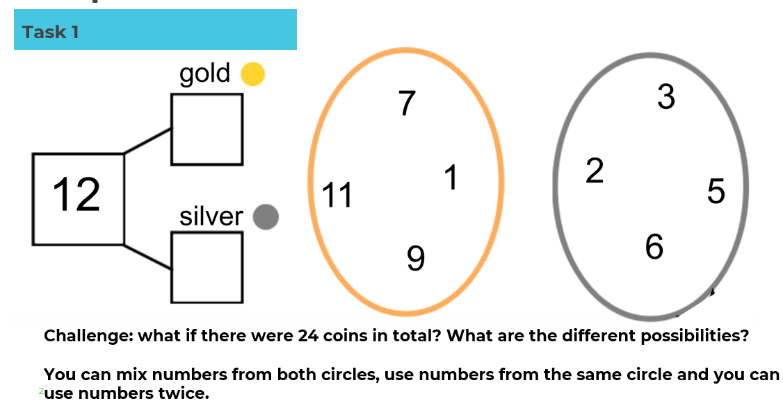

Wednesday 5th May
https://classroom.thenational.academy/lessons/to-add-two-digit-numbers-and-ones-65j36d

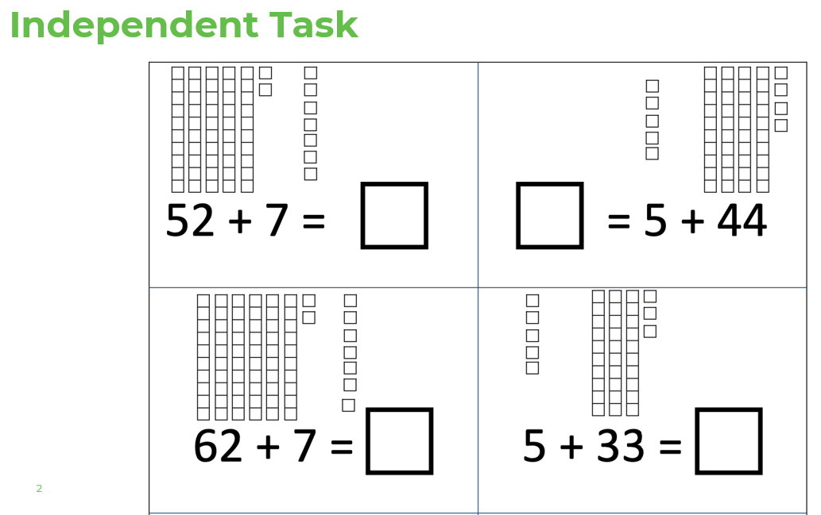

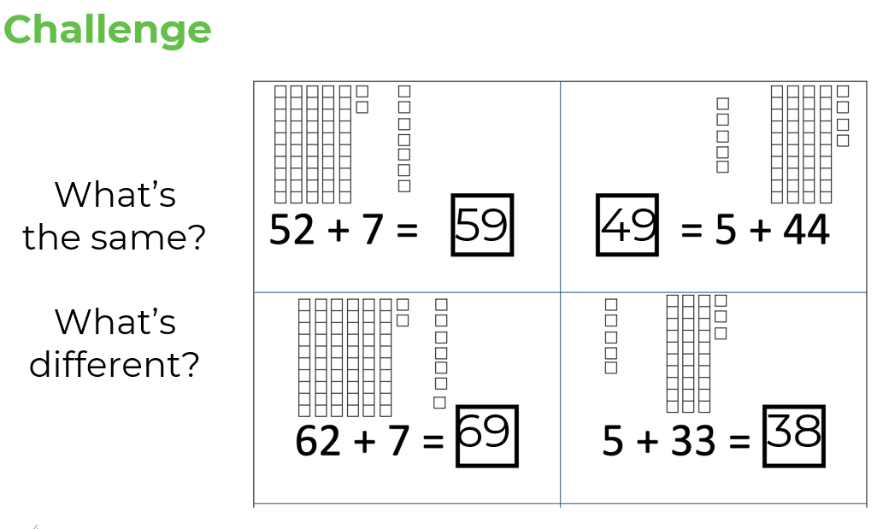

Thursday 6th May

https://classroom.thenational.academy/lessons/to-subtract-two-digit-numbers-and-ones-65h62c

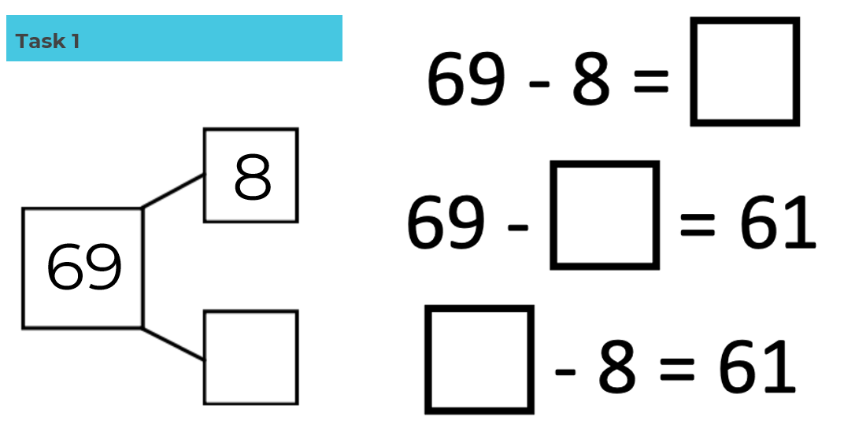

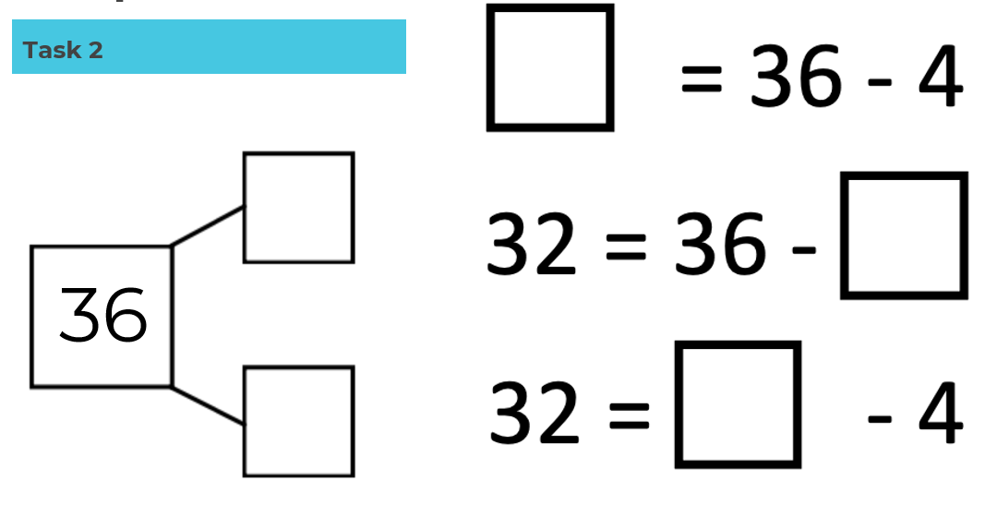

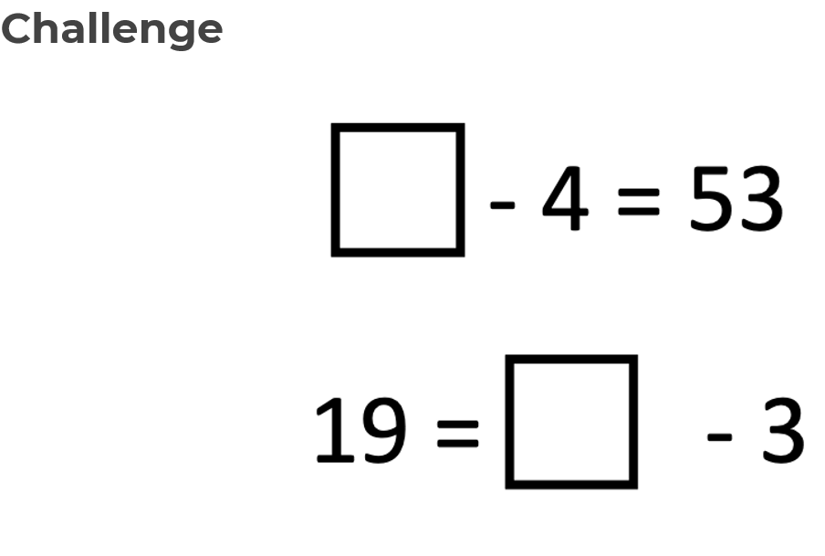

Friday 7th May

https://classroom.thenational.academy/lessons/to-add-two-digit-numbers-and-ones-with-regrouping-6dgkad

