Topic w/b Monday 19th April
Monday 19th April
Dance
Learning to: To respond to stimuli with a range of actions.
Watch the story Old Bear by Jane Hissy by clicking on the link https://www.youtube.com/watch?v=ePCof76DLO0
In the story there is a toy bear. The bear is very special and has been put away in a box.
Warm up:
♫♪ Children travel around space in different ways (walking to start, then progress to skipping, hopping, etc) and respond to different commands. This can either be verbally, visually or both. ► Play- Movement around space, ►►l Fast Forward- perform movement with grater speed, l◄◄ Skip back- Movement backwards, ιι Pause Balance still for four seconds, ■ Stop- stop.

Ask child: What do you think might be in a toy box? Discuss some different movements for different toys.
- Think about how a toy bear would sit, still.
- How would it move it if the bear was able to move. ( if it’s an old bear it would walk slowly. His legs might be stiff.
- Jack in the box: Actions jumping from a small shape to a large shape. Dynamics: sudden and surprising.
- A toy car: Encourage the children to imagine putting on their seatbelts, moving to find a space, stopping and starting using traffic lights.
Children try to create the different movements to mirror the actions of the toys.

Monday 19th April
Circle Time

To introduce our new topic memory box as child to choose a special item in the house such as a blanket or a toy that they remember from being younger. Ask questions such as:
- Why is this special to you?
- How does it make you feel?
- What do you remember about this item?

Tuesday 20th April
History
Learning to: compare similar toys from different times.
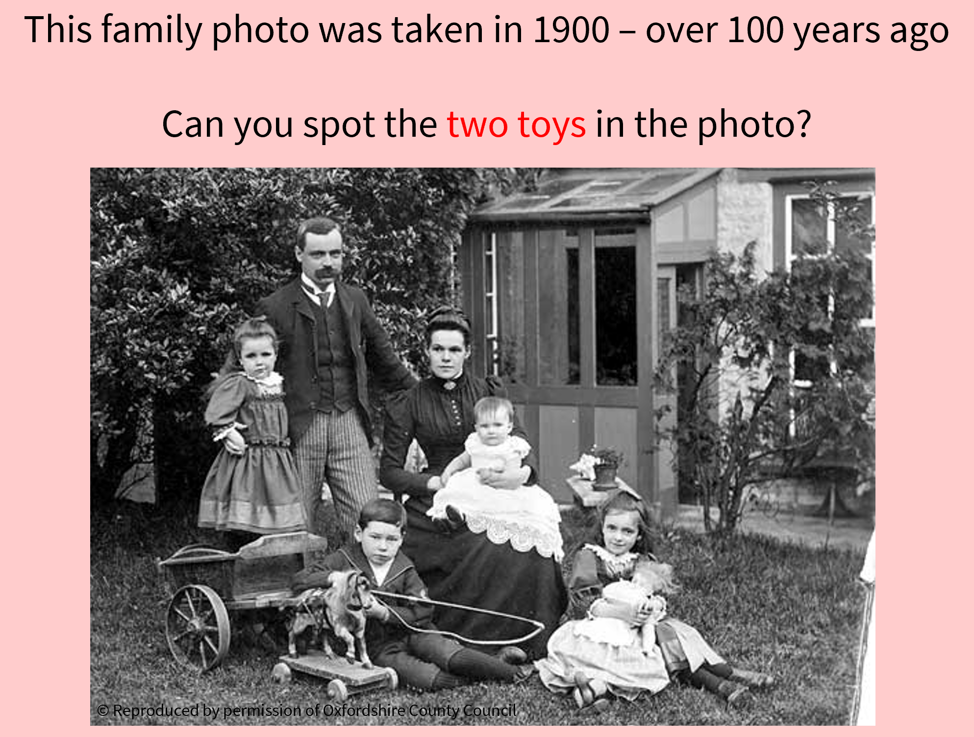
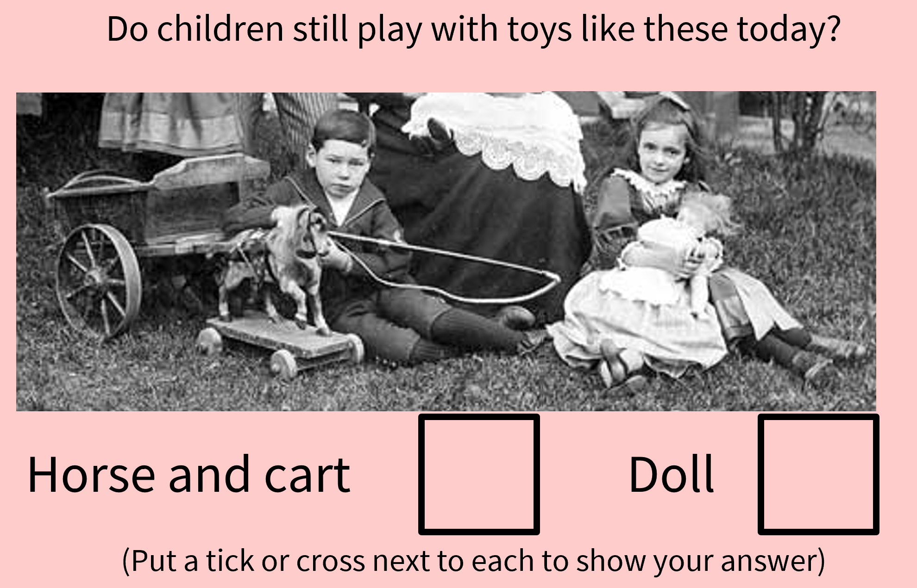
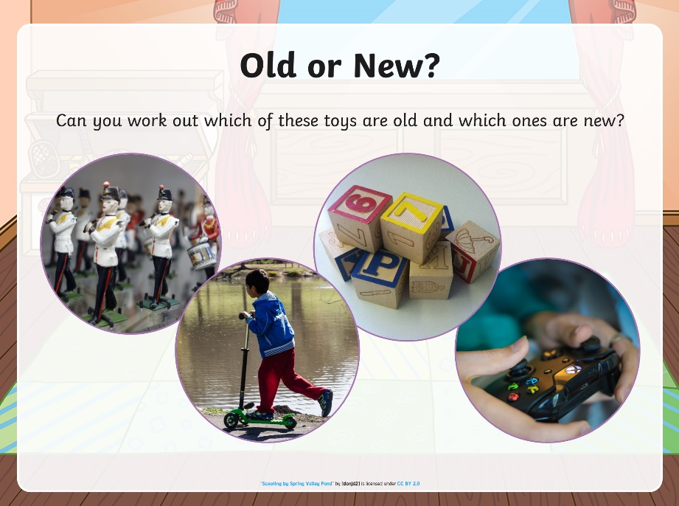

Cut out these pictures and sort them into old toys and new toys.

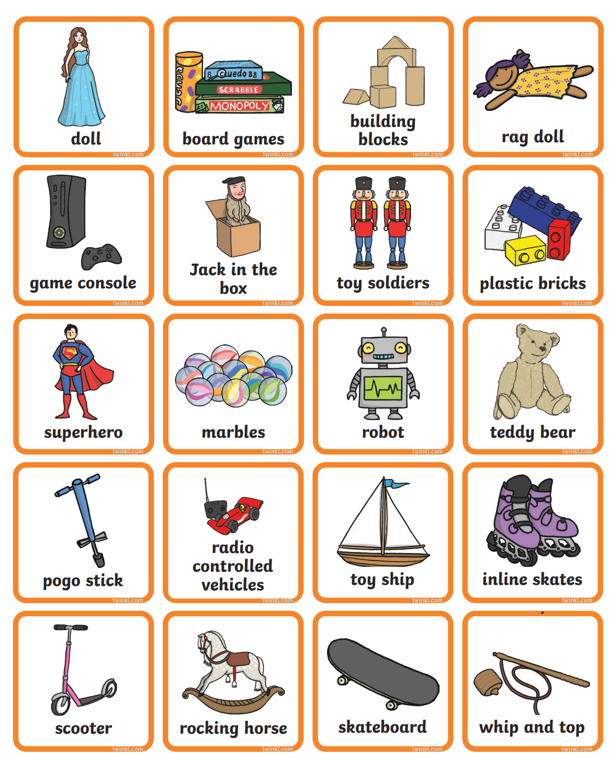

Wednesday 21st April
Music and PE

Music - from Mrs Jackson You can access this week’s Music lessons using your child’s Charanga log in.

PE- In PE with Miss Panter the children have been learning about catching throwing balls. Practice catching and throwing a ball to a partner.

Thursday 22nd April
Geography
Learning to: identify the countries in the UK.

Explain to children that this year no one can go on holiday to another country abroad. If we want to go on holiday where can we go?
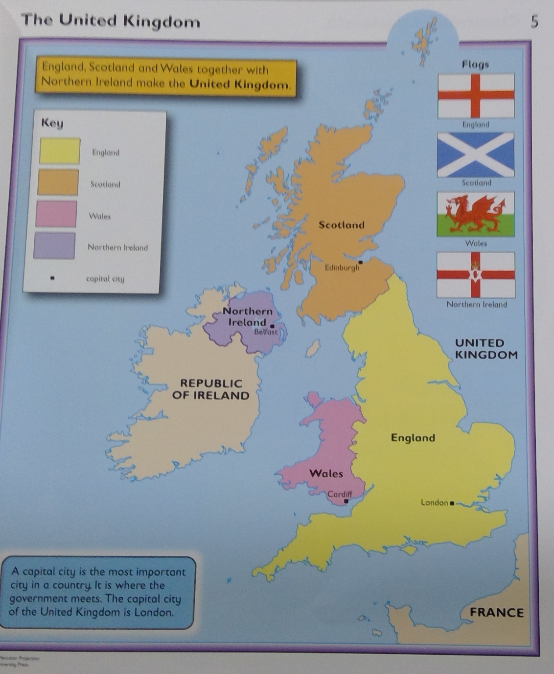
We can go to the countries in the UK! Can children spot the 4 countries by looking at the map?
Children now need to use playdough to create the 4 countries in the United Kingdom.

Friday 26th March
Computing
Learning to describe what different tools can do.
On the laptop or tablet go to the website https://paintz.app/
Children can explore the different tools on the tool bar and then create a picture of themselves using a variety of tools.

