Monday 29th March
PSHE – I can identify the actions of a bully.

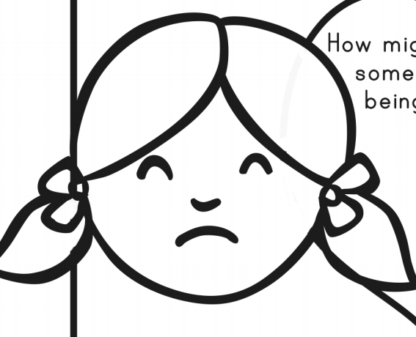
What does a bully do?

