Maths Home learning w/b 29th March

This week we are learning;
To identify one half of a shape and quantity.
To identify one quarter of a shape and quantity

You will need to watch the videos first and then complete the activity as explained and modelled ijn the videos.

Monday 29th March

https://classroom.thenational.academy/lessons/to-identify-one-half-of-a-shape-60up2c

Use some pieces of bread and investigate how many different ways you can cut it in half.

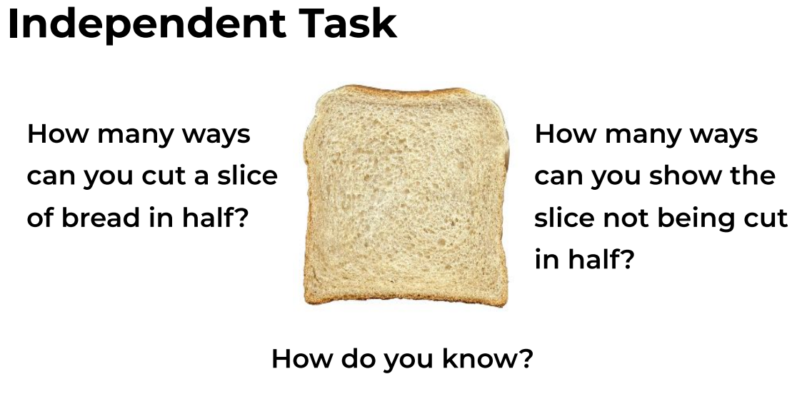

Tuesday 30th March
https://classroom.thenational.academy/lessons/to-find-half-of-a-quantity-6nhpct
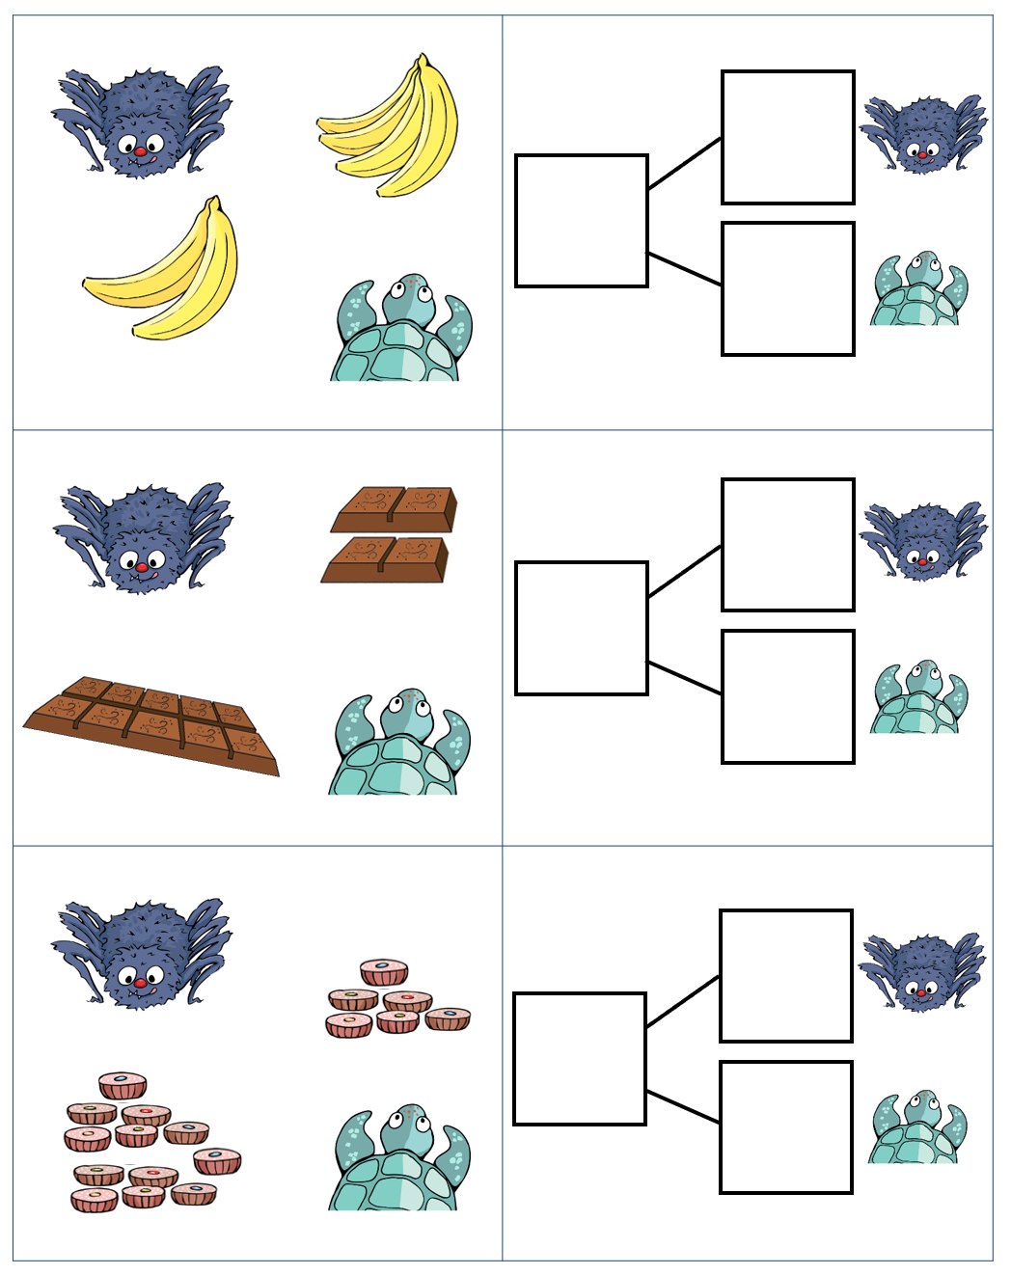

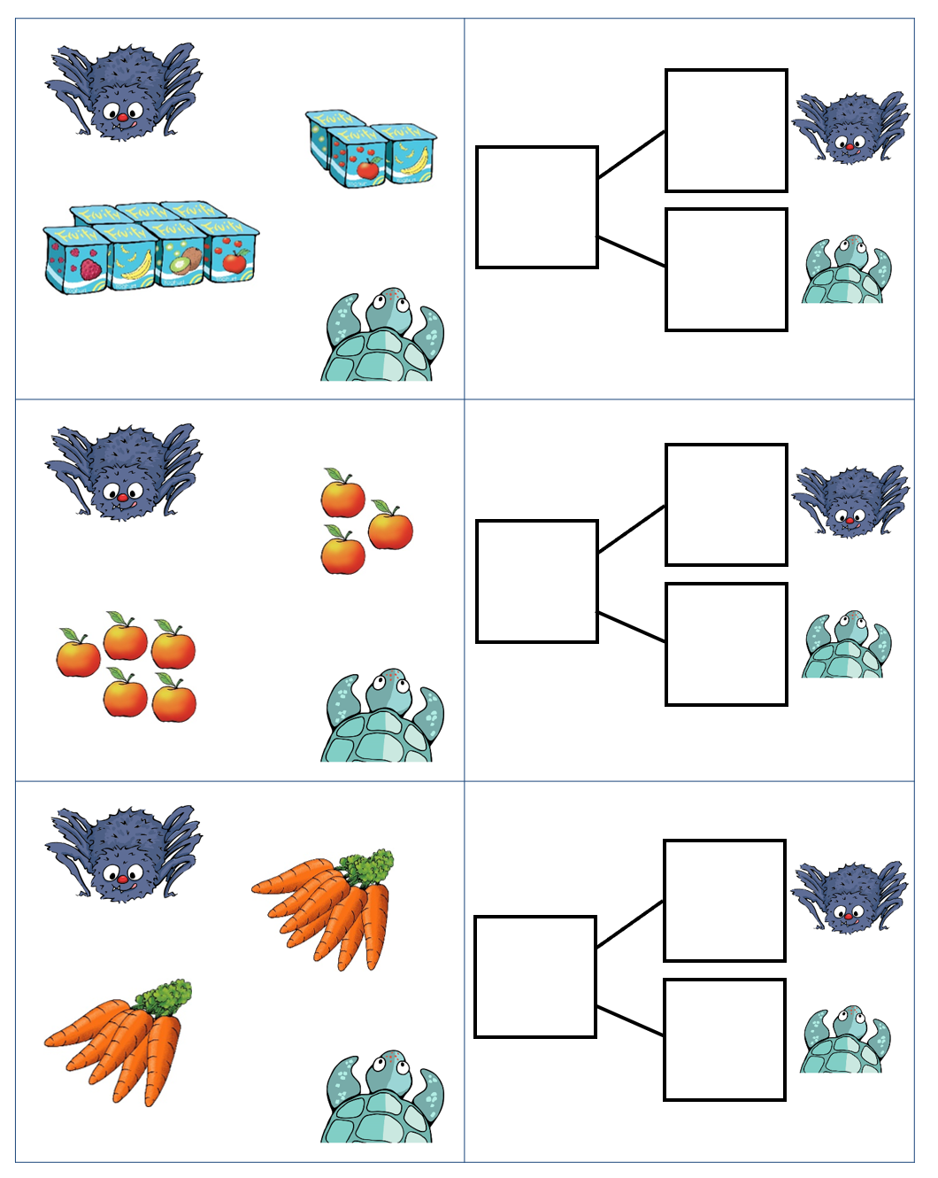

Wednesday 31st March
https://classroom.thenational.academy/lessons/to-find-one-quarter-of-a-shape-c8r66c

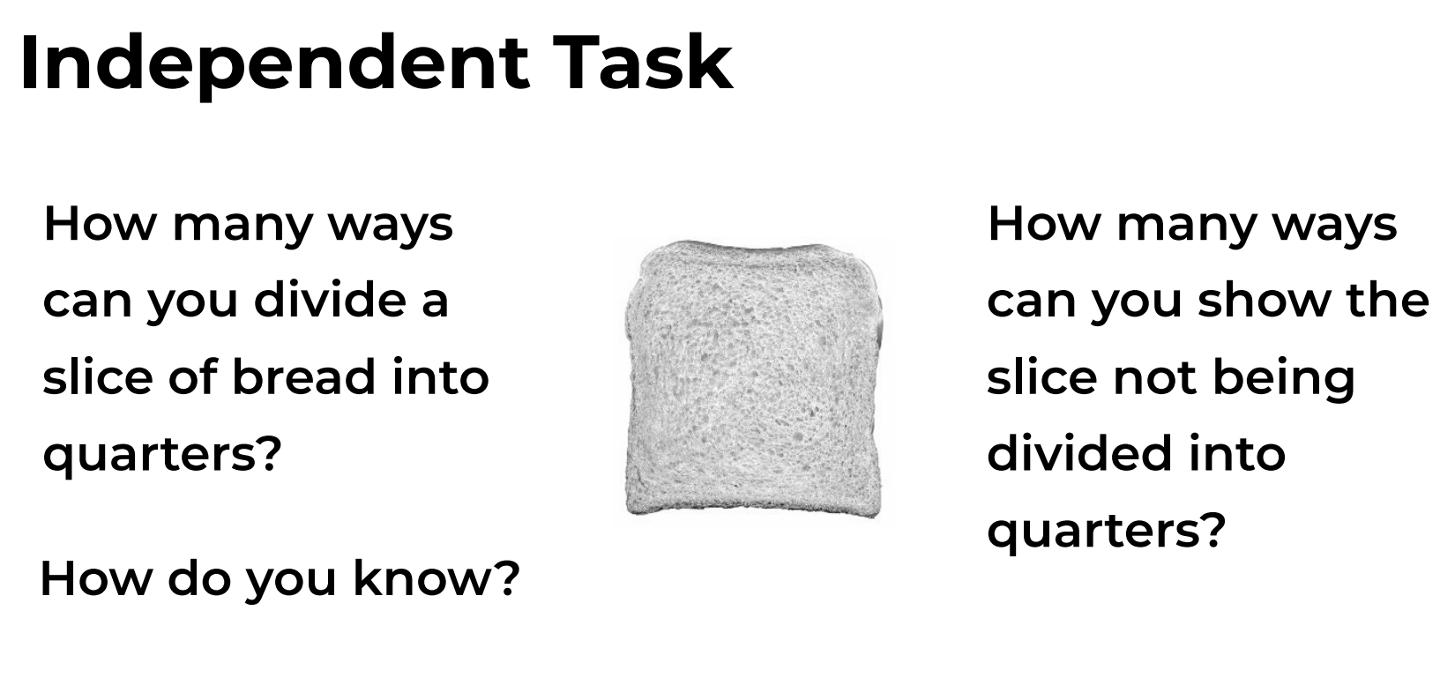
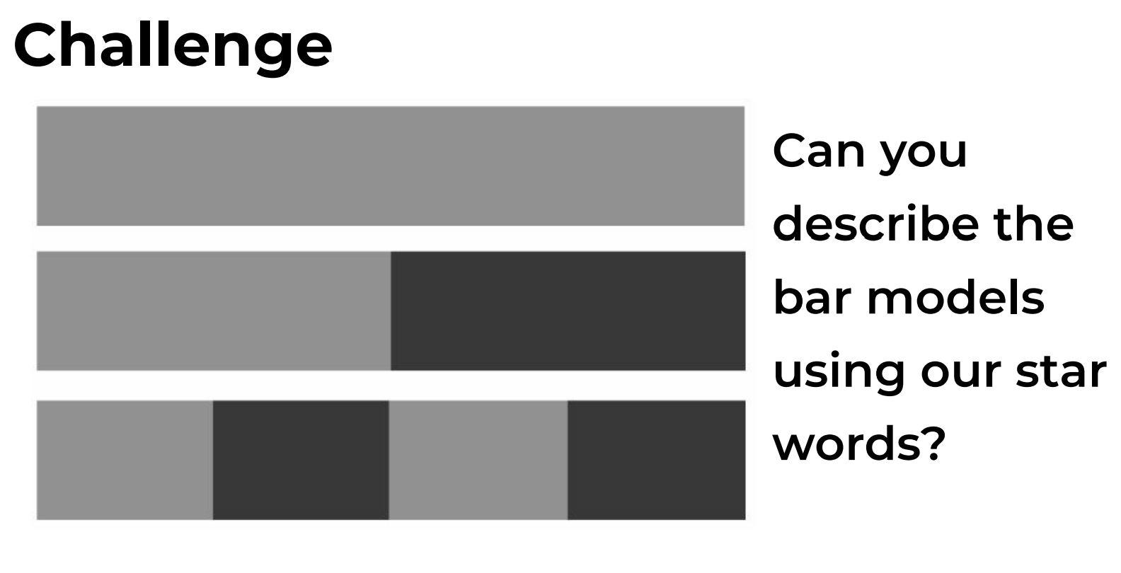

Thursday 1st April
https://classroom.thenational.academy/lessons/to-find-one-quarter-of-a-quantity-6xjkad

