Maths Home learning w/b 17th May

This week we are learning to;
- Add ones to a two-digit number.
- Subtract ones from a two-digit number.
- Solve problems using adding and subtracting.

Lesson 1
Circle the two numbers that you will add first. For example in the equation 16 + 3 you will first add 6 and 3. I know that 6+3 =9 so 16+3=19
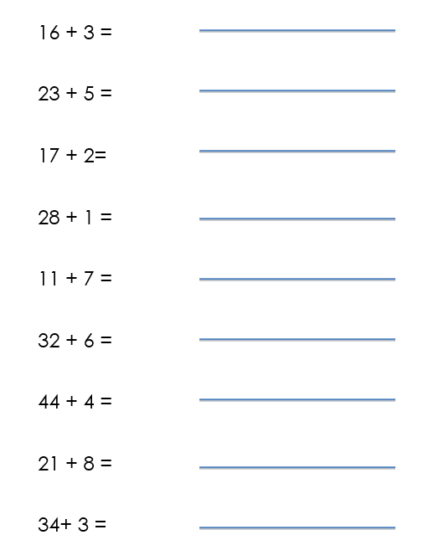

Lesson 2
Circle the two numbers that you will subtract first. For example, in the first equation you will subtract 3 from 8. I know that 8-3=5 so 28-3=25

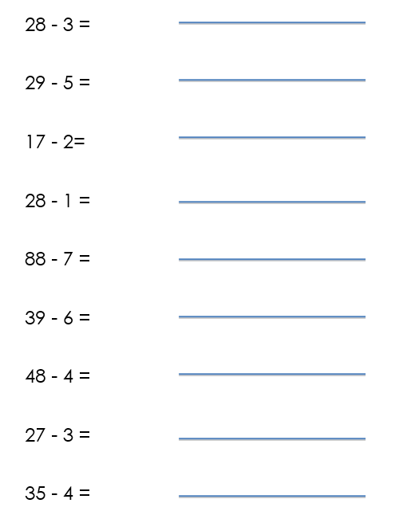

Lesson 3
Watch this video and then complete the independent tasks.
https://classroom.thenational.academy/lessons/to-add-two-digit-numbers-and-ones-with-regrouping-6dgkad

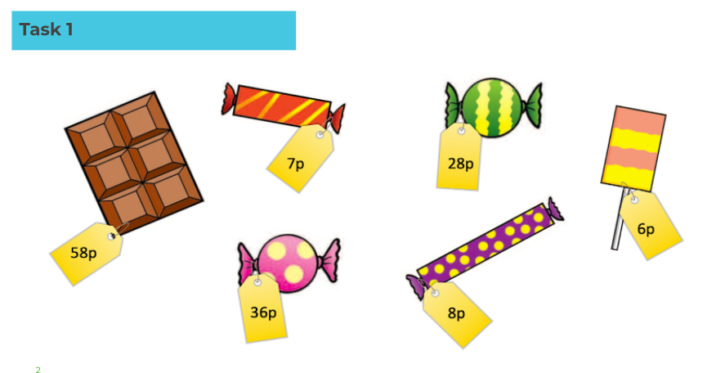
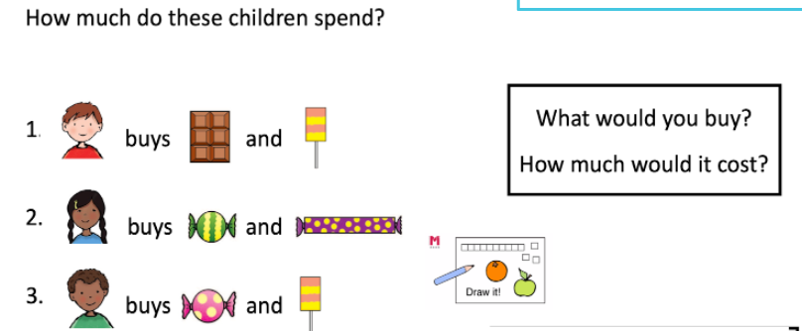

Lesson 4
Watch this video and complete the independent tasks.
https://classroom.thenational.academy/lessons/to-subtract-two-digit-numbers-and-ones-with-regrouping-6gwpar

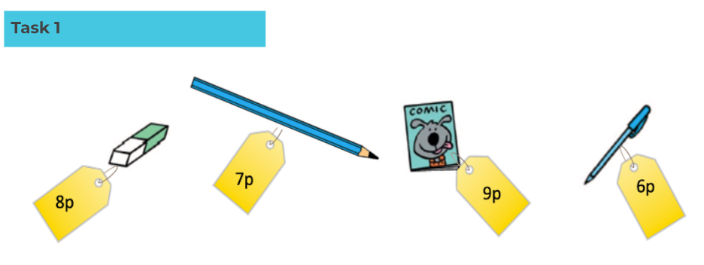

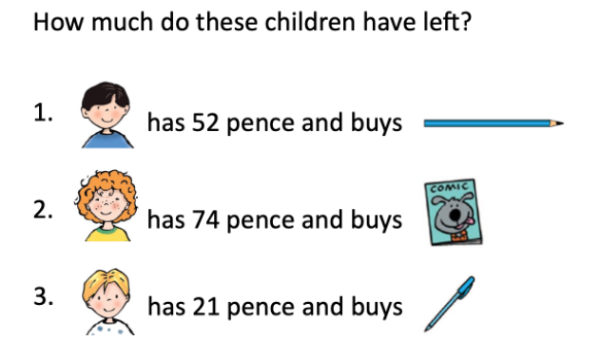

Lesson 5
Watch this video and complete the independent tasks.
https://classroom.thenational.academy/lessons/to-solve-word-problems-6ru3ec

