Topic w/b Monday 26th April
Monday 10th May 2021
Computing
Learning to identify that the look of text can be changed on a computer:
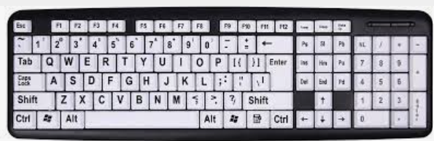

Do you know what these keys do?
Can you see the Caps lock? This allows you to write in capital letters.
When do we need to use capital letters in our writing? Names , start of the sentence, titles.
These icons show you what will happen to the text . bold, italic, and underline
Today you will write a sentence using capital letters in the correct place. Next try to underline your text and make it bold.

Tuesday 11th May 2021
Art
Learning to: use a range of textures in a self portrait

What is texture?
Texture is how a surface feels eg smooth, bumpy, rough.
Last week you created the background of your portrait using wax crayon rubbings.
Today we are going to think about ourselves, what we look like? The different textures we notice on our faces for example- skin, hair

Now watch the video about two girls who notice differences about themselves. https://www.youtube.com/watch?v=fXErvNDKCks

What things make us different?
One thing that makes us different is our hair.
hair texture – curly, smooth, bouncy, soft
Texture can be created by showing different shapes.

Wool - hair ( we all have very different hair, straight, curls, long and short this can be created with wool) Model spirals, straight pieces etc. Cotton/ materials can be used for clothes.
Skin- is smooth , what material would be good to use to represent our skin? Felt.
Children select appropriate materials to represent themselves in a self portrait and stick onto background from last week.

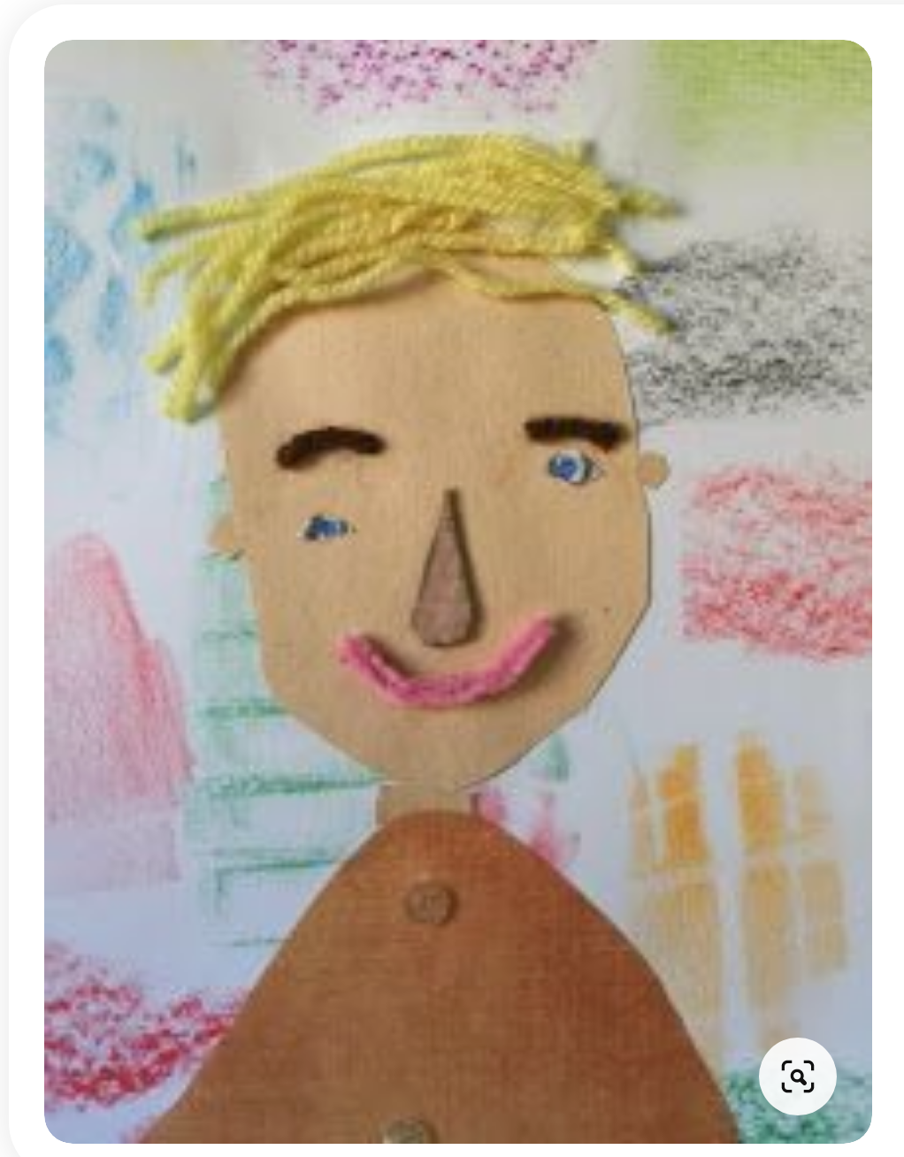

Wednesday 12th May
Music

Music - from Mrs Jackson You can access this week’s Music lessons using your child’s Charanga log in.

Thursday 13th May
Geography
Learning to ask simple questions.
Today you will ask some questions to someone who lives in Brookside. This could be your mum, dad, nan or grandad for example.

Remember questions end with a question mark. Think about asking things such as
Was there a park on Brookside when you were growing up?
What clothes did you wear to school?
What type of house did you live in?

Thursday 14th May
DT

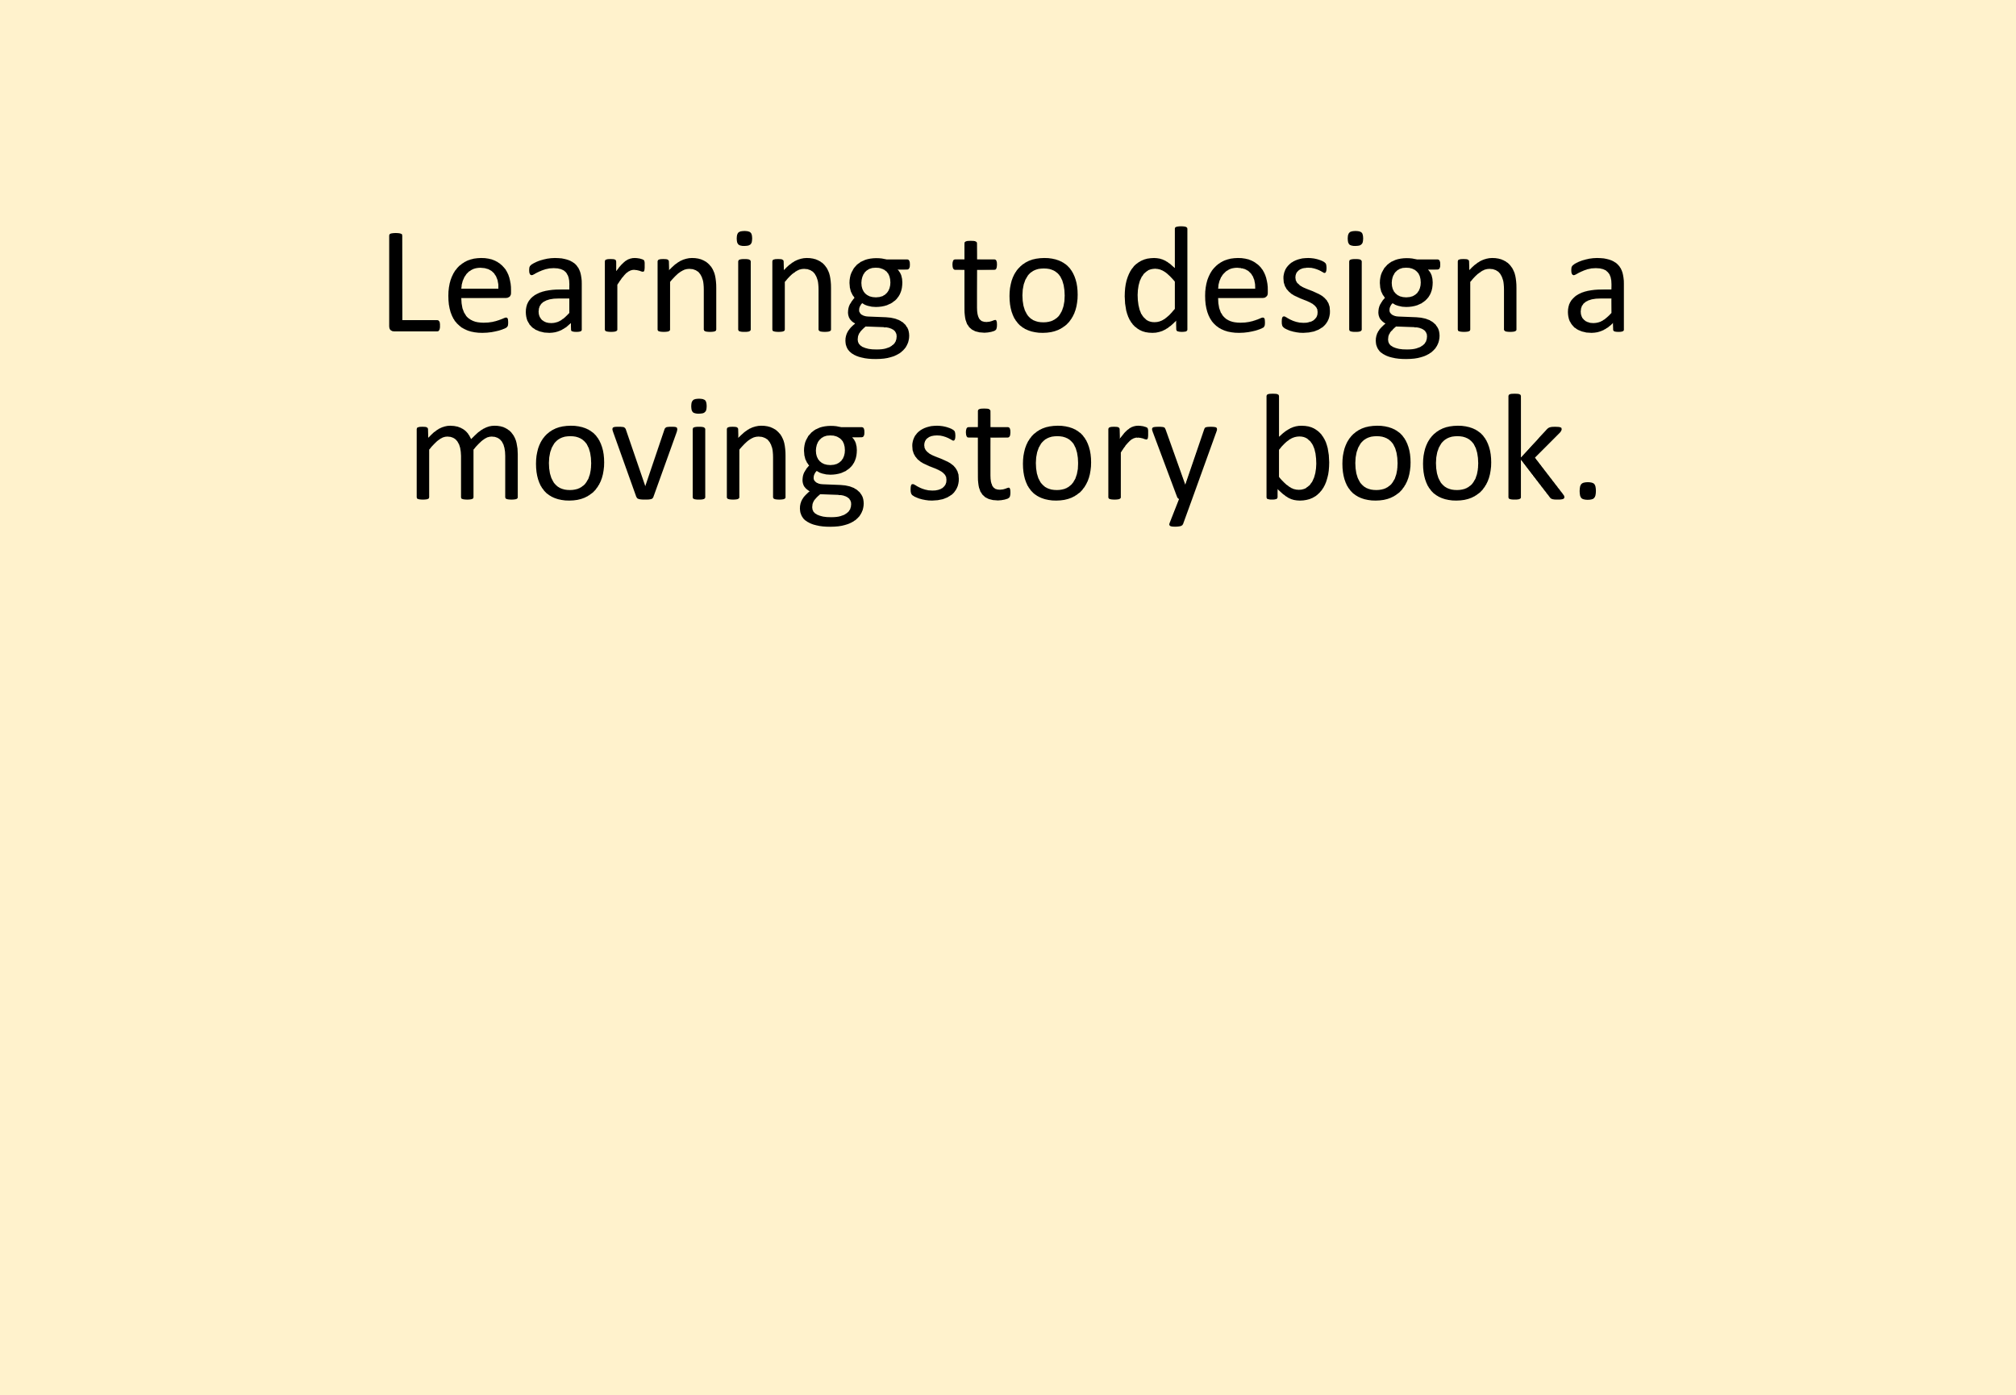

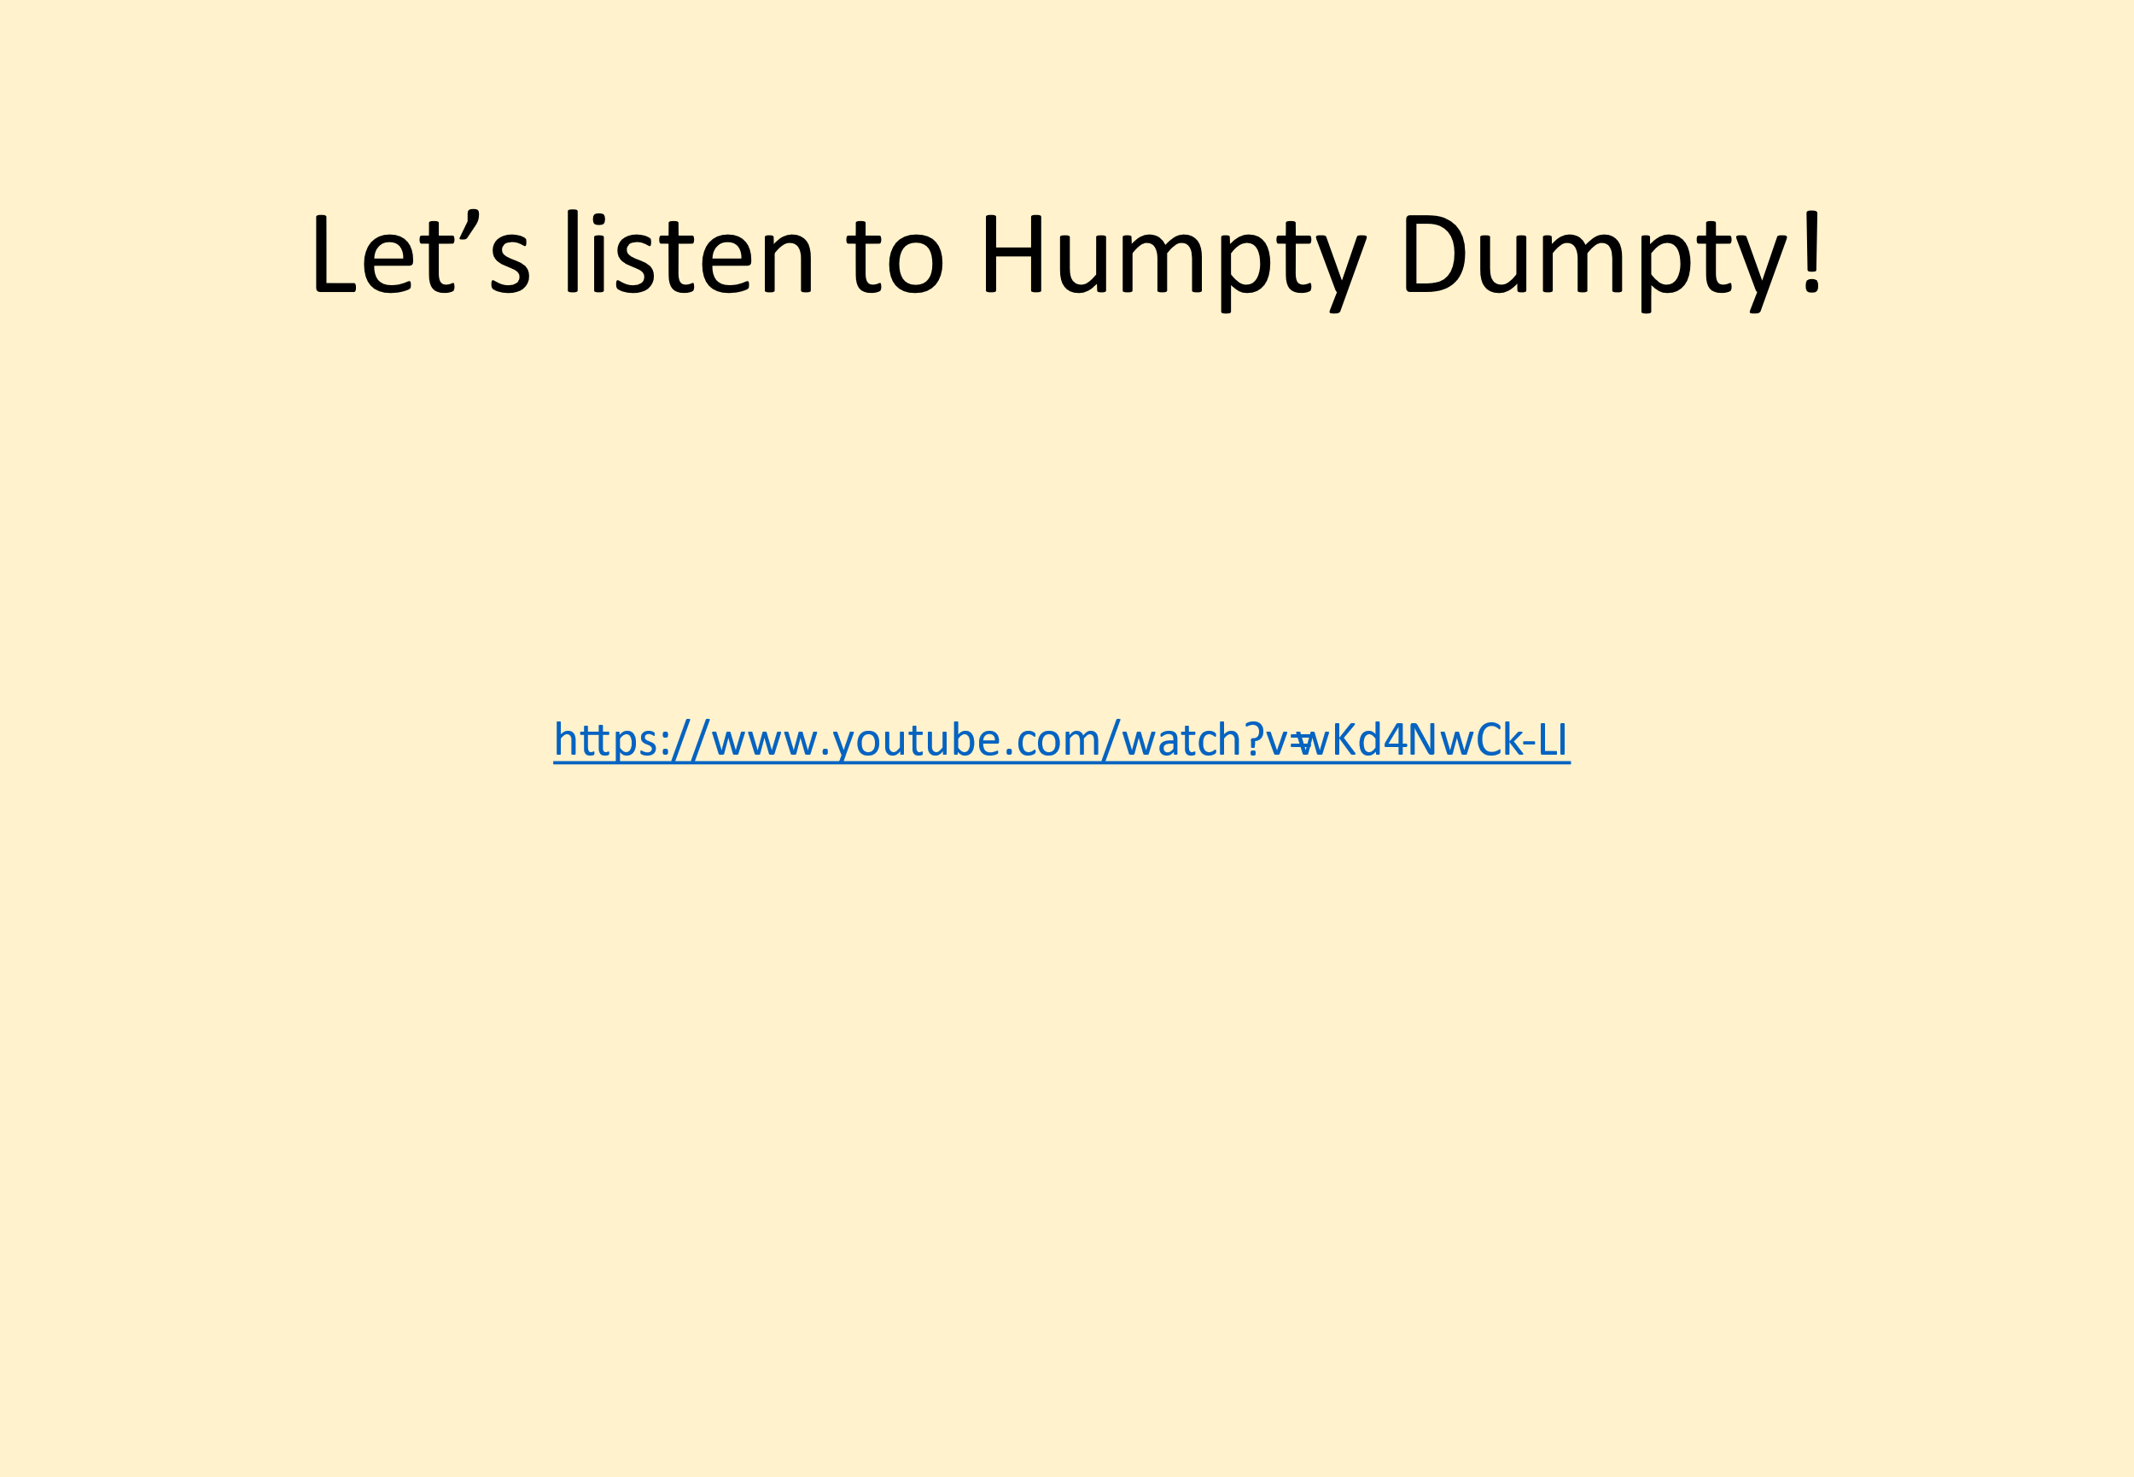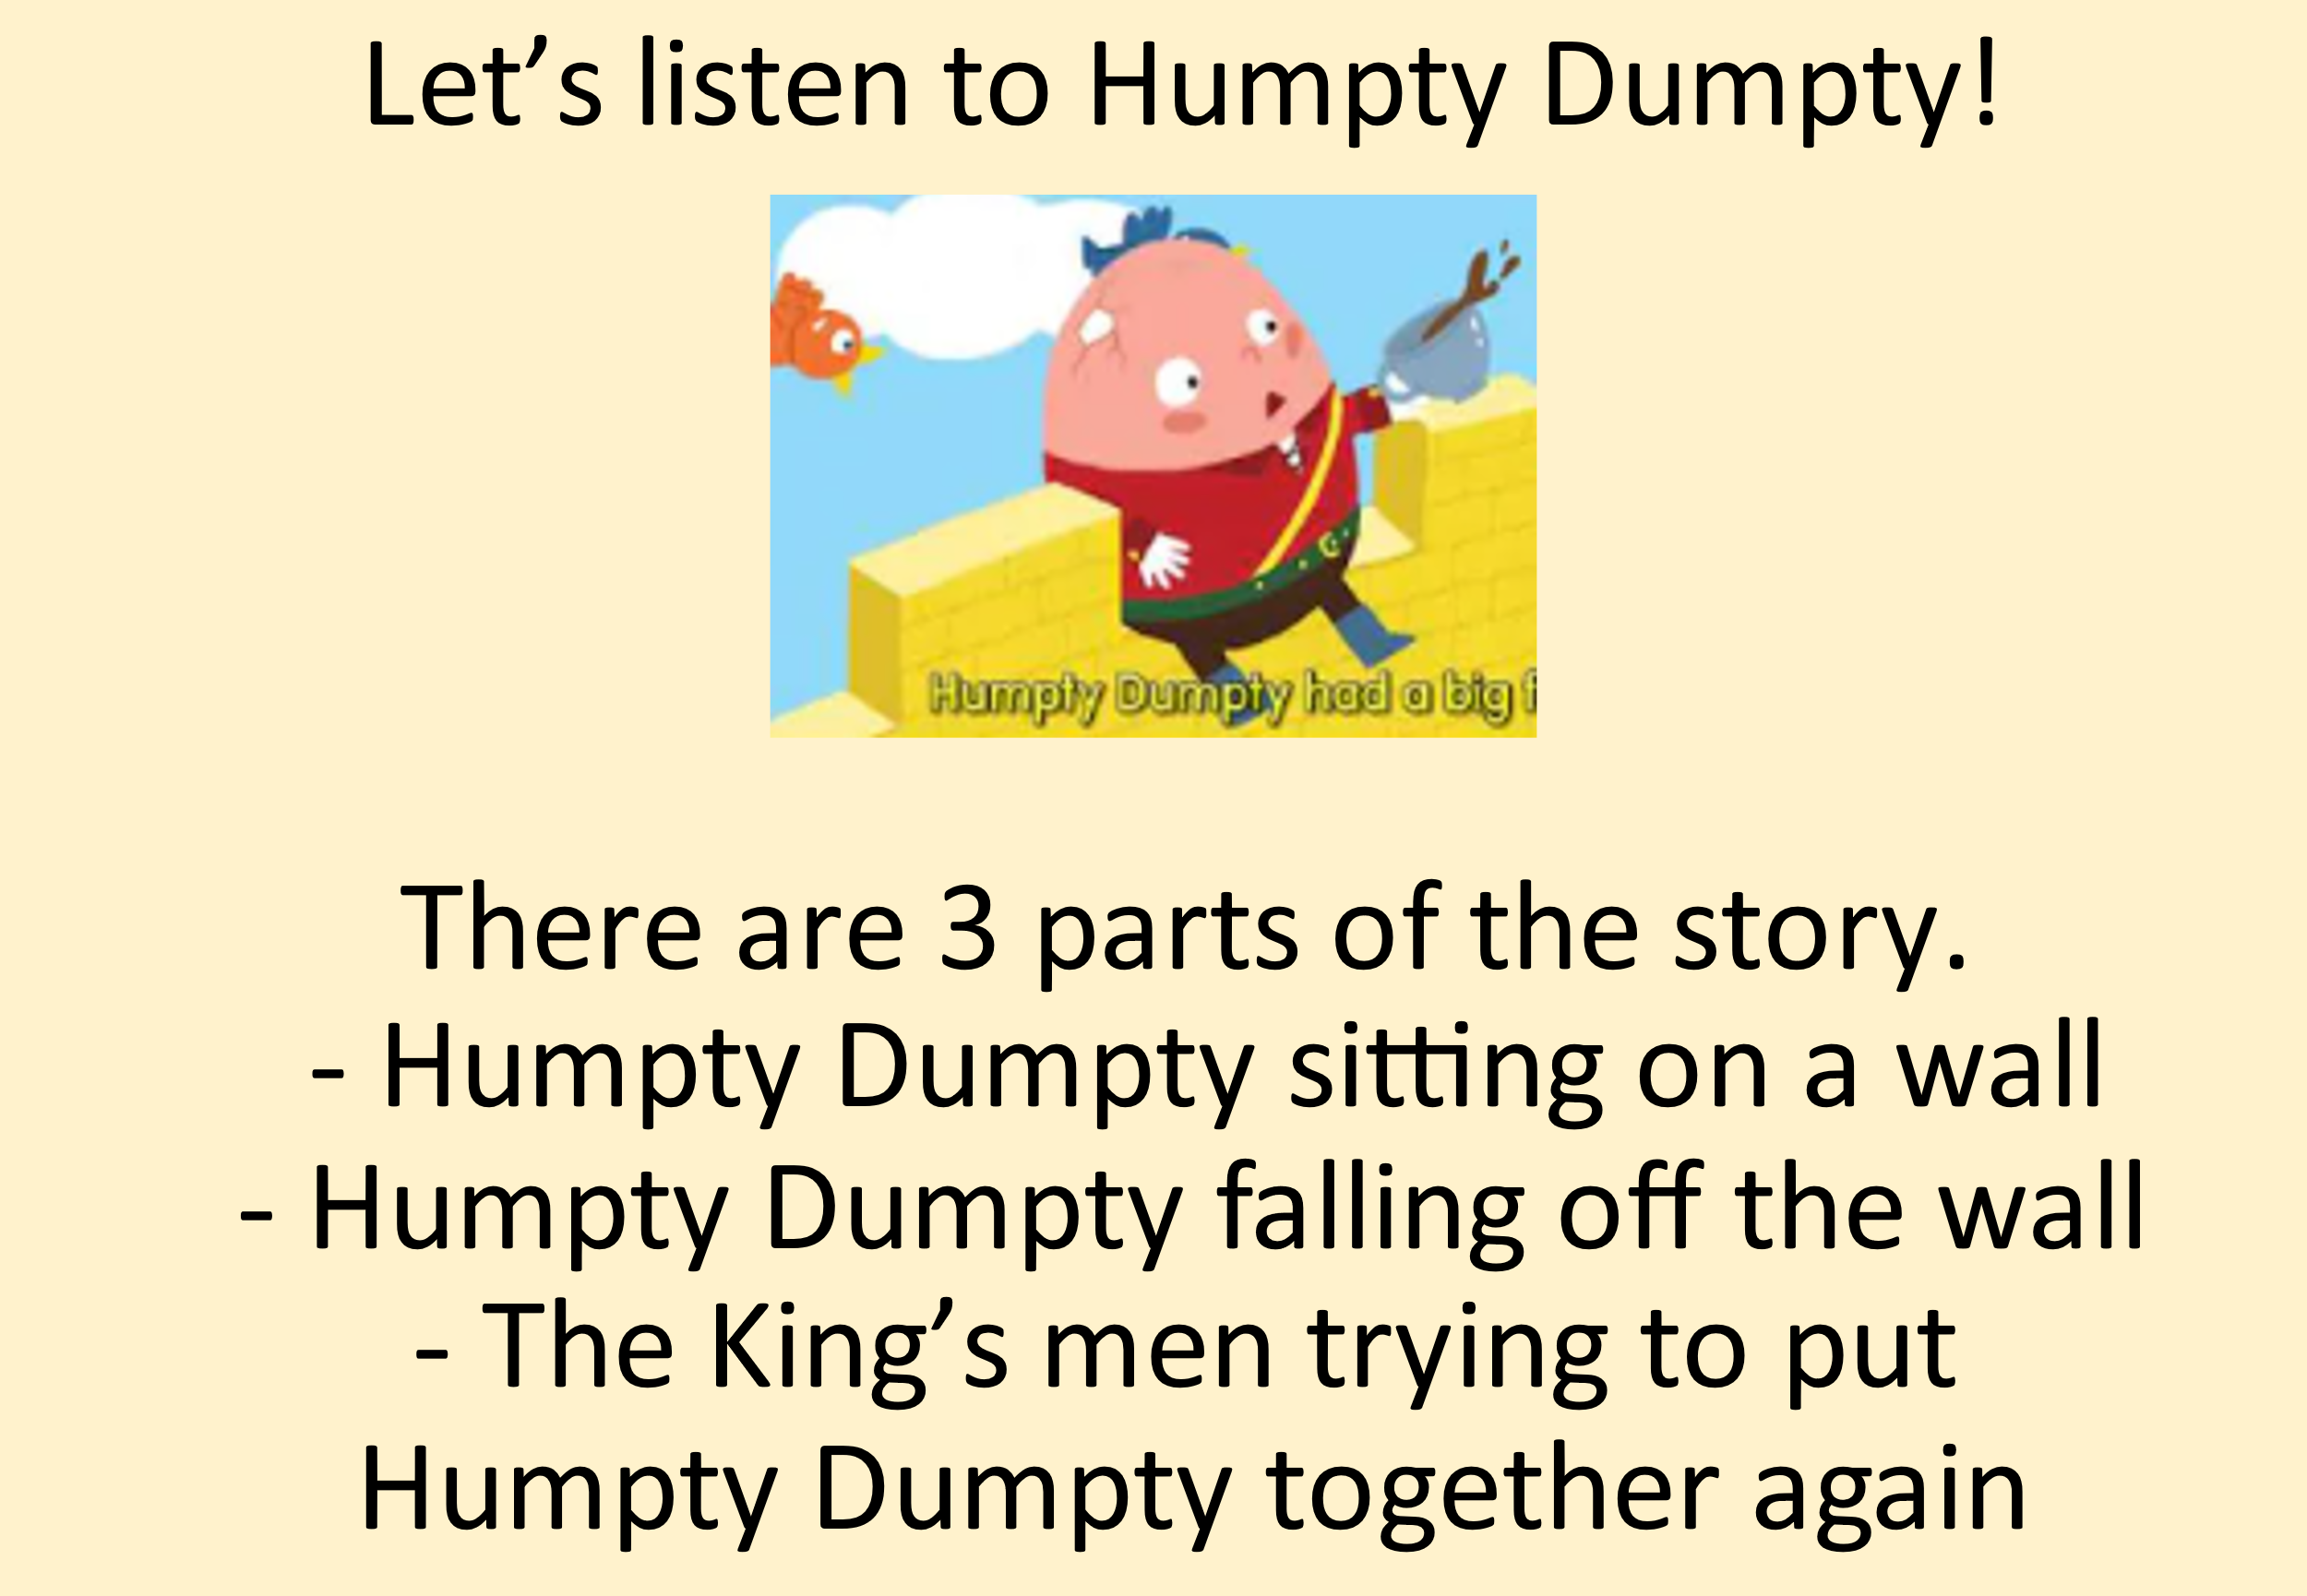

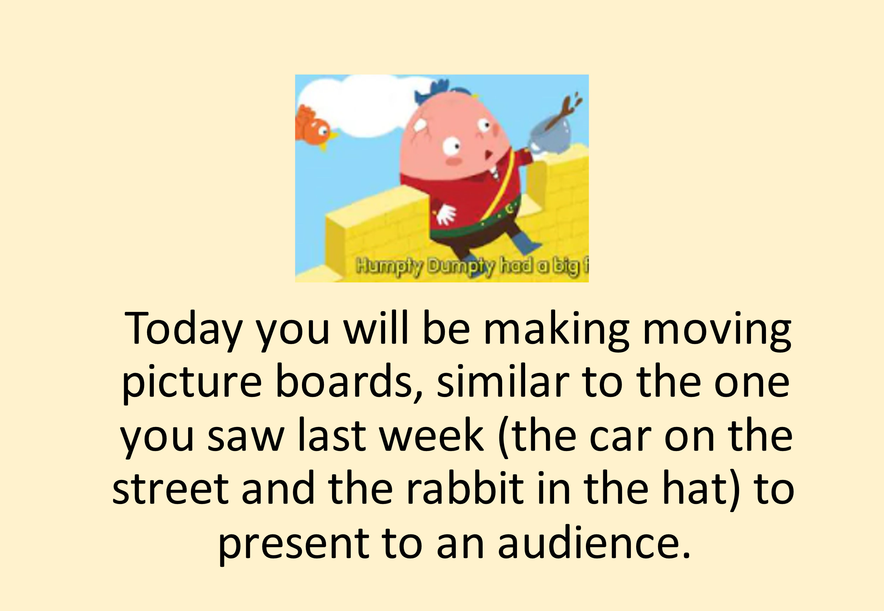
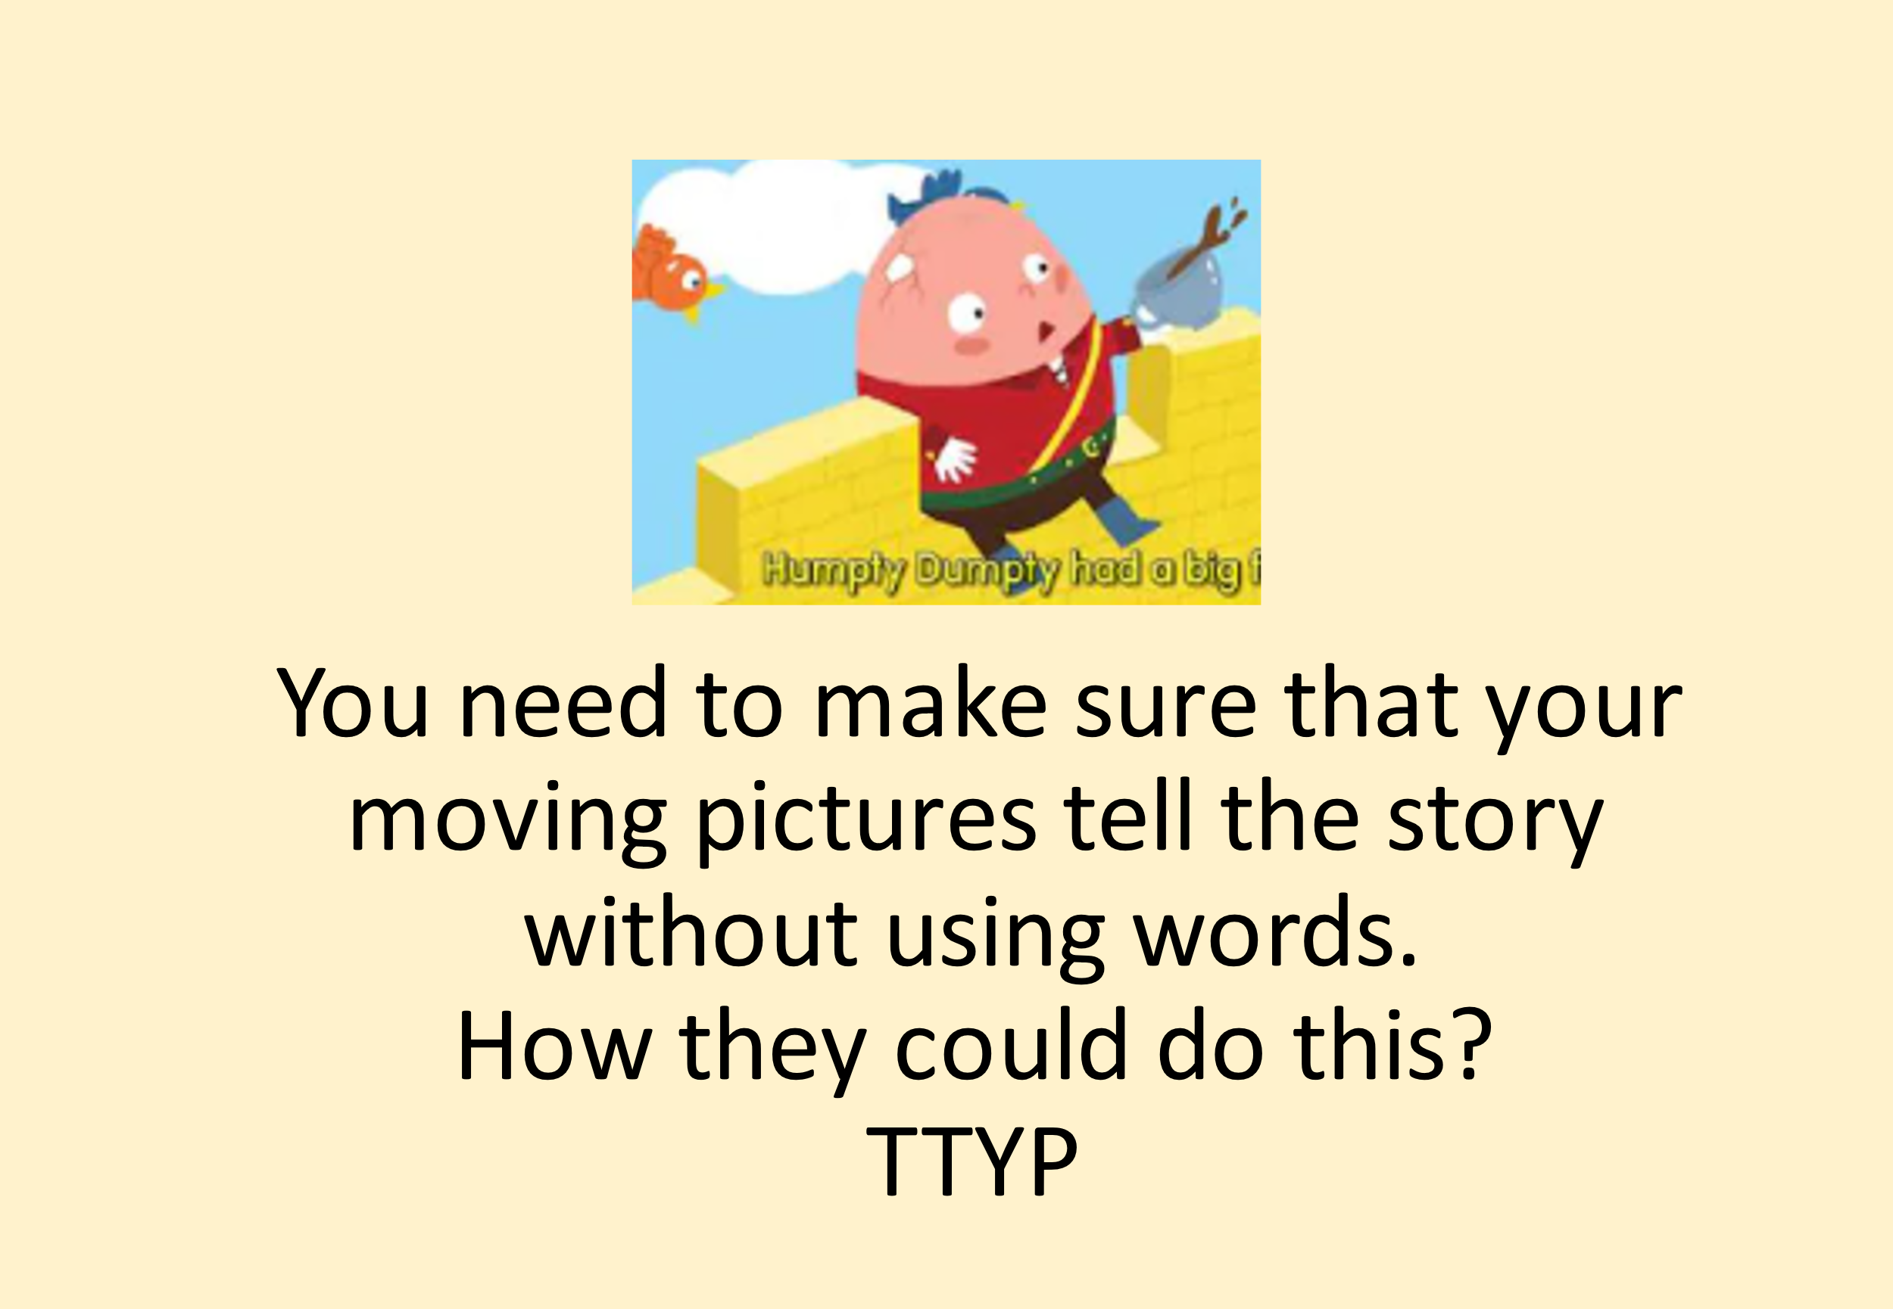

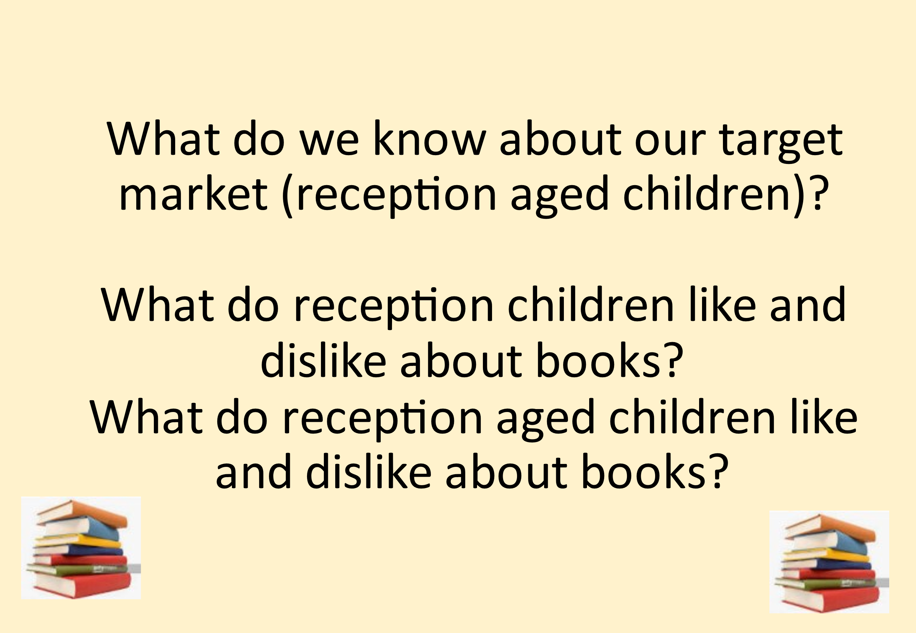
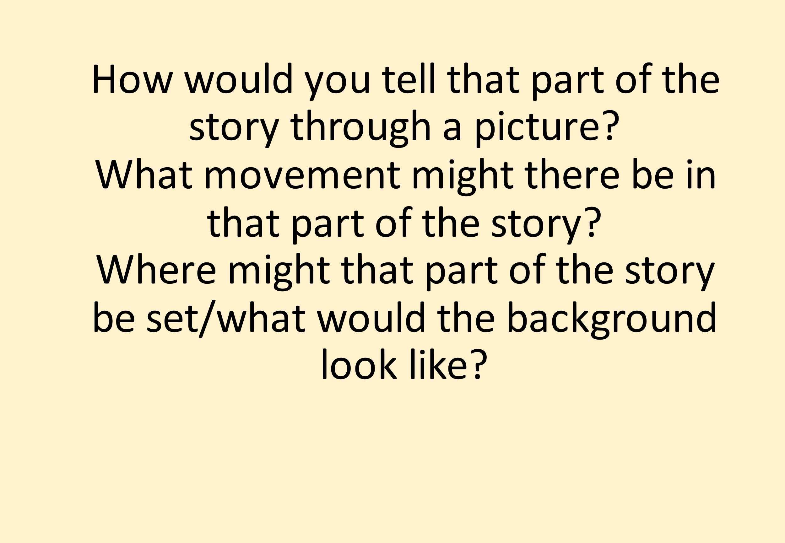

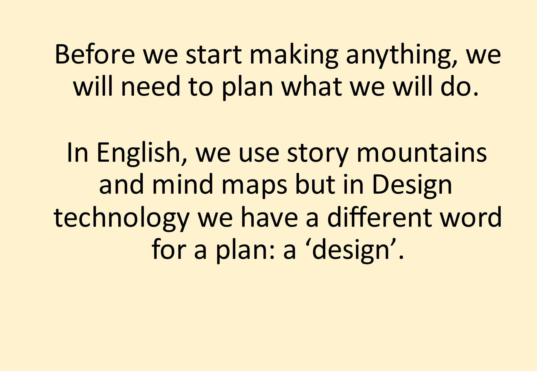
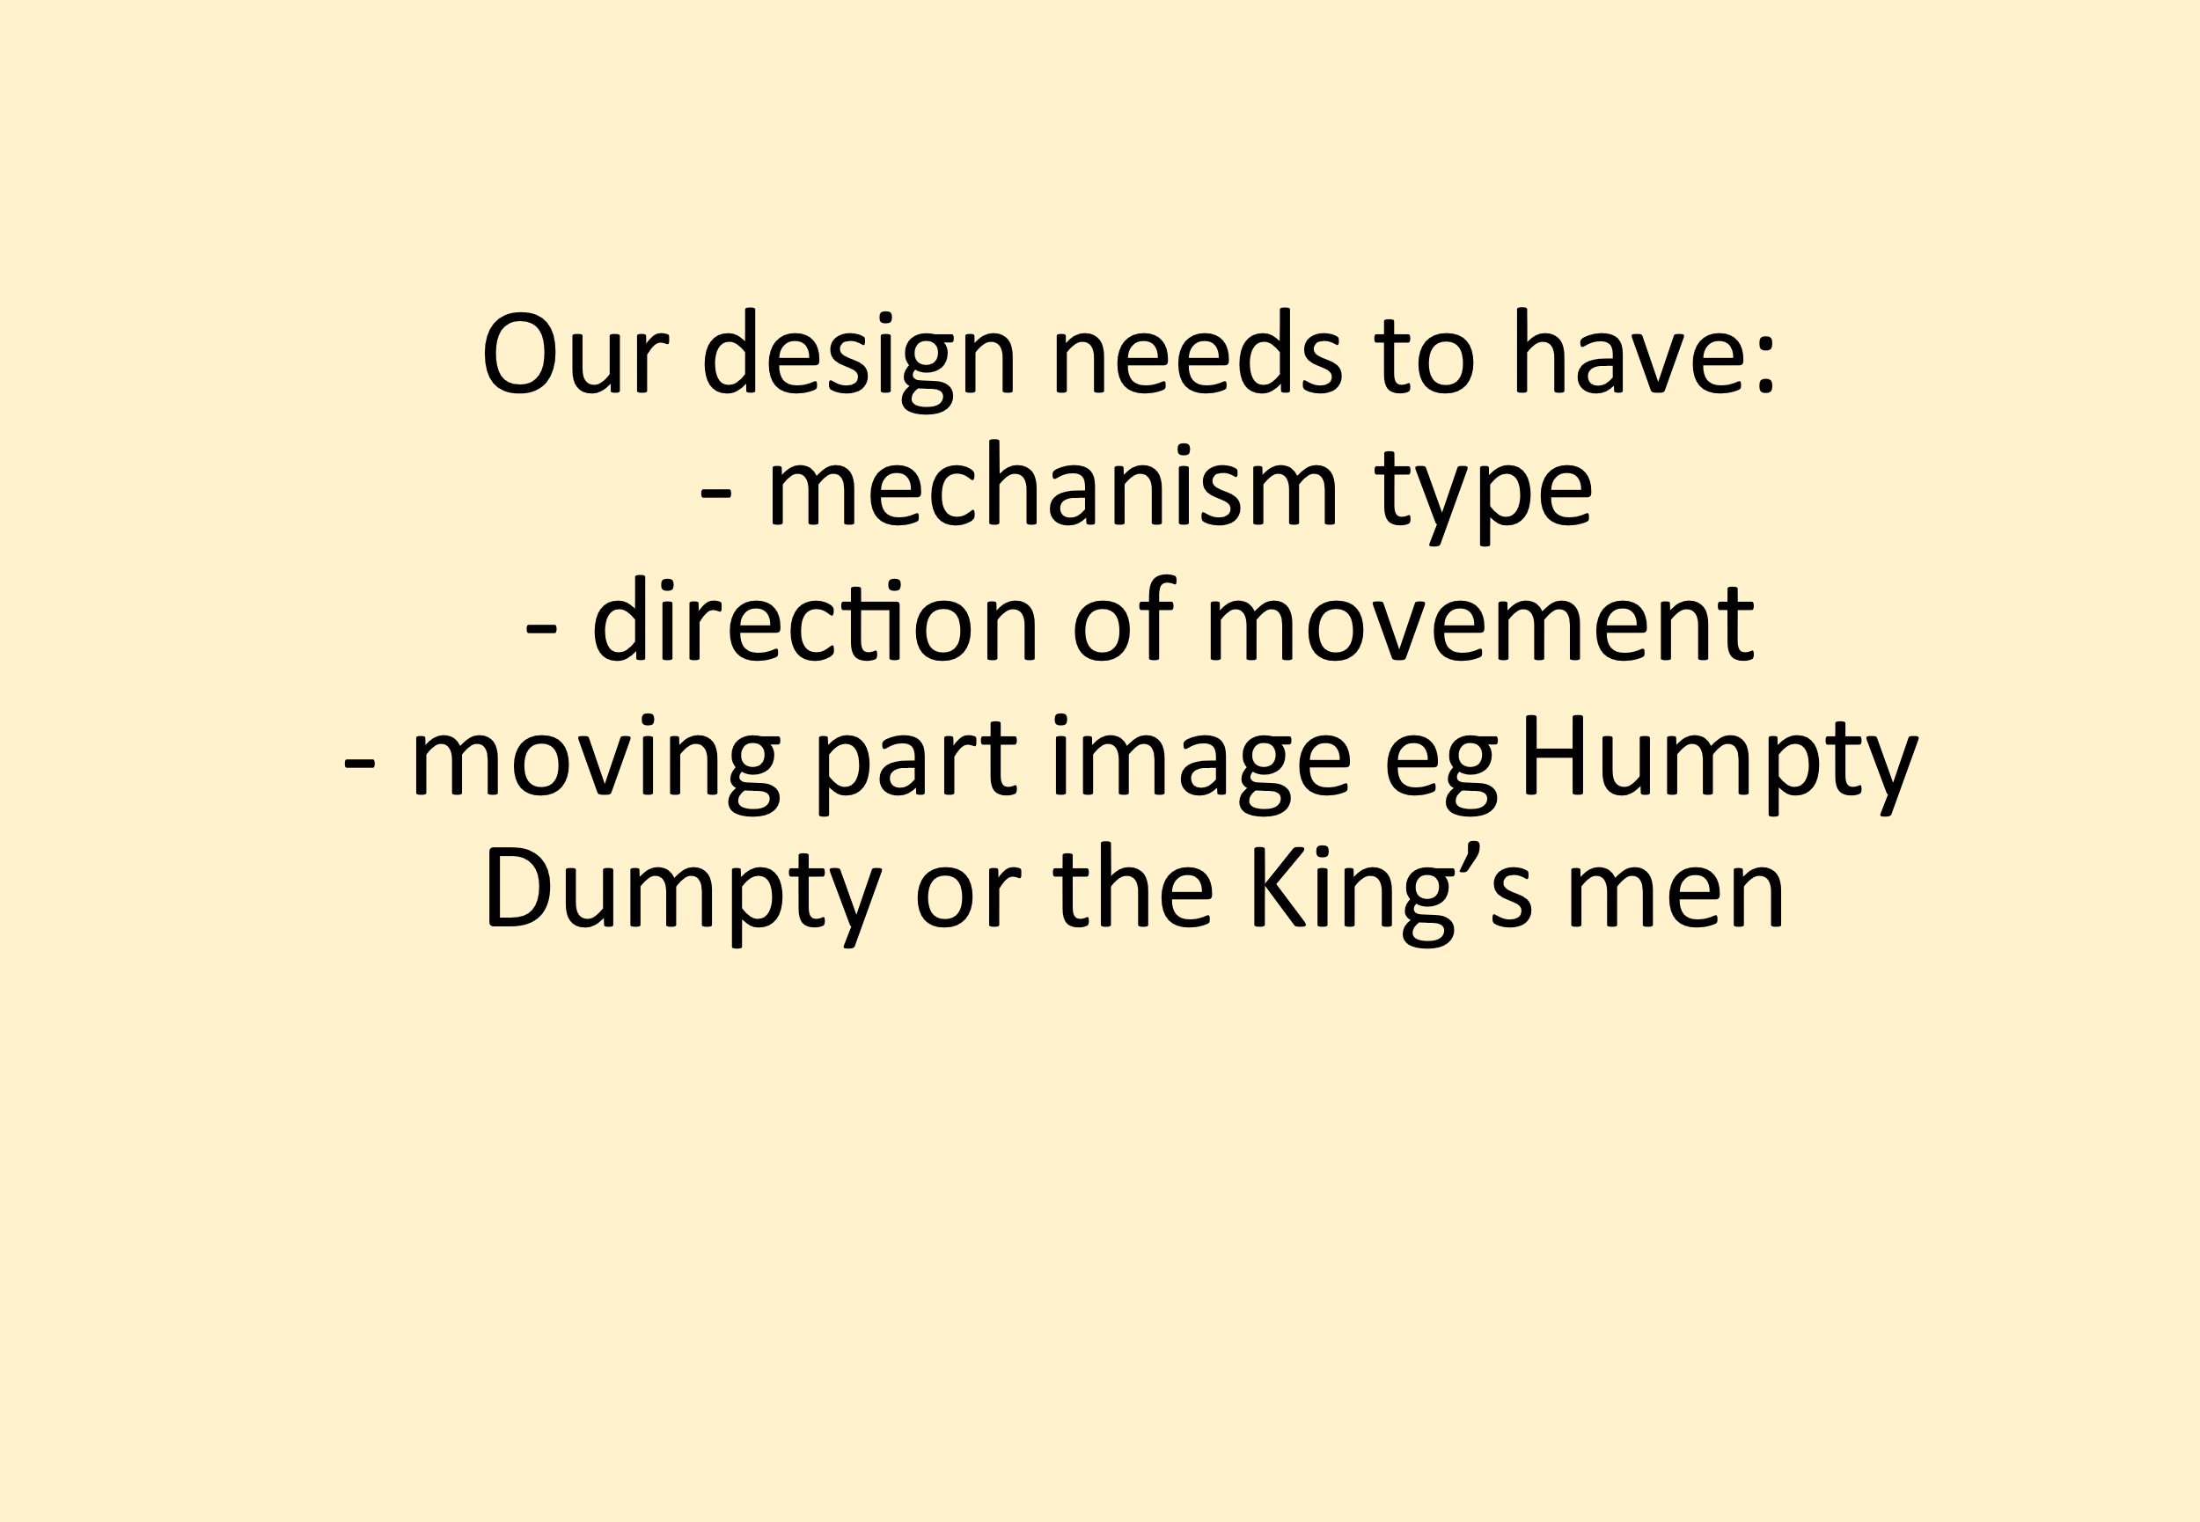

Now use the sheet below to draw the 3 parts of Humpty Dumpty and show what part will move and whether it will need a side to side slider mechanism or an up and down slider mechanism.

Friday 14th May
Geography
