Maths Home learning w/b 10th May

This week we are learning to;
- Recall number bonds to 20.
- Subtract ones from two-digit numbers.
- Add two-digit numbers and ones together with regrouping.

Lesson 1
Practise your number bonds by choosing a song from this link:
number bonds to 20 - YouTube
Complete the work sheet by finding 6 different ways of making 20. Challenge: How many ways can you make 20? Draw them on another piece of paper.

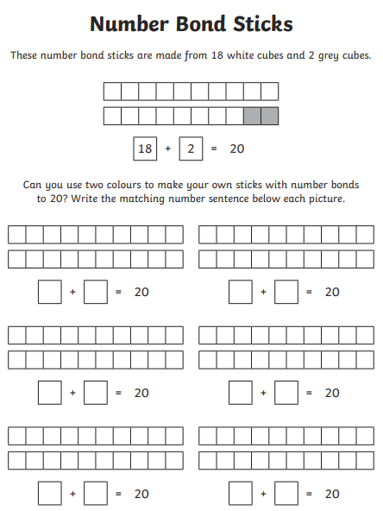

Lesson 2
Practise your number bonds by choosing a song from this link:
number bonds to 20 - YouTube

Play the number bond game with an adult in your house. Who can find the pairs of numbers that make 20?
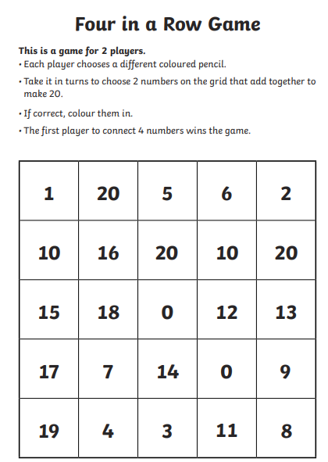

Lesson 3
Look at these equations. What do you notice? What is the same?
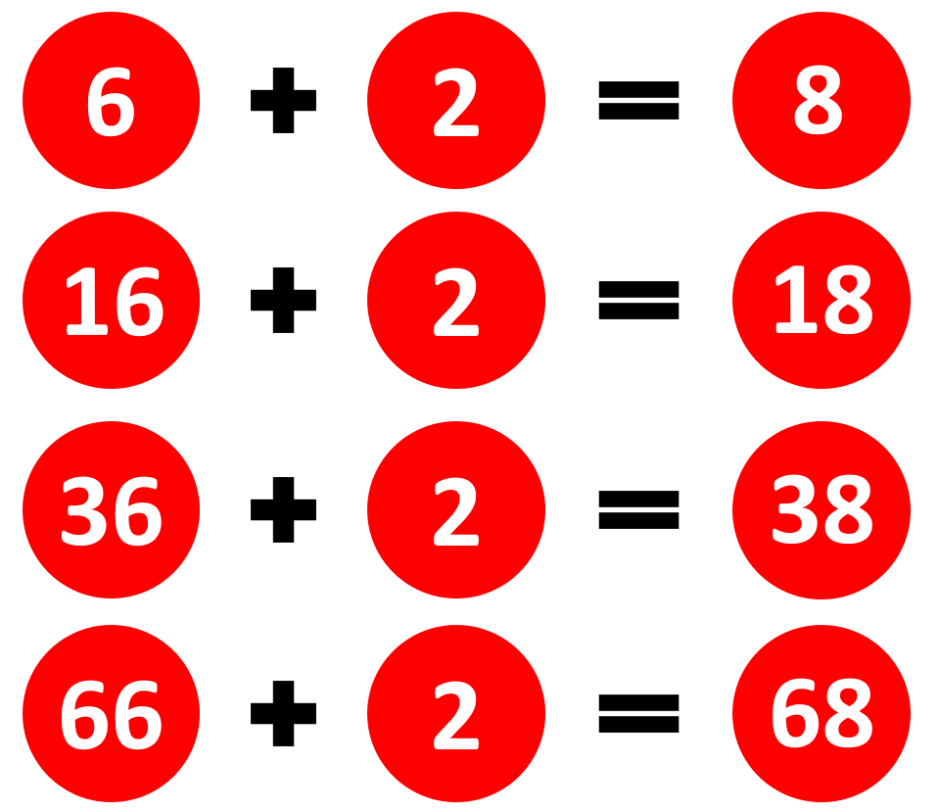

Can you complete these equations?
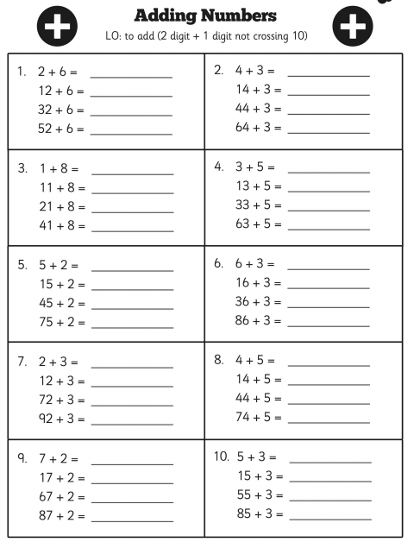

Lesson 4
Look at these equations. What do you notice? What is the same?
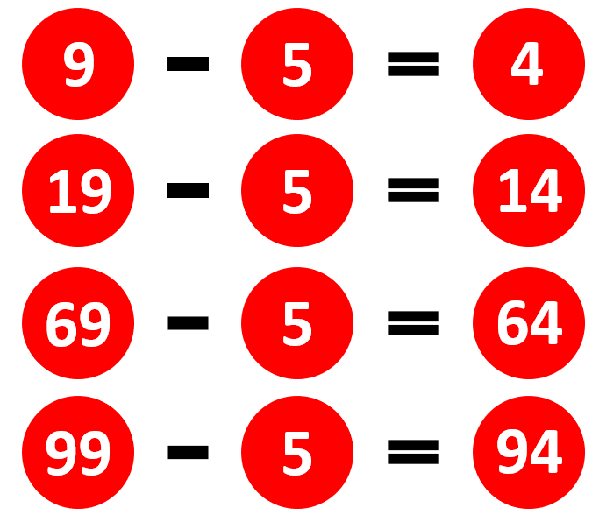
Have a go at these subtraction equations.
