Maths Home learning w/b 26th April

This week we are learning;
- To find one more or one less and ten more or ten less
- To compare numbers within 100 on a number line
- To compare numbers within 100 on a place value chart
- Count, compare and order numbers to 100

Please watch the videos to accompany each lesson first before completing the independent tasks.

Monday 26^{h} April

In this lesson you will find one more, one less and ten more and ten less from a given number by using manipulatives to support your counting.

https://classroom.thenational.academy/lessons/to-find-one-more-or-one-less-and-ten-more-or-ten-less-ccvk6c

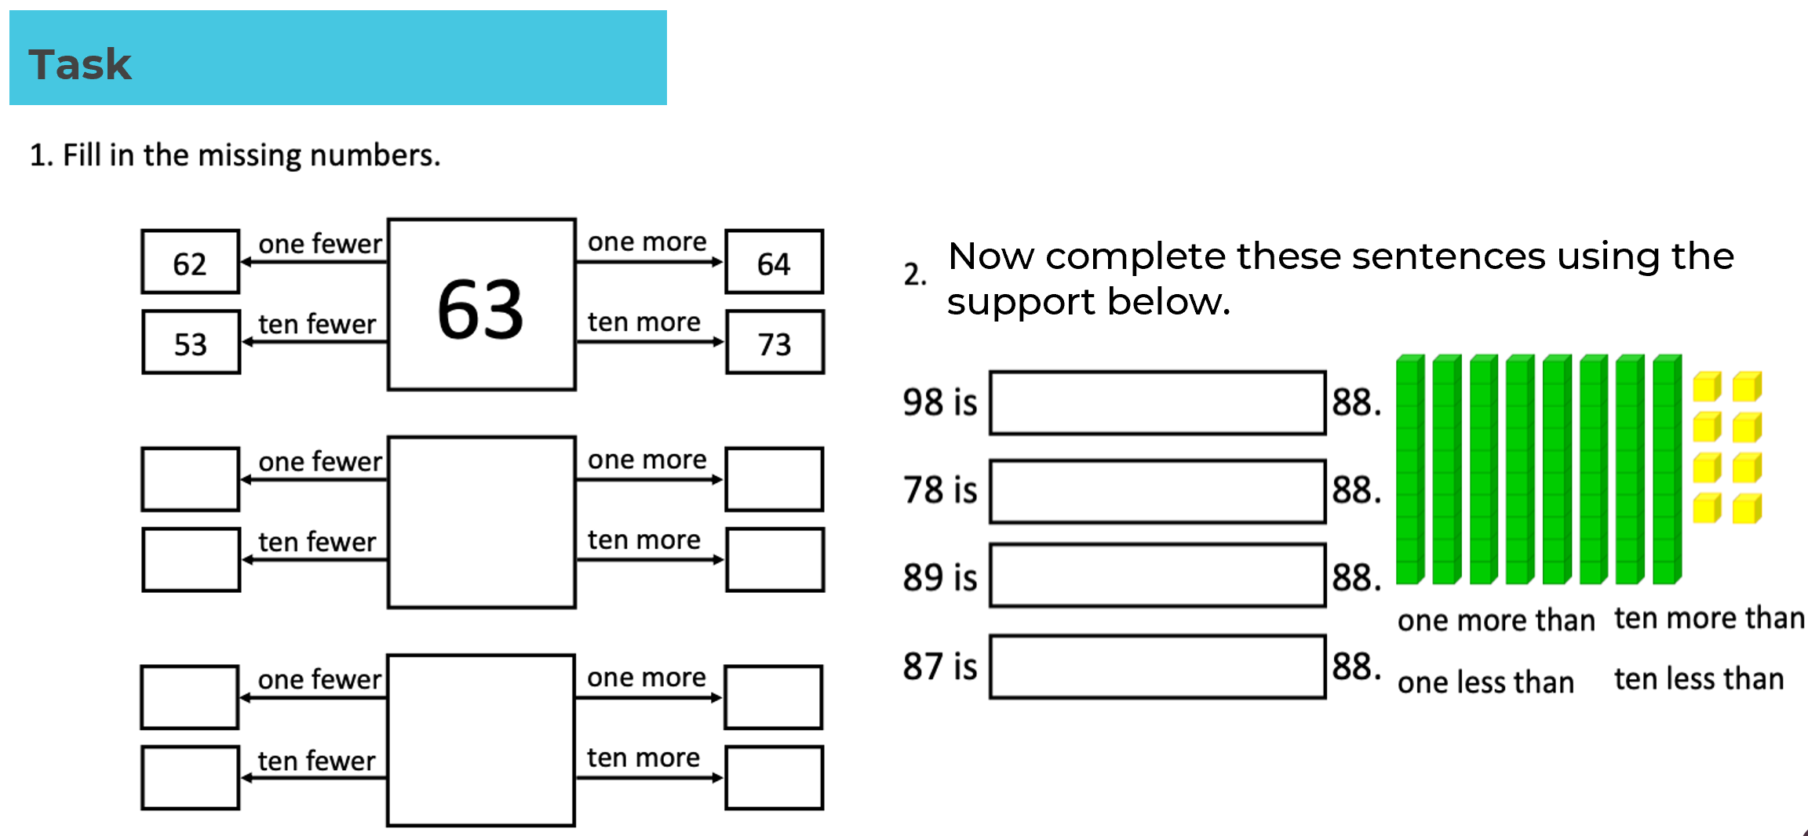
Tuesday 27th April
In this lesson you will be counting and comparing numbers within 100 using a number line. You will be using the vocabulary, greater and less to decide which number has the greatest or lesser value.

https://classroom.thenational.academy/lessons/to-compare-numbers-within-100-on-a-number-line-60wpcd

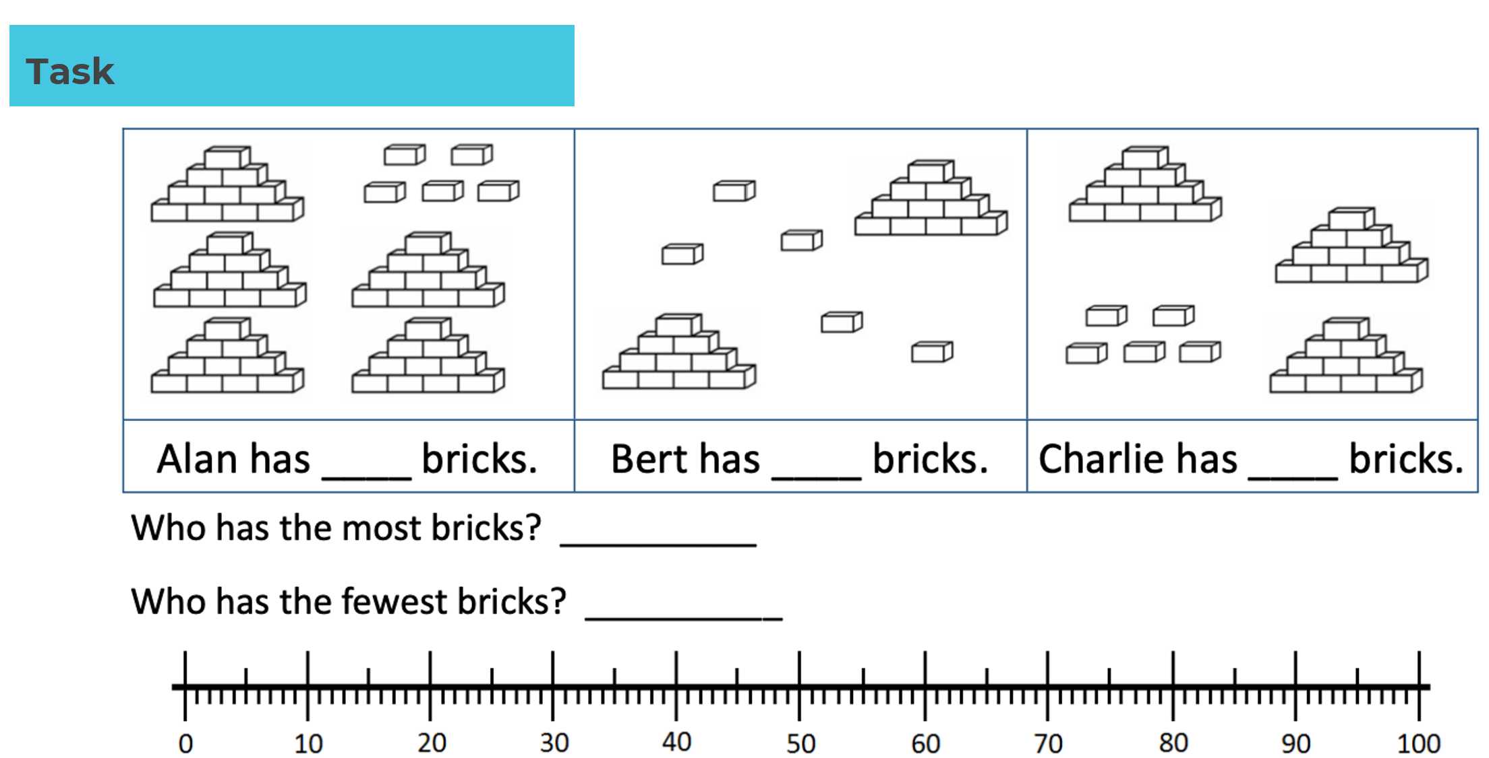

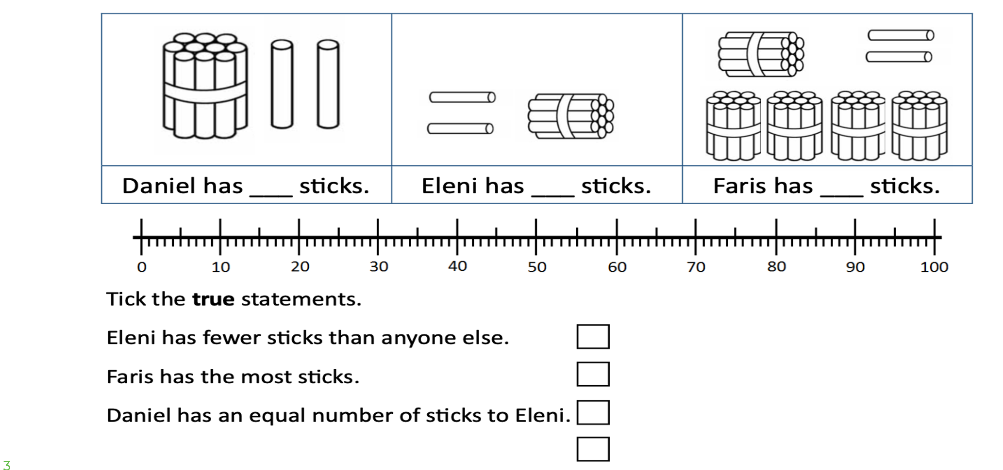

Wednesday 28th April

In this lesson you will be counting and comparing numbers within 100 using a place value chart

https://classroom.thenational.academy/lessons/to-compare-numbers-within-100-on-a-place-value-chart-6mrp6r

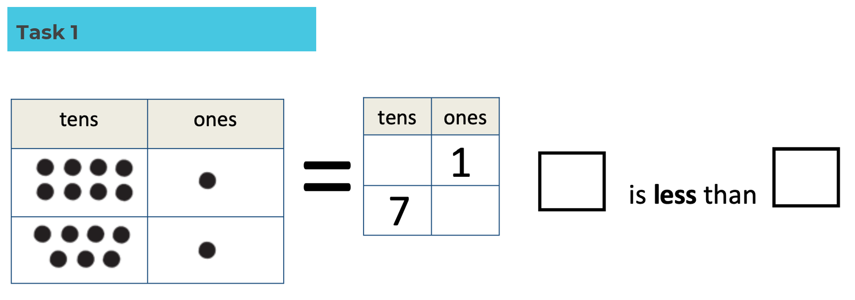
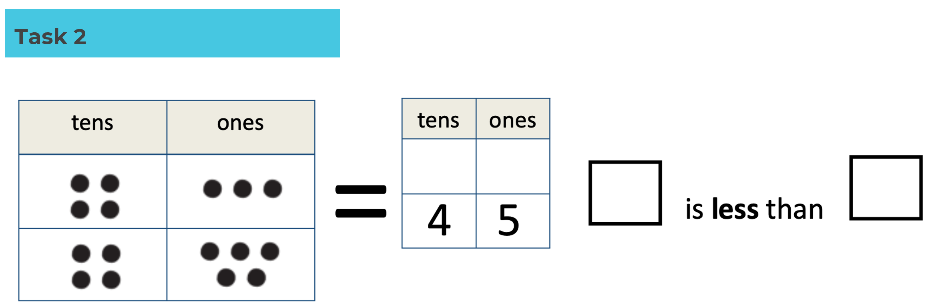

Thursday 29th April

In this lesson you will be counting, comparing and ordering numbers within 100.

https://classroom.thenational.academy/lessons/to-order-numbers-within-100-part-1-65jkat
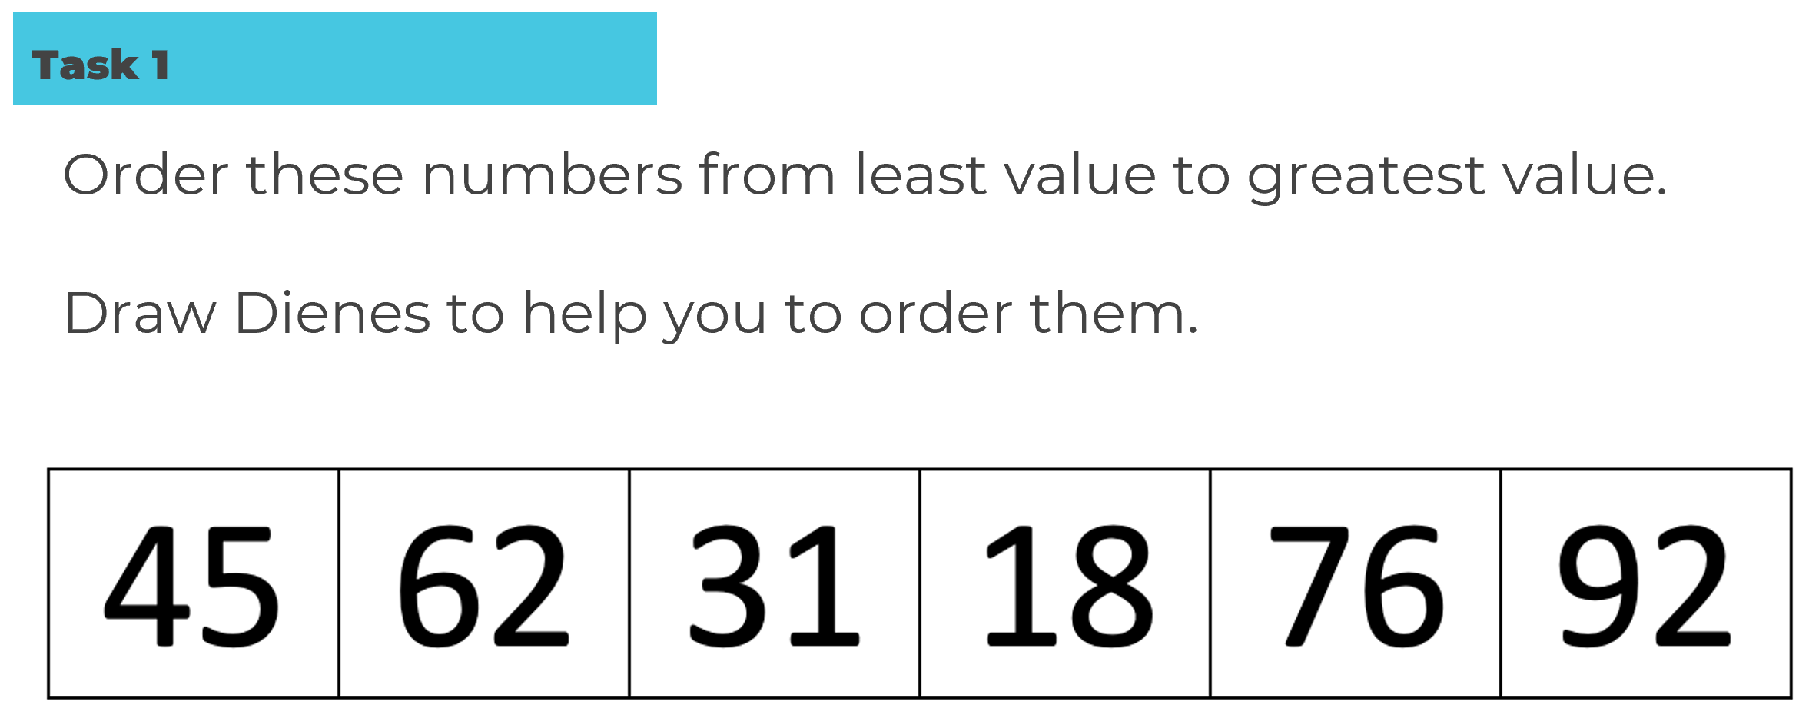

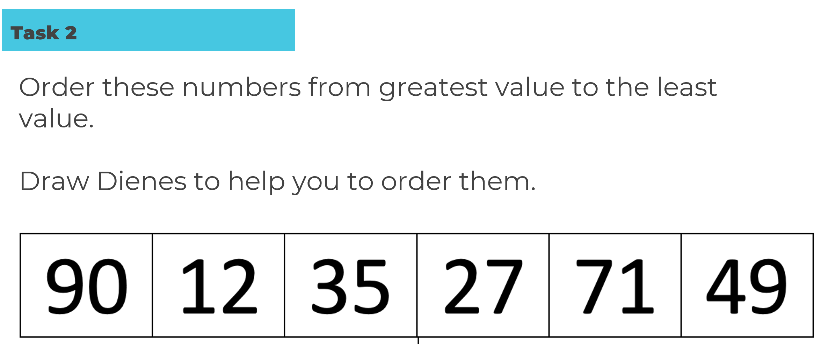

Friday 20th April

In this lesson you will be counting, comparing and ordering numbers within 100.

https://classroom.thenational.academy/lessons/to-order-numbers-within-100-part-2-6nk64d

