Topic w/b Monday 26th April
Monday 26th April
Dance
Learning to: use simple movements with control.
Show video: Chitty Chitty bang https://www.youtube.com/watch?v=L_l2ii_25tc

Recap prior learning:
What was in the toy box last week? A rag doll, a teddy bear, a soldier, a toy car and a spinning top, Jack in the box.
How did the toy move? Eg skip, wide gait, turn, change speed.

Corner work: Children rehearse moving from one corner of the room to the other in character.
If we took away the movement, your toy would be still. Model freezing as a character.
I would like you to imagine you have taken a photograph of your partner (They need to be still)
Have the children all start frozen as one of the characters. Freeze frame ( A freeze frame is like somebody is taking your photograph)

Monday 26th April
Circle Time
Learning to identify what a baby needs to be healthy.

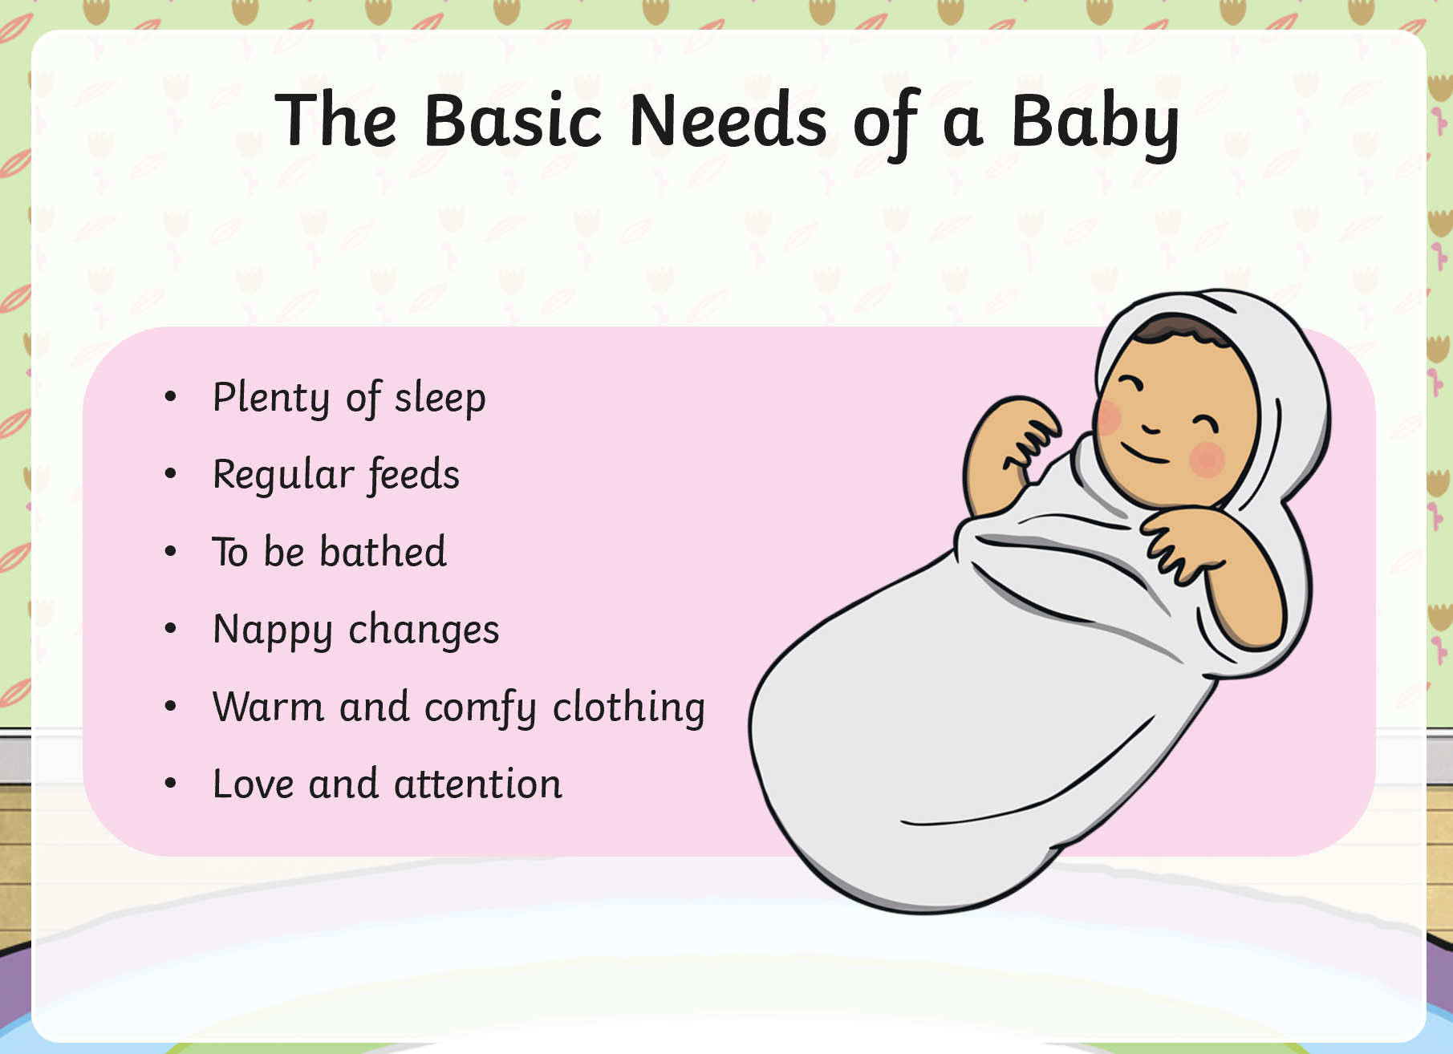

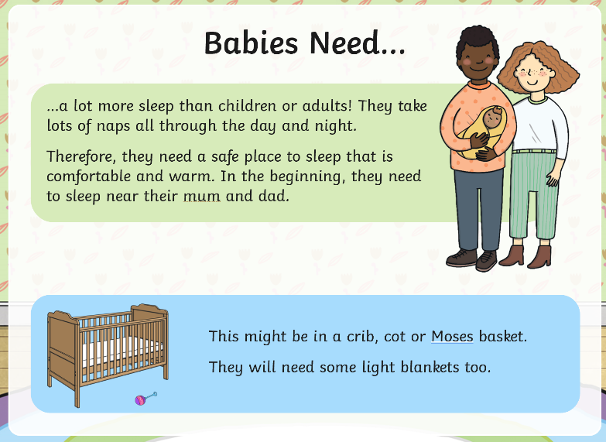
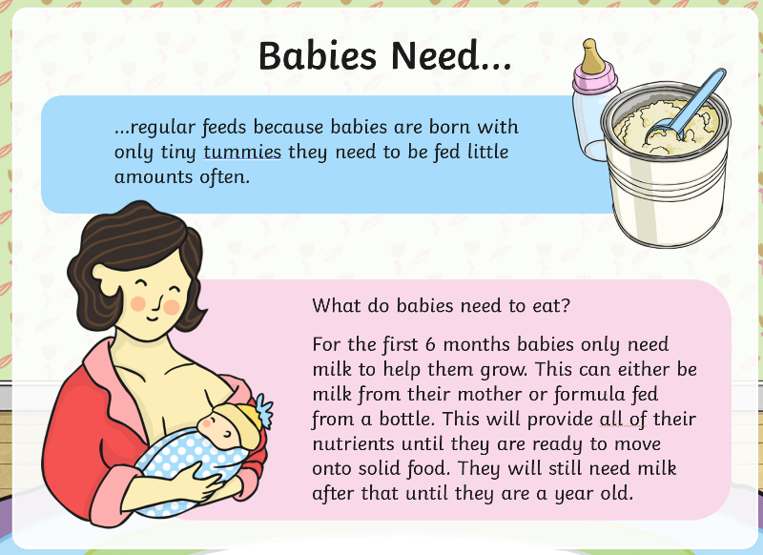

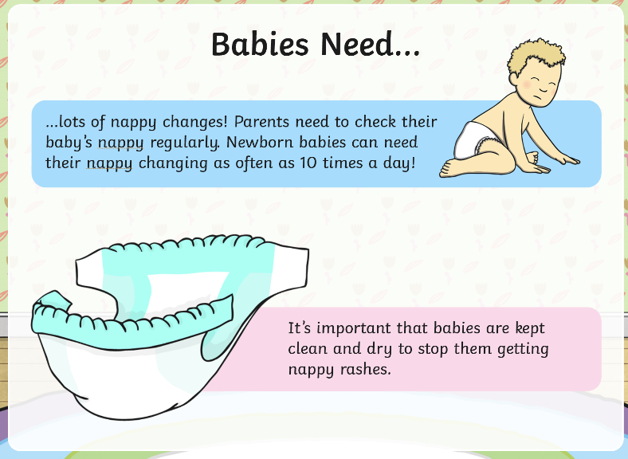
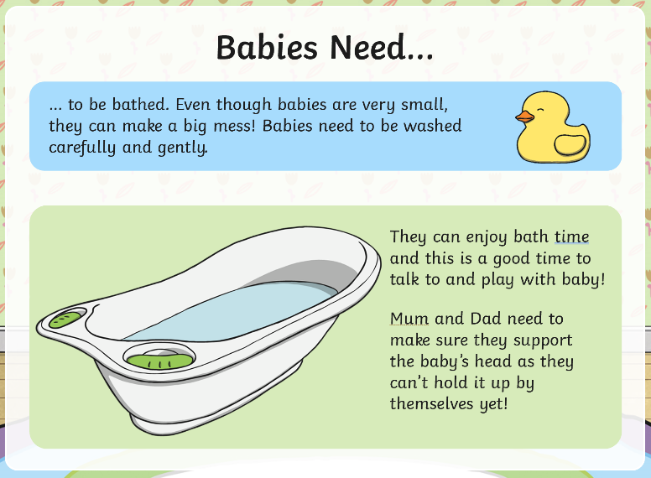

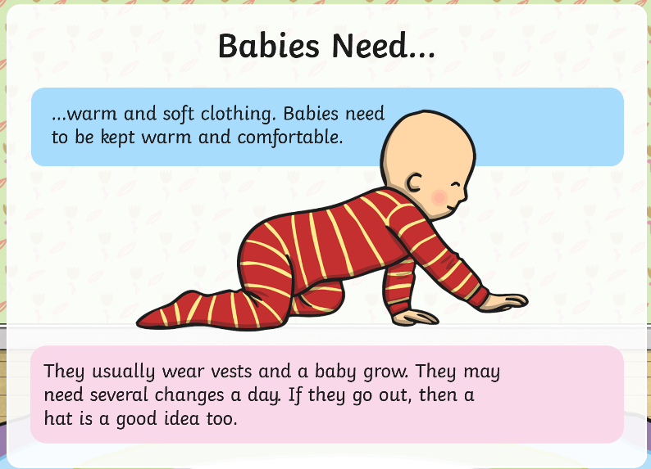
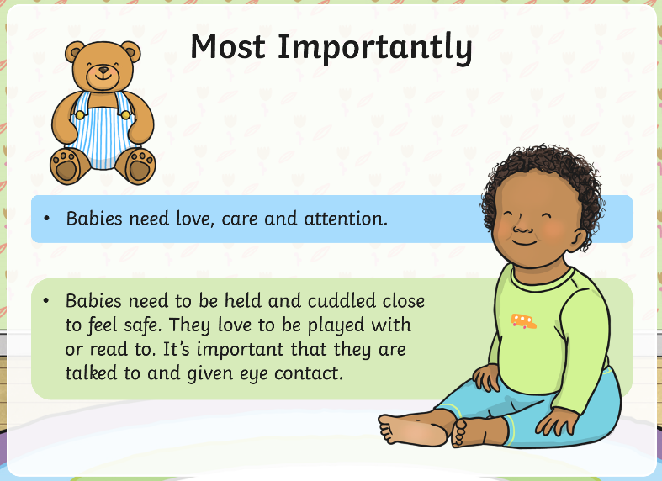

Now write as many things a baby needs around the picture on the following page.

Tuesday 27th April
Computing

Learning to: Use the shape and line tools on a computer to recreate a piece of artwork.
Vocabulary – Primary colours, Piet Mondrian, shape, line, fill, undo
This is a painting by Piet Mondrian. It is abstract art tat is made up of different colours, shapes and lines.
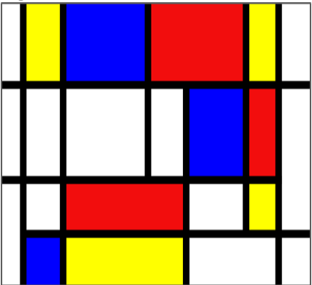

Use the paintz.app website to to create a picture in the style of Piet Mondrian. Use the shapes tool to make different sized shapes and the fill tool to colour the shapes in.

.

Tuesday 27th April
History

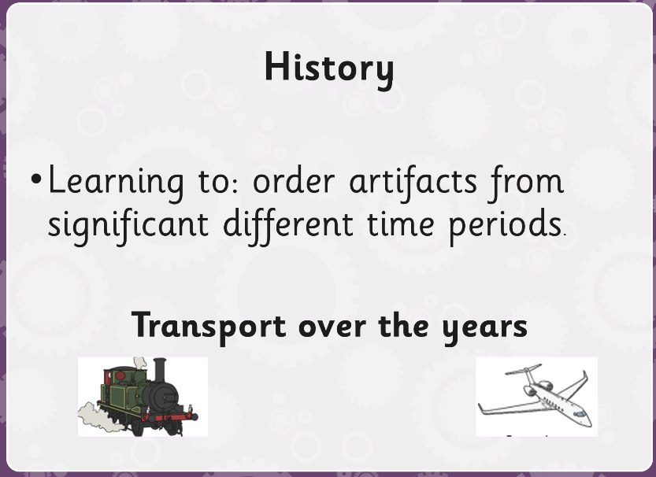
Learning to identify old and new transport.
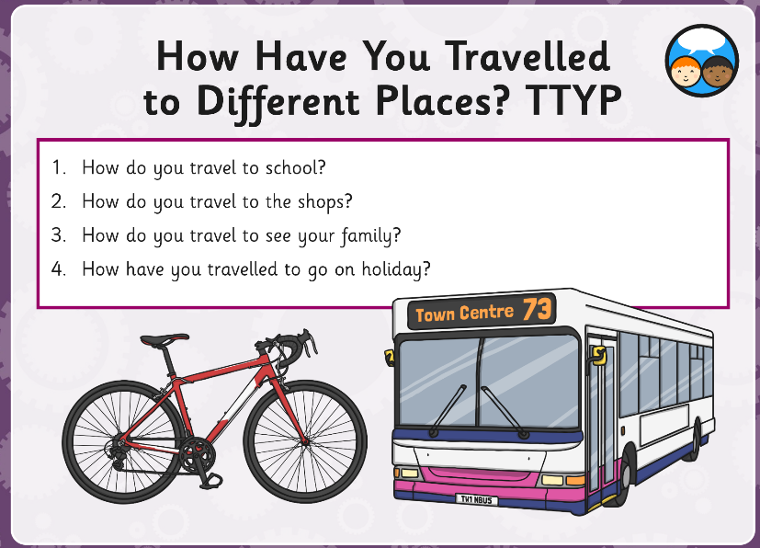

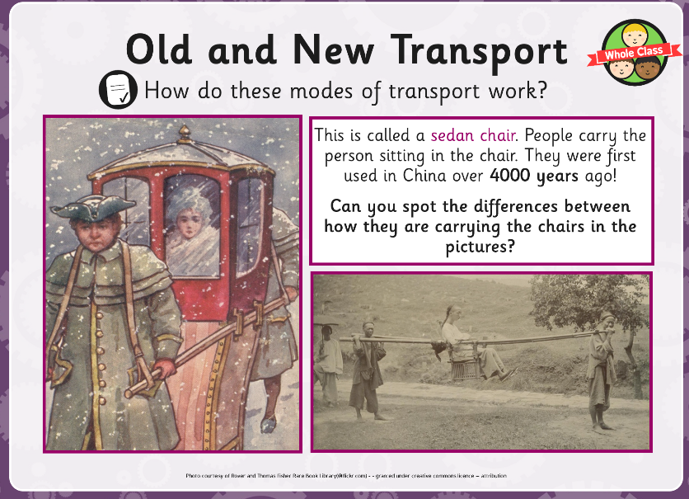
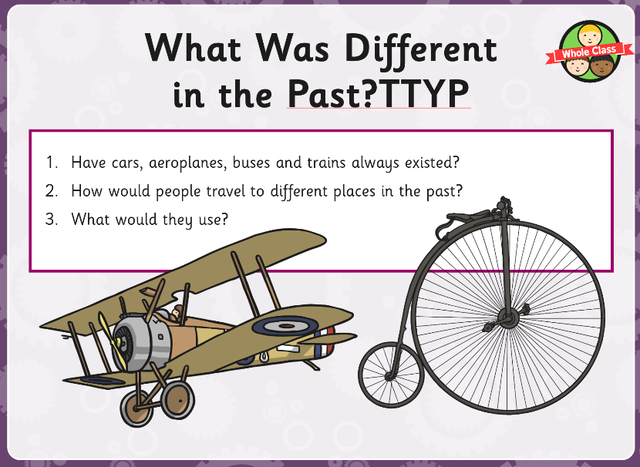

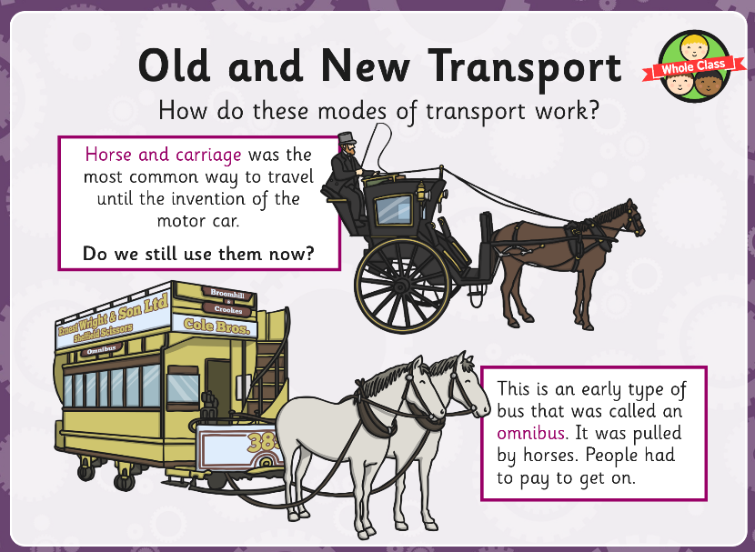
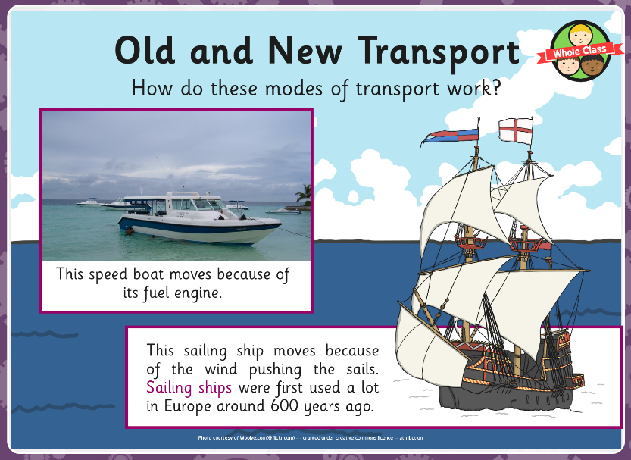

Now order the old and new transport in the timeline.

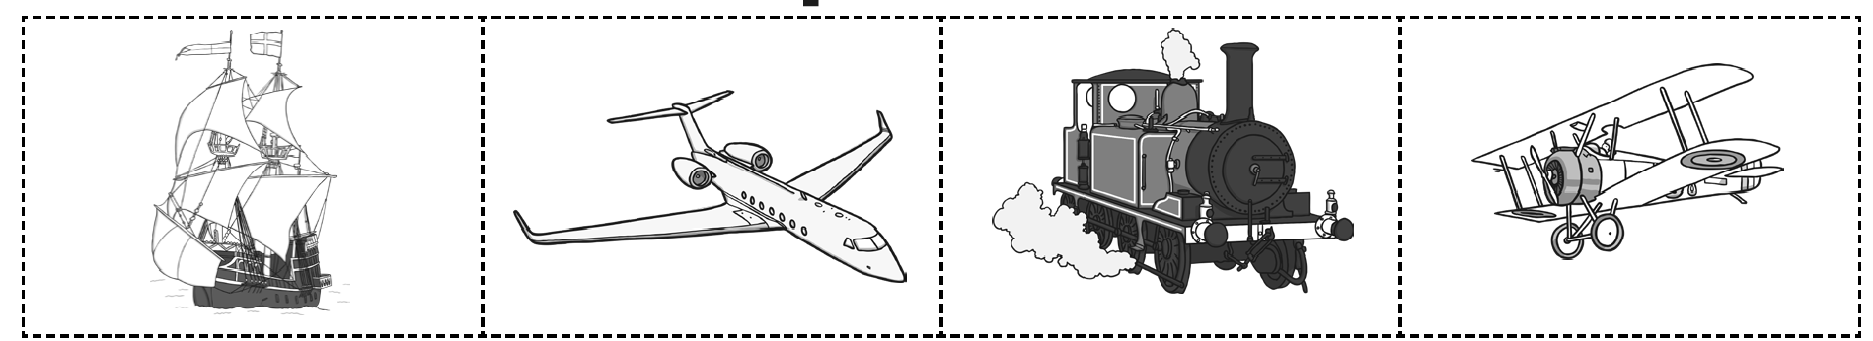

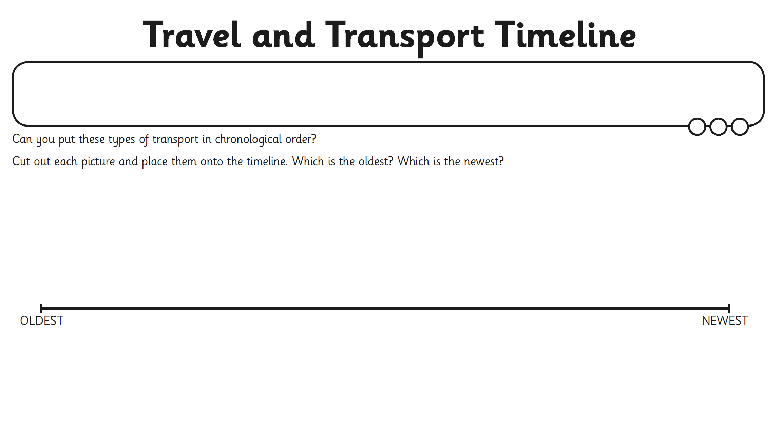

Wednesday 28th April
Music

Music - from Mrs Jackson You can access this week’s Music lessons using your child’s Charanga log in.

Thursday 29th April
DT

Learning to identify what a slider mechanism is.

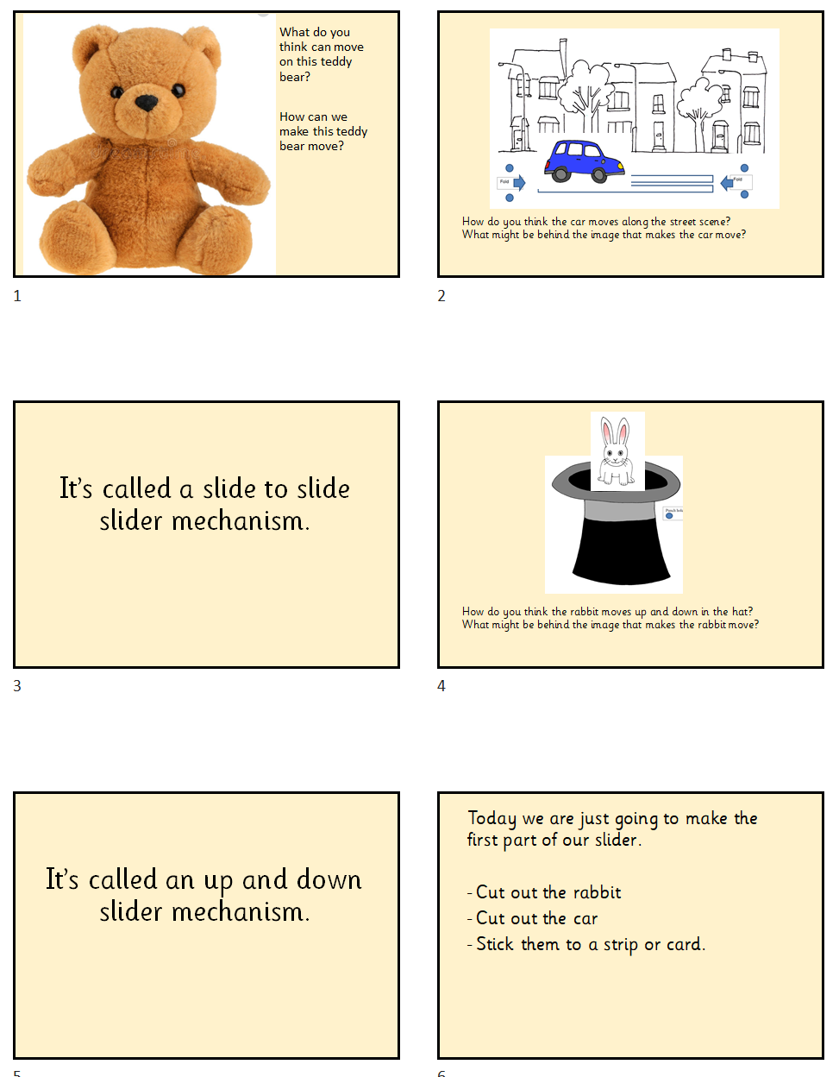

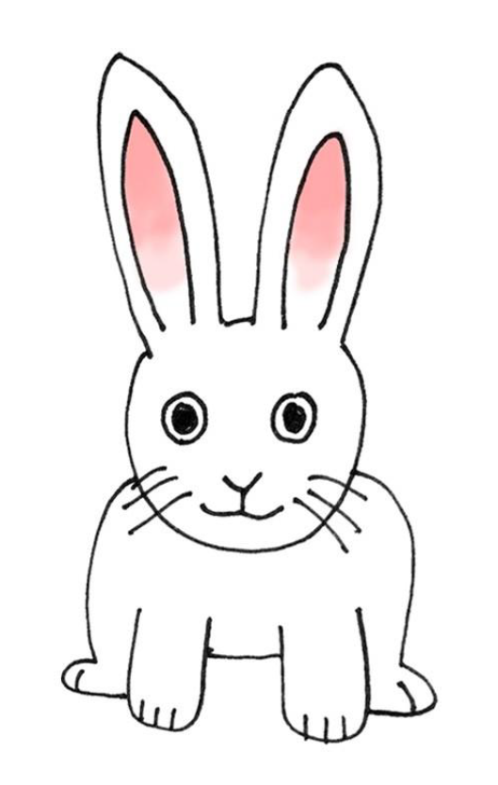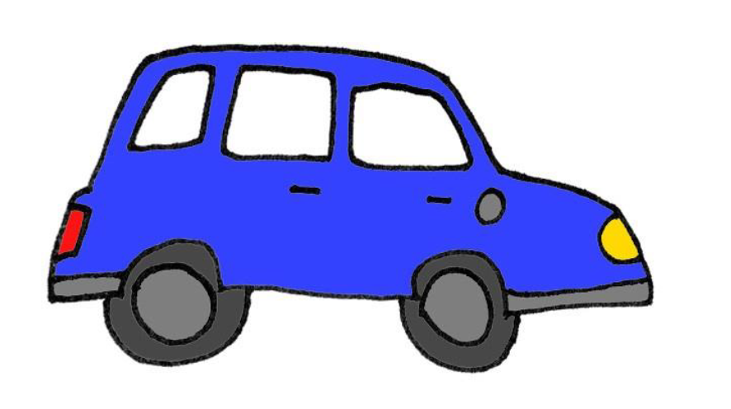

Friday 30th April
Computing
Learning to: use appropriate shape and line tools to recreate Henri Matisse’s artwork.
Vocabulary – Henri Matisse, shape, line, fill tools
Explain to the children Matisse created collages made from cut up paper.
Model drawing different size squares and using the fill tool to create a collage.
Independent task – To create Matisse artwork using the shape, lines, fill tools.

