Maths Home learning w/b 19th April

This week we are learning;
- To count in groups of tens and ones.
- To understand the value of a 2 digit number
- To represent the number 100 and understand that it is equal to ten groups of ten.
- To represent numbers within 100 as number bonds.
Please watch the videos first before completing the independent tasks.

Monday 19th April

https://classroom.thenational.academy/lessons/to-recognise-read-and-write-numbers-to-100-ctk64t

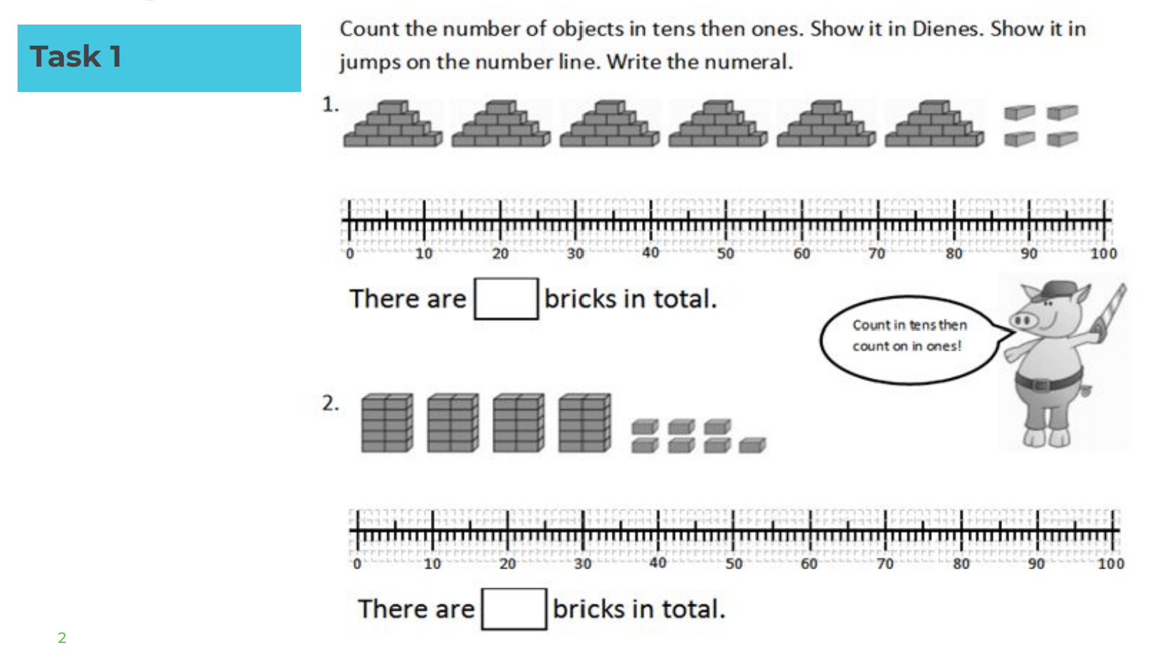

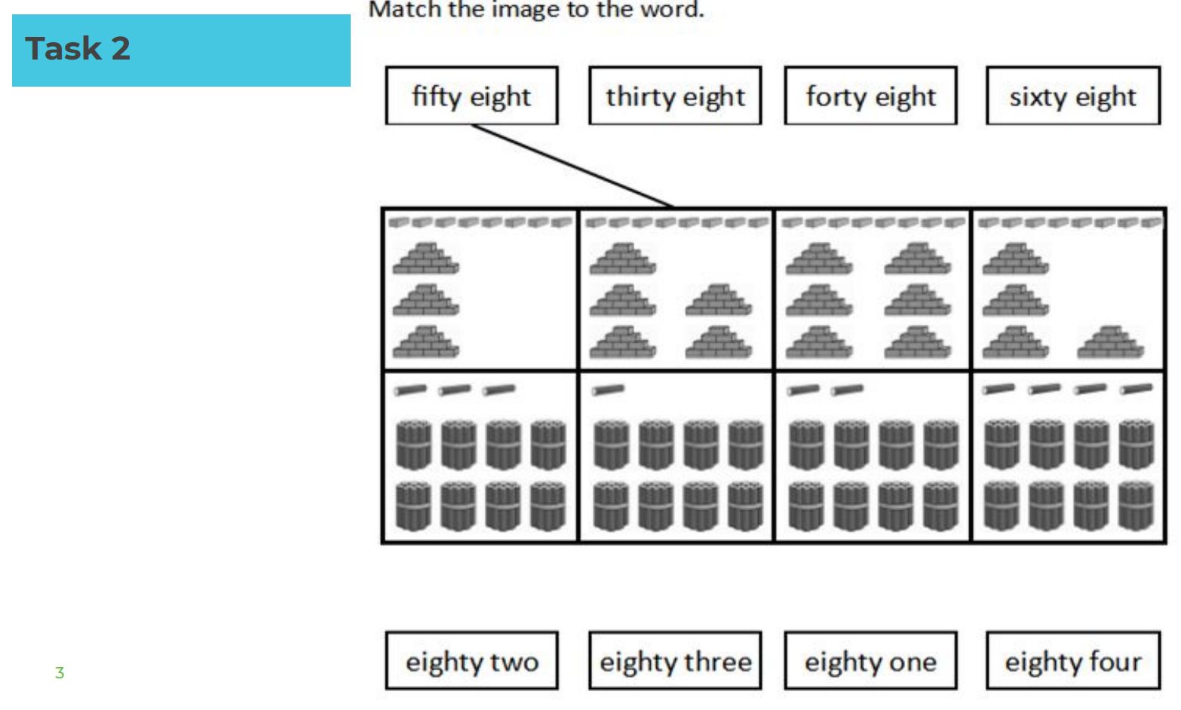

Tuesday 20th April

https://classroom.thenational.academy/lessons/to-explore-the-components-of-numbers-within-100-70tk4t

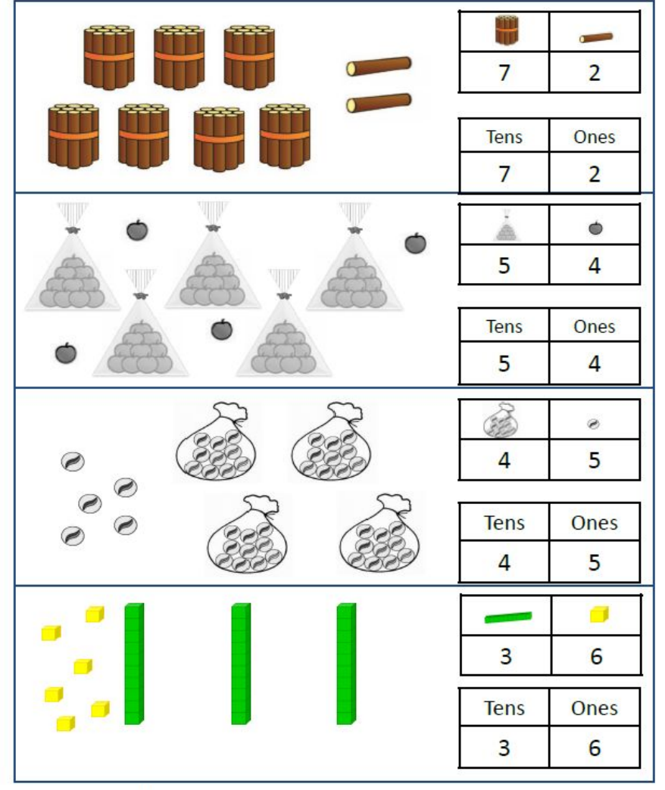
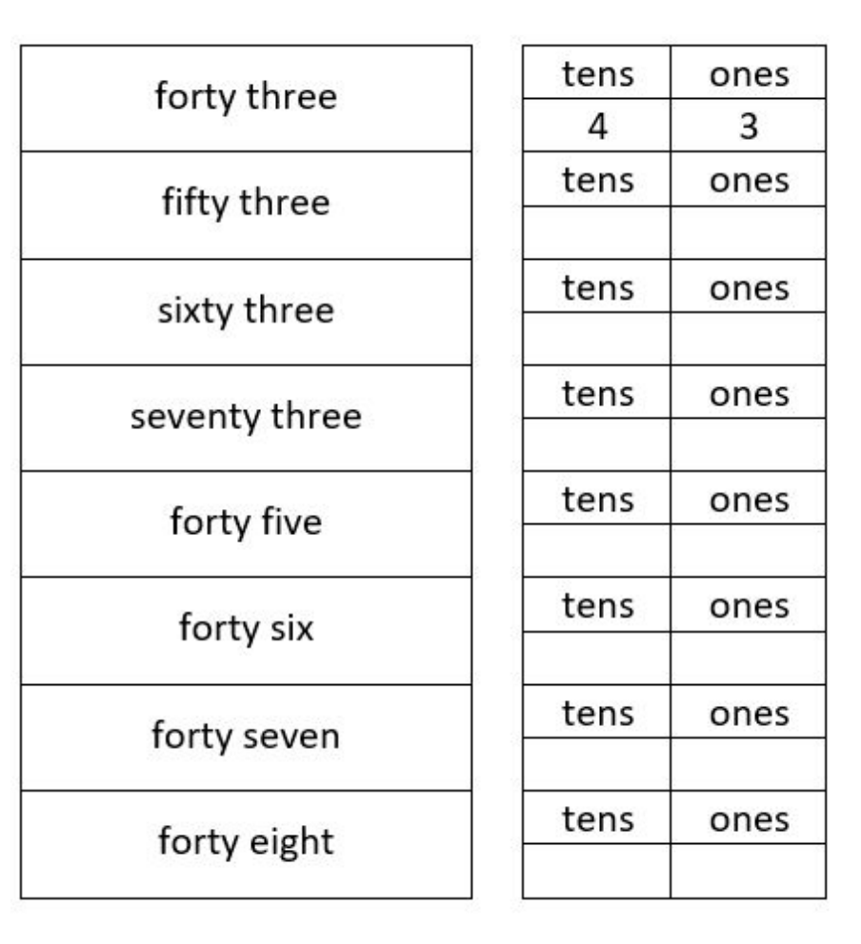

Wednesday 21st April

https://classroom.thenational.academy/lessons/to-explore-the-components-of-numbers-within-100-part-2-6dhk2t

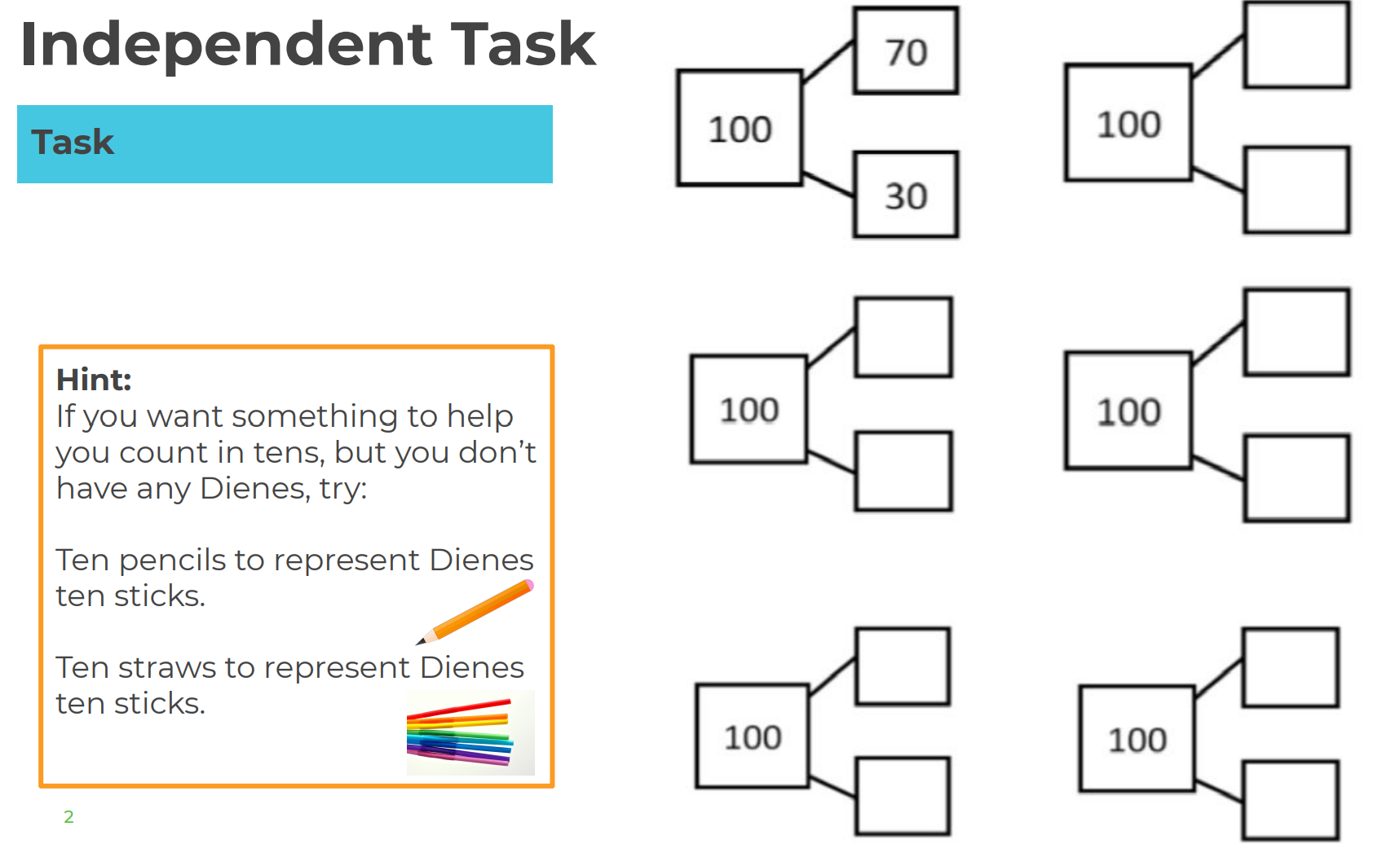
Thursday 22nd April

https://classroom.thenational.academy/lessons/to-apply-knowledge-of-number-bonds-75hp4d

