Maths 28.3.21 Monday
https://classroom.thenational.academy/lessons/fractions-recognising-equivalent-fractions-1-crt36e
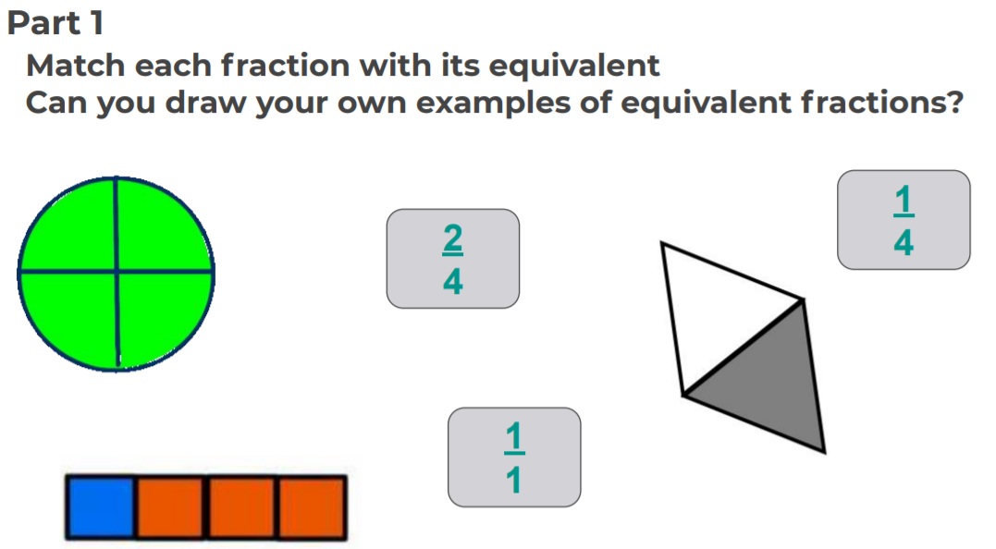
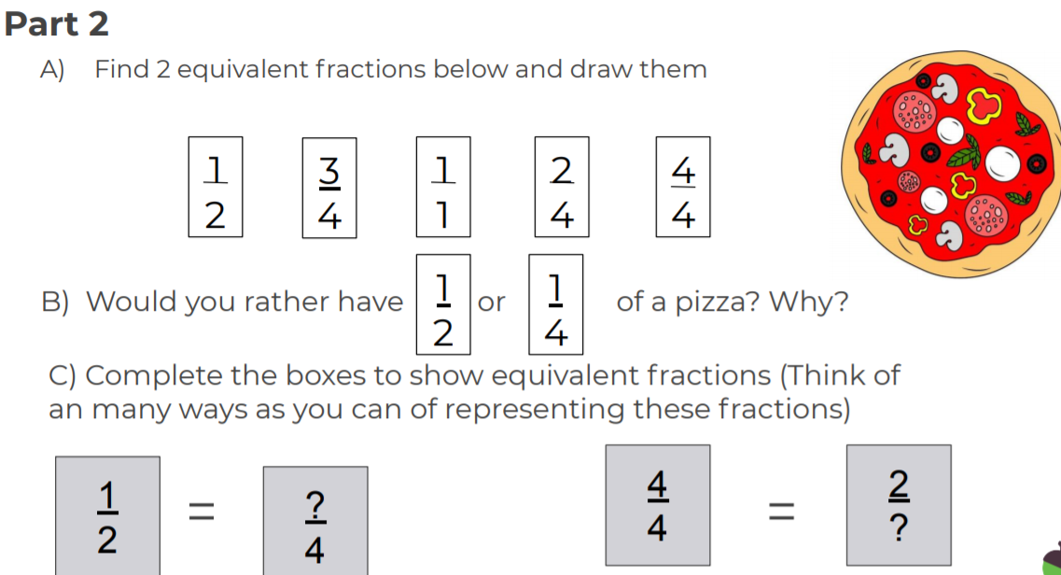

Maths 29.3.21 Tuesday
https://classroom.thenational.academy/lessons/fractions-recognising-equivalent-fractions-2-ccr38c
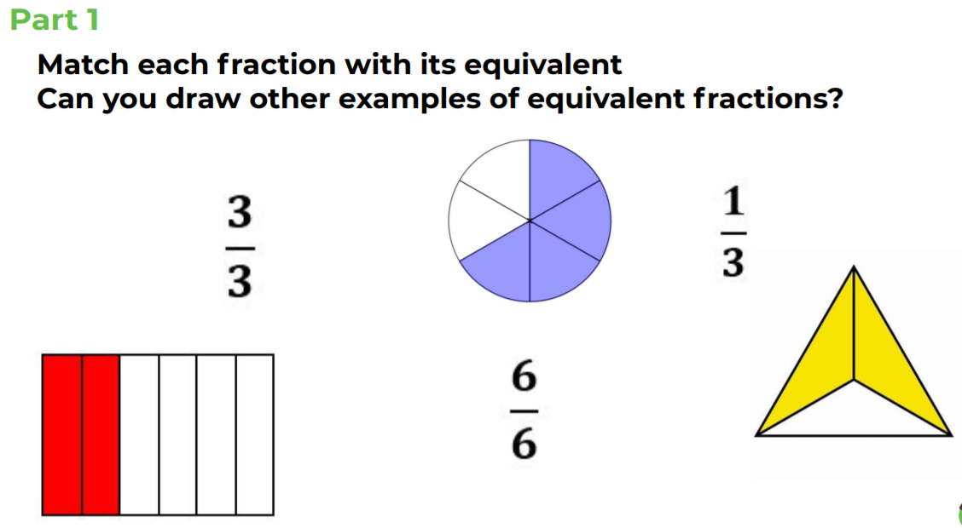
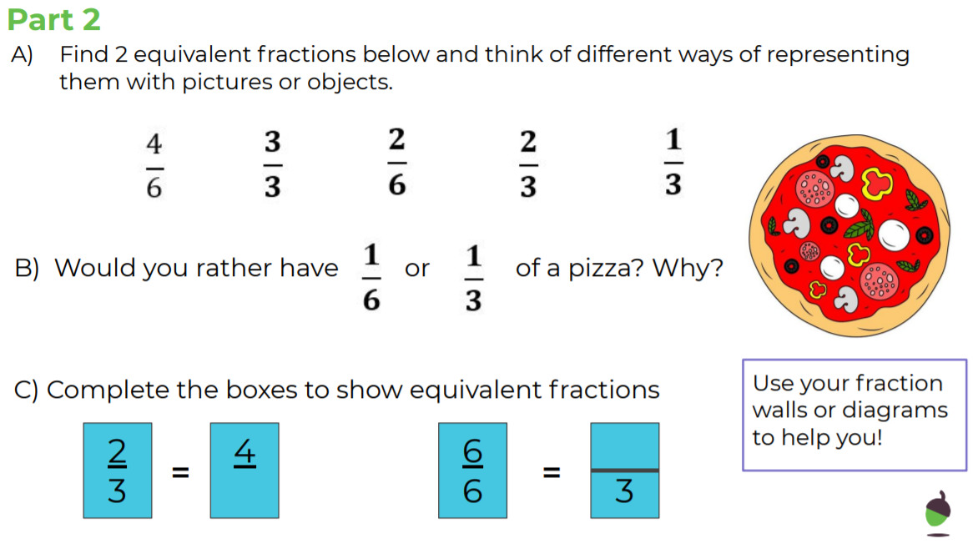

Maths 30.3.21 Wednesday
https://classroom.thenational.academy/lessons/fractions-adding-fractions-with-the-same-denominator-c9k3jc
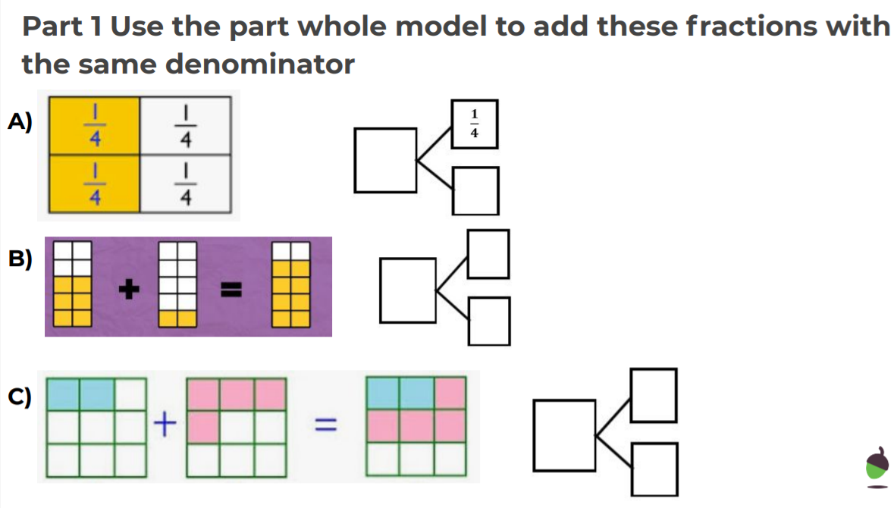
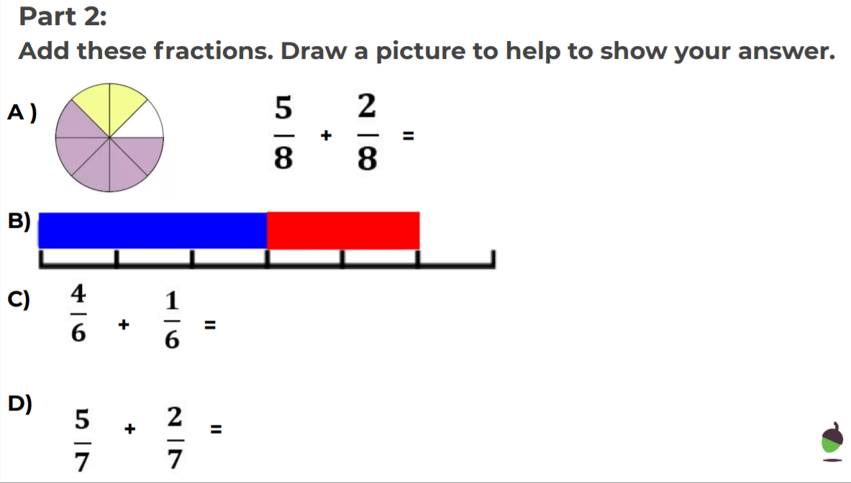

Maths 31.3.21 Thursday
https://classroom.thenational.academy/lessons/fractions-subtracting-fractions-with-the-same-denominator-c9jker

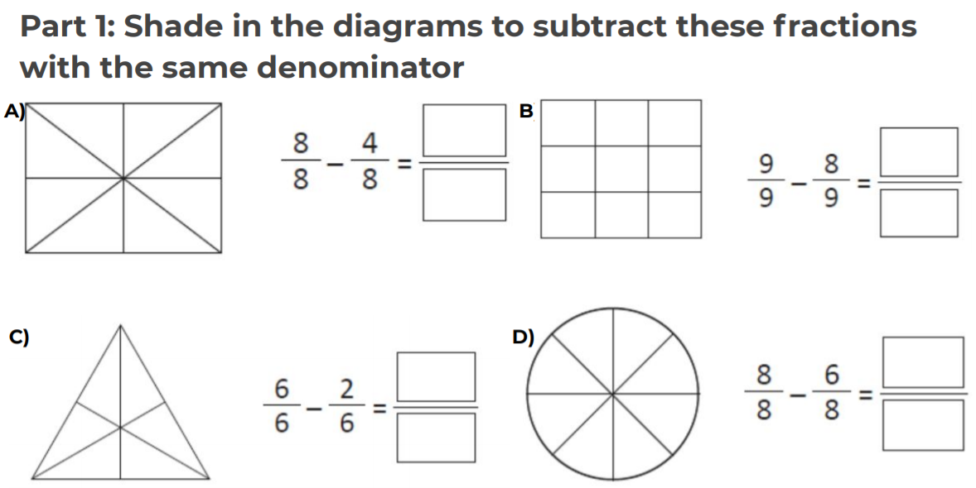
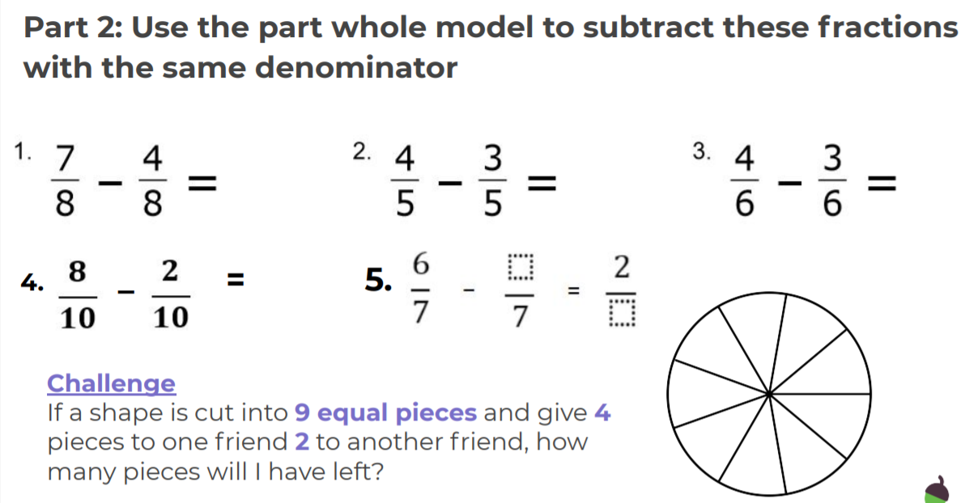

Science 28.3.21 Monday
https://www.bbc.co.uk/bitesize/topics/zsxxsbk
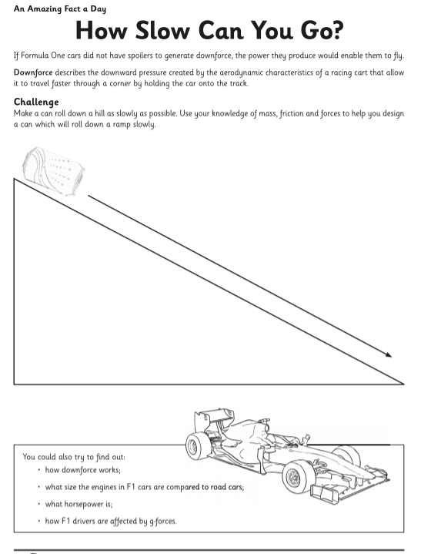

Monday
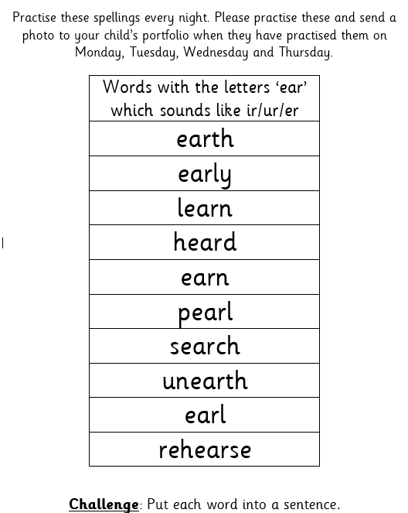

Read this introduction to the Easter story and find all the verbs, nouns, adjectives and adverbs. Create a key and highlight them.

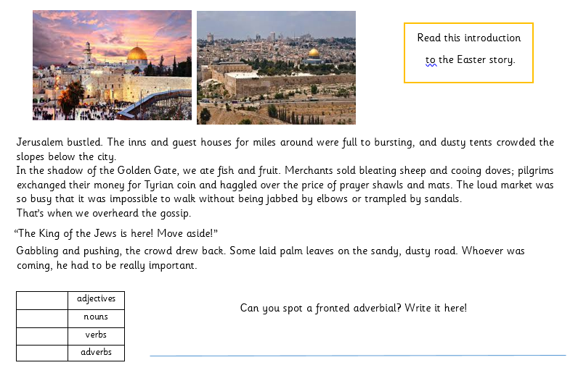

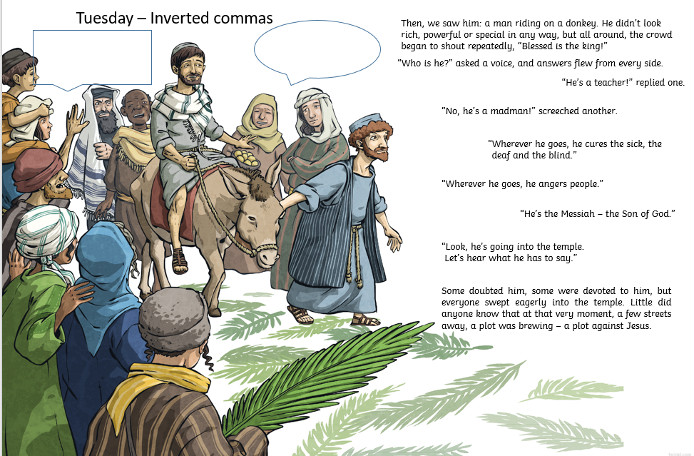
Recap the use of Inverted commas by reading the passage above.
Look at the speech bubbles – write a conversation between the two men in the picture. One is ‘for’ Jesus and one is ‘against’ him.

Read Chapter 5 of the Iron Man on the PDF
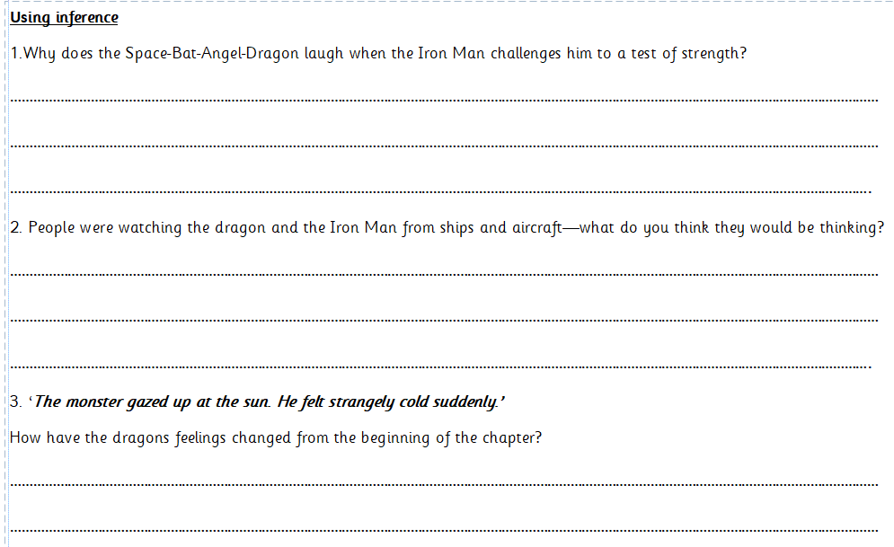
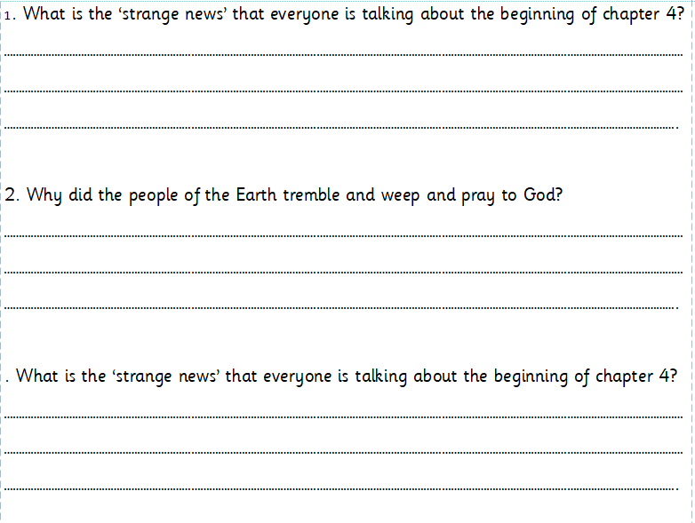
Answer the following questions about Chapter 4 and 5

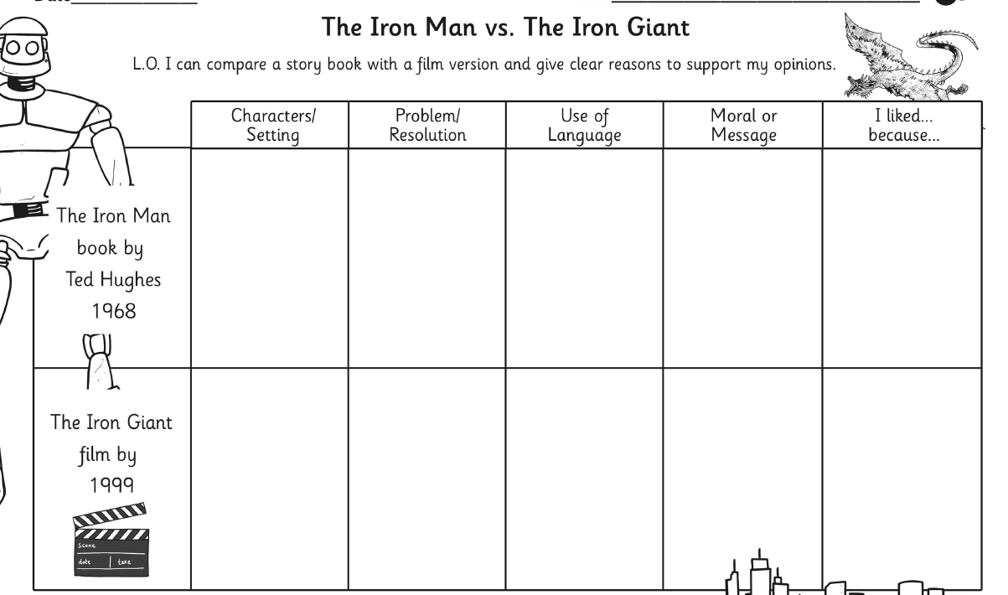
Use youtube to watch the film ‘The Iron Giant’. Compare the book and the film in the grid below and then in your own words.

